Developer Environment Setup

Version <1.3.3>

**By < Raiju Mathew >**

Revision History

|  |  |  |  |
| --- | --- | --- | --- |
| **Date** (dd/mm/yy) | **Version** | **Description** | **Author** |
| 17/05/10 | 0.4.0 | Initial Draft | Pavan Kumar Vedam |
| 16/03/11 | 0.1.4 | Added DTS shared lib for dependencies and eclipse settings for dependencies, Token replacement in eclipse and running mule in eclipse | Anvith V Karkera |
| 14/10/11 | 1.0.0 | Added Apache HTTP Server, Tomcat Web Server and Apache Ant Setup information. Also added is a trouble shoot section which contains some tips and tricks for trouble shoot the possible problems. | Raiju Mathew |
| 31/10/11 | 1.1.0 | DTS and DTS RP builds, deployments and running processes separated and elaborated. | Raiju Mathew |
| 09/11/11 | 1.2.0 | The instructions to run local Mule instance of DTS RP and DTS are updated. | Raiju Mathew |
| 17/11/11 | 1.3.0 | Adding information for Soap-UI testing | Nicolas Vaton |
| 25/03/13 | 1.3.1 | Verifying the document and adding details to make the document ready to be understandable by a beginner. | Raiju Mathew |
| 26/04/13 | 1.3.2 | Separating RP and DTS environment setup | Raiju Mathew |
| 17/05/13 | 1.3.3 | Added much details and screen shots to all sections. | Raiju Mathew |

Approved By

|  |  |  |  |
| --- | --- | --- | --- |
| **Date** | **Version** | **Name** | **Author** |
|  |  |  |  |
|  |  |  |  |
|  |  |  |  |
|  |  |  |  |
|  |  |  |  |

Table of Contents

1. Introduction 6

1.1 Purpose 6

1.2 Scope 6

1.3 Definitions, Acronyms and Abbreviations 6

1.4 Patterns and Best Practices 6

1.5 References 6

1.6 Overview 6

1.7 Tools and APIs 6

2. Code Base and Build Tool Setups 7

2.1 Application Structure / SVN Setup (Code Base) 7

2.1.1 Install a SVN Client 7

2.1.2 Browsing through the Repository 8

2.1.3 SVN Checkout from DTS RP CODE Repository 9

2.1.4 SVN Checkout from DTS CODE Repository 11

2.1.5 DTS Branches Information 13

2.1.6 DTS Tags Information 14

2.2 Apache ANT setup (Build Tool) 14

2.2.1 Download Apache ANT 14

2.2.2 Install Apache ANT 14

2.2.3 Setting Environment variable ANT_HOME 15

3. Reverse Proxy Side Environment Setups 15

3.1 SUN JDK Setup 15

3.1.1 Download the JDK 15

3.1.2 Install the JDK 16

3.1.3 Setting Environment variable JAVA_HOME and PATH 16

3.1.4 Integration of JCE Unlimited Strength files for JDK 6 17

3.2 Tomcat Web Server Setup 18

3.2.1 Introduction to Apache Tomcat 18

3.2.2 Download Apache Tomcat 18

3.2.3 Pre-Requisites for Tomcat Installation 18

3.2.4 Installation of Apache Tomcat 19

3.2.5 Starting and Stopping the Tomcat Server 22

3.2.6 Other Information 23

3.3 Apache HTTP Server Setup 24

3.3.1 Introduction to Apache Http Server 24

3.3.2 Download the Apache Http Server 24

3.3.3 Installing the Apache Http Server 25

3.3.4 Starting and stopping the Apache Http Server 29

3.3.5 Other Information 29

4. DTS Side Environment Setups 31

4.1 WebSphere Application Server setup 31

4.1.1 Uninstall any already existing products 31

4.1.2 Install WebSphere Application Server 7.0 40

4.1.3 Create a New Application Server Profile ‘DTSDomain’ 56

4.1.4 Configure the Profile ‘DTSDomain’ 72

4.1.5 Create a New Data Source 91

4.1.6 JMS Setup for DTS Batch and Online MDBs: (Optional) 101

4.1.7 Integration of JCE Unlimited Strength files for WAS JRE 103

5. Eclipse IDE Setup for Code Development 104

5.1 IDE Configuration Setup 105

5.1.1 Import Order Set-up 105

5.1.2 Code Formatter Set-up 108

5.1.3 Code Templates Set-up 111

5.2 Java Runtime Setup for Eclipse IDE 114

5.2.1 Adding WAS Java Runtime for Eclipse 114

5.2.2 Adding Sun Java Runtime to Eclipse 117

5.3 Importing DTS Projects into Eclipse IDE 120

5.3.1 Import DTS Project into Eclipse 120

5.3.2 Import DTS RP Project into Eclipse 122

6. Building, Token Replacing and Deploying of DTS Projects 125

6.1 Building and Token replacing DTS Projects in Local Server 125

6.1.1 Build DTS Projects in Local Server 125

6.1.2 Token Replace DTS Projects in Local Server 128

6.2 Deploying DTS Projects in Local Server 131

6.2.1 Uninstall DTS Application if already Deployed 131

6.2.2 Deploy DTS Projects in Local Server with no MDBs in DTS EAR 132

6.2.3 Deploy DTS Projects in Local Server with all MDBs in DTS EAR 136

6.2.4 Deploy DTS Projects in Local Server with only selected MDBs in DTS EAR 155

7. Building and Deploying of DTS RP Projects 155

7.1 Building DTS RP Projects in Local Server 155

7.1.1 Build DTS RP Projects in Local Server 156

7.2 Deploying the DTS RP Project in Local Server 159

7.2.1 Deploy DTS RP Project in Tomcat Server 160

7.2.2 Deploy DTS RP Project in Apache Server 162

7.2.3 Setting Proxy Pass configuration for DTS RP in Apache Server 167

8. Testing of DTS Services 168

8.1 Testing DTS RP Services in Local Server 169

8.1.1 Testing of DTS Services through RP 169

8.1.2 Testing Example: The DTS RP WSDL URLs 170

8.1.3 Testing Example: JavaScript, CSS and JAR Files Download 172

8.1.4 Testing Example: DTS Rest Service 174

9. Running DTS and DTS RP Services from Eclipse 175

9.1 Running DTS Services from Eclipse 175

9.1.1 Solving Project Dependencies 175

9.1.2 Setting Java Runtime for DTS Projects 179

9.1.3 Setting Classpath Variable for Third party Libraries 187

9.1.4 Extending the Third party Libraries Classpath Variable for DTS Projects 189

9.1.5 Cleaning and Building the DTS Projects 196

9.1.6 Token Replacing in DTS Projects 199

9.1.7 Setting up the DTS DB for the DTS Projects 200

9.1.8 Setting up the RTS DB for the DTS Projects 202

9.1.9 Setting up the Log File Location for the DTS Projects 204

9.1.10 Setting up the Logging Level for the DTS Projects 205

9.1.11 Setting up the DTS Logging in Eclipse IDE Console 206

9.1.12 Using HTTP for Web Service instead of HTTPS 207

9.1.13 Setting the Mule Configuration Path 209

9.1.14 Starting the Mule Engine 210

9.2 Running DTS RP Services from Eclipse 211

9.2.1 Setting Java Runtime for DTS RP Project 211

9.2.2 Adding Third party Libraries for DTS RP Project 215

9.2.3 Cleaning and Building the DTS RP Project 218

9.2.4 Setting up the Log File Location for the DTS RP Project 220

9.2.5 Setting up the Logging Level for the DTS RP Project 221

9.2.6 Setting up the DTS RP Logging in Eclipse IDE Console 222

9.2.7 Using HTTP for Web Service instead of HTTPS 223

9.2.8 Setting the Mule Configuration Path 224

9.2.9 Starting the RP Mule Engine 225

Developer Environment Setup

# Introduction

The PCI-DTS Developer Environment Setup document provides the information to set up the developer environment in local systems. It can be classified as shown below.

1. Common Environment Setup
2. Application Structure / SVN Setups
3. Eclipse IDE Setup
4. Apache ANT setup
5. Reverse Proxy Side Environment Setups
6. Apache Tomcat Web Server Setup
7. Apache HTTP Server Setup
8. SUN JDK Setup
9. DTS Side Environment Setups
10. IBM WebSphere Application Server Setup
11. JMS Setup
12. IBM WAS JDK Setup

## Purpose

The purpose of this document is to provide step-by-step procedures to be followed to set up the PCI-DTS Developer Environment in a local machine.

## Scope

This document will help the development team to set up the local development environment and to be in the same level on the build/dev environment

## Definitions, Acronyms and Abbreviations

**WAS_HOME** – Folder in which WebSphere is installed into. In our case it is: ‘E:\IBM\WebSphere\AppServer\’

**PROFILE_HOME** – The folder in which the DTSDomain has been installed. In our case it is: E:\DTSDomain

## Patterns and Best Practices

## References

## Overview

## Tools and APIs

* IBM WebSphere 7 Fix Pack 17 (Application Server)
* Eclipse Galileo 3.5 (Eclipse IDE for Java Developers)
* Tortoise SVN (A Subversion client for Windows)
* Apache Tomcat 6 (Web Server)
* Apache 2.2 (HTTP Server)
* Apache Ant 1.8.0 (Automated Software Build)

# Code Base and Build Tool Setups

## Application Structure / SVN Setup (Code Base)

This section talks about the setting up of SVN environment (SVN Client and the initial checkout of the application structure and code from the SVN repository)

### Install a SVN Client

Tortoise SVN is a subversion client for Windows.

NOTE: There are other ways of communicating to SVN like using SVN plug-ins like subclipse or subversive from the IDE (Eclipse). But it is advised to use the Tortoise SVN. The other plug-in tools or other SVN clients too can be used as well here if needed. This section below depicts the use of client.

1. Tortoise SVN can be downloaded here:

<http://tortoisesvn.net/downloads>

1. Select the appropriate install:

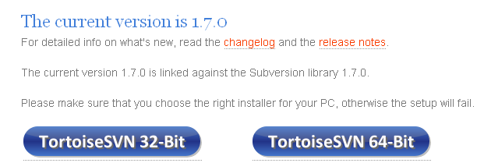

1. It will be a very self-explanatory install and accept all defaults and install.
2. Further help here: <http://sciencefair.math.iit.edu/about/tortoisesvn_tutorial.html>
3. Once Tortoise SVN gets installed, it will push you for a restart. And after restart, it is ready to be used
4. It will add context sensitive menu item in windows explorer and as such is always available.

### Browsing through the Repository

Optional Step: You may look into the repository using Repo-Browser.

1. Launch the windows explorer and reach ‘E:’. Create a directory ‘dts’ in ‘E:\’.
2. Right click would show the ‘TortoiseSVN’ options as shown below.

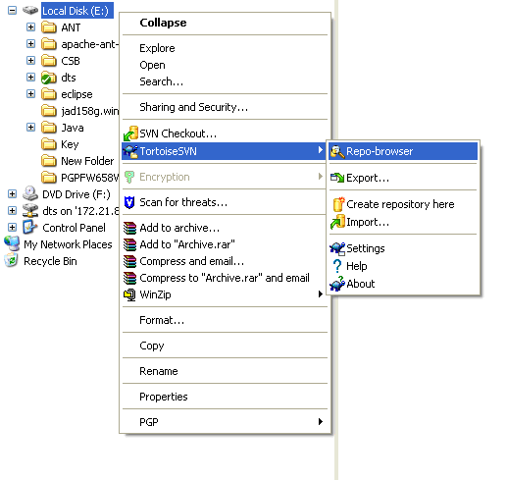

1. ‘Repo-browser’ can be used to browse and add repositories. Select the ‘Repo-browser’ and enter the following :

<http://172.24.204.136/svn/dts/trunk/>

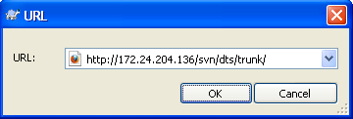

### SVN Checkout from DTS RP CODE Repository

1. Create a directory for checkout of code under E drive (may be named as **dts_rp_release2)**.
2. Check-out can be done as follows (You should be in VPN).

* Right click on the created **dts_rp_release2** folder and select **SVN Checkout**.

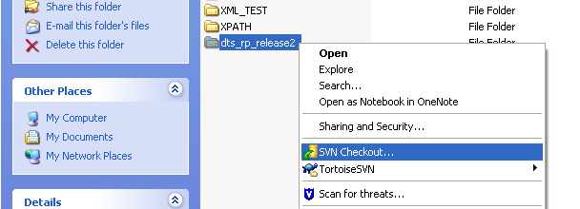

* The following screen will appear. Enter URL of DTS RP latest branch code repository and press OK. Other options are by default ‘Fully recursive’ Checkout Depth and HEAD revision.

Note: For the latest branch information see section 2.1.5 DTS Branches Info.

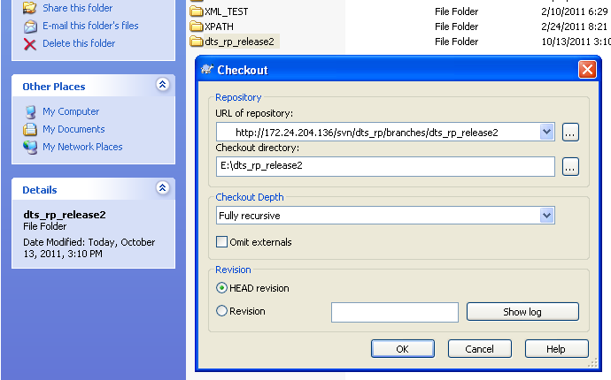

* The checkout will get started with the following screen and when finishes click OK.

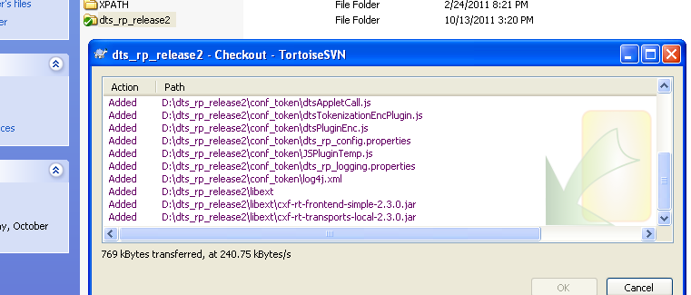

(If you are checking out for the first time, it will challenge for the username and password for authentication to the repository for the checkout as follows. Provide your SVN credentials. If you don’t have SVN credentials please inform you team lead so that he can take necessary steps to create one for you. Till you get your own credentials, you can use one of your team mate’s.)

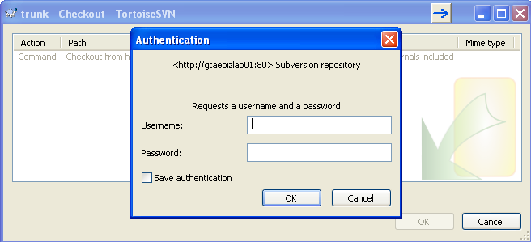

You may check the **Save authentication** checkbox so that it does not challenge you every time you go for a checkout.

### SVN Checkout from DTS CODE Repository

1. Create a directory for checkout of code under E drive (may be named as **dts_release2)**.
2. Check-out can be done as follows (You should be in VPN).

* Right click on the **dts_release2** folder and select **SVN Checkout**.

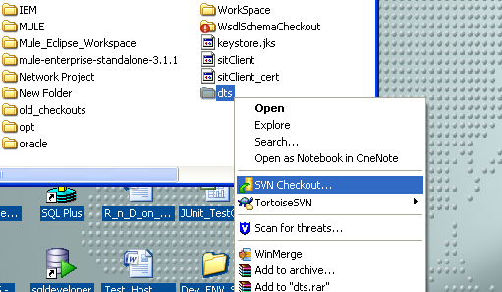

* Enter the URL for the DTS latest branch code repository and press OK. Other options are by default ‘Fully recursive’ Checkout Depth and HEAD revision.

Note: For the latest branch information see section 2.1.5 DTS Branches Info.

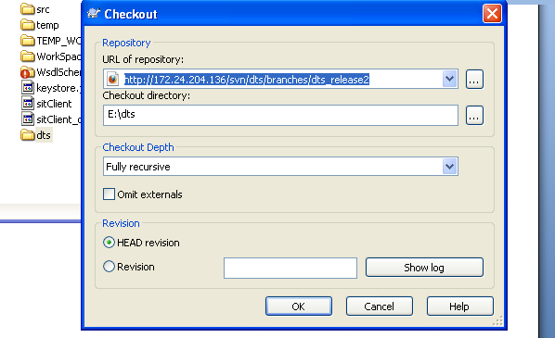

* The checkout will get started as below and when finishes click OK.

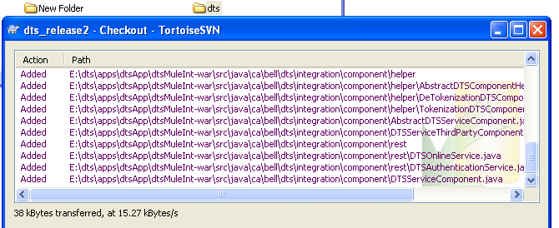

Now you have done with SVN Checkout for DTS Release 2 Code Base.

### DTS Branches Information

You should be connected to Bell VPN to access the SVN repository. Accessing the SVN links prompts for SVN credentials. DTS has various branches created for DTS development. Given below are the major ones for DTS side, RP side and utilities.

1. DTS Side Branches

DTS side branches can be accessed using the link <http://172.24.204.136/svn/dts/branches/>. Following are the main DTS side branches.

|  |  |
| --- | --- |
| DTS Trunk  (Phase 1) | <http://172.24.204.136/svn/dts/trunk/> |
| DTS Release 2  (Phase 2 Online) | <http://172.24.204.136/svn/dts/branches/dts_release2/> |
| DTS Release 2 b  (Phase 2 Batch) | <http://172.24.204.136/svn/dts/branches/dts_release2b/> |
| DTS Release 5  (**Latest DTS Branch**, Online and Batch combined) | <http://172.24.204.136/svn/dts/branches/dts_release5/> |

1. DTS RP Side Branches

DTS RP side branches can be accessed using the link <http://172.24.204.136/svn/dts_rp/branches/>. Following are the main DTS RP side branches.

|  |  |
| --- | --- |
| DTS RP Trunk  (Phase 1) | <http://172.24.204.136/svn/dts_rp/trunk/> |
| DTS RP Release 2  (Phase 2) | <http://172.24.204.136/svn/dts_rp/branches/dts_rp_release2/> |
| DTS RP Release 5  (**Latest RP Branch**) | <http://172.24.204.136/svn/dts_rp/branches/dts_rp_release5/> |

1. Other DTS Utility Branches

\

|  |  |
| --- | --- |
| DTS Utilities Trunk | <http://172.24.204.136/svn/dts_utilities/trunk/> |
| Test Credit Card Numbers Generator | <http://172.24.204.136/svn/dts_utilities/trunk/CreditCardNumbeDataGenerator> |
| DTS Log Parser | <http://172.24.204.136/svn/dts_utilities/trunk/DtsLogParser/> |

### DTS Tags Information

SVN is tagged when DTS builds are taken, with the flag for tagging is set to true. Given below are the links to access the existing tags in SVN for DTS and RP builds.

|  |  |
| --- | --- |
| DTS Tags | <http://172.24.204.136/svn/dts/tags/> |
| DTS RP Tags | <http://172.24.204.136/svn/dts_rp/tags/> |

## Apache ANT setup (Build Tool)

**Apache Ant** is a software tool for automating software build processes. Ant is written in Java. It requires the Java platform to execute. Ant uses XML to describe the build process and its dependencies and by default the XML file is named build.xml. PCI-DTS uses Ant scripts to build the projects.

### Download Apache ANT

Download the **Ant binary** from the following URL.

<http://ant.apache.org/manual/install.html#getting>

### Install Apache ANT

The binary distribution of Ant consists of the following directory layout. Only the **bin** and **lib** directories are required to run **Ant**.

|  |
| --- |
| ant  +--- README, LICENSE, fetch.xml, other text files. //basic information  +--- bin // contains launcher scripts  |  +--- lib // contains Ant jars plus necessary dependencies  |  +--- docs // contains documentation  | |  | +--- images // various logos for html documentation  | |  | +--- manual // Ant documentation (a must read ;-)  |  +--- etc // contains xsl goodies to:  // - create an enhanced report from xml output of various tasks.  // - migrate your build files and get rid of 'deprecated' warning  // - ... and more ;-) |

To install Ant, **choose a directory and copy** the distribution files there. This directory will be known as **ANT_HOME**. In our case it is normally **E:\apache-ant-1.8.0**.

### Setting Environment variable ANT_HOME

Add the bin directory to your path and set the **ANT_HOME** environment variable to the directory where you installed Ant.

# Reverse Proxy Side Environment Setups

## SUN JDK Setup

### Download the JDK

Download JDK 6 update 21 or later from Oracle. As of May 2013, DTS is using JDK 6 update 35 from Oracle. Following links refer to JDK 6 update 21 download page.

<http://www.oracle.com/technetwork/java/javasebusiness/downloads/java-archive-downloads-javase6-419409.html>

<http://www.oracle.com/technetwork/java/javasebusiness/downloads/java-archive-downloads-javase6-419409.html#jdk-6u21-b07-oth-JPR>

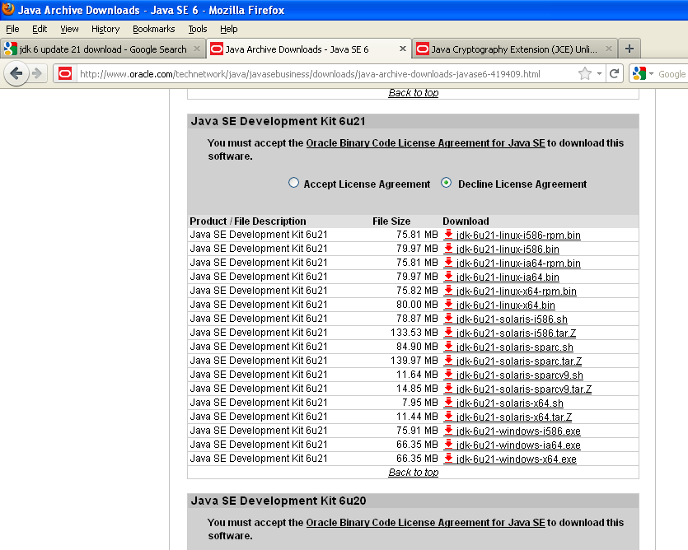

Accept license agreement and download the JDK 6(You may be asked to register with Oracle Web). If your windows OS is of 32 bit click on **jdk-6u21-windows-i586.exe.** Click on **jdk-6u21-windows-x64.exe** if it is of 64 bit.

### Install the JDK

Install it by double clicking the exe file. Accept the license agreement and accept the defaults. By default JDK 6 Update 21will get installed to C:\Program Files\Java\jdk1.6.0_21.

### Setting Environment variable JAVA_HOME and PATH

To reach environment variables section:

Right click on My Computer-> Properties-> Advanced tab-> Environment Variables->

To set the **JAVA_HOME** environment variable:

Click New-> give the variable name as **JAVA_HOME** and variable value as JDK installation path. (For example : C:\Program Files\Java\jdk1.6.0_21).

Note that this variable should contain the path of JDK installation directory. It should not contain the path up to bin folder.

To set the **PATH** environment variable:

Click New-> give the variable name as **PATH** and variable value as **%JAVA_HOME%\bin; %PATH%**

### Integration of JCE Unlimited Strength files for JDK 6

#### History behind JCE Unlimited Strength files

For historic reasons, until 1996, export of cryptographic methods (including software) from the USA was severely limited legally. These restrictions also applied to the Java platform. Accordingly, users outside the US could only be supplied with cryptographic methods with keys of reduced length. To this end, the component “Java Cryptography Extension (JCE)” was configured through “policy files” that limited export versions of Java to 128-bit encryption while the US version could handle 256-bit encryption.

Meanwhile, legal restrictions have been changed so that most countries, including the European Union, may receive and use 256-bit encryption. Oracle, however, still delivers its standard Java only with the weaker JCE, simply because some countries restrict the import of cryptography and Oracle will not take responsibility for compliance with local laws. European users do not fall under any import restriction and therefore may deploy the "Unlimited Strength Jurisdiction Policy Files" legally.

#### Why DTS need JCE Unlimited Strength files?

The Oracle JDK comes with 128-bit encryption strength by default. DTS design uses 256-bit encryption. So it is necessary to download the JCE Unlimited Strength files and copy it to corresponding folder of JDK installation for DTS to run successfully.

#### How to integrate JCE Unlimited Strength files in Oracle JDK?

Go to the <DTS RP Checkout folder>\docs folder and extract the content of jce_policy-6.zip file. This zip file is also embedded below.



(You may also download this zip file from http://www.oracle.com/technetwork/java/javase/downloads/jce-6-download-429243.html location also)

Copy and paste it somewhere, then extract the zip file and when extracted, copy the **US_export_policy.jar** and **local_policy.jar** files to JDK installation directory’s **security** folder.

If JDK 6 got installed to C:\Program Files\Java\jdk1.6.0_21 then copy and paste the jar files to C:\Program Files\Java\jdk1.6.0_21\jre\lib\security folder by replacing the existing files.

## Tomcat Web Server Setup

This section talks about the setting up of Tomcat in the local machine.

### Introduction to Apache Tomcat

Apache Tomcat is an open source software implementation of the Java Servlet and Java Server Pages technologies. Different versions of Apache Tomcat are available for different versions of the Servlet and JSP specifications. The mapping between the specifications and the respective Apache Tomcat versions available at the time of creation of this document is:

|  |  |  |  |
| --- | --- | --- | --- |
| **Servlet/JSP Spec** | **Apache Tomcat version** | **Actual release revision** | **Minimum Java Version** |
| 3.0/2.2 | 7.0.x | 7.0.21 | 1.6 |
| 2.5/2.1 | 6.0.x | 6.0.33 | 1.5 |
| 2.4/2.0 | 5.5.x | 5.5.34 | 1.4 |
| 2.3/1.2 | 4.1.x (archived) | 4.1.40 (archived) | 1.3 |
| 2.2/1.1 | 3.3.x (archived) | 3.3.2 (archived) | 1.1 |

### Download Apache Tomcat

Tomcat comes in two forms: .zip file or the Windows installer (.exe file). The easiest way to install Tomcat on a Windows machine is by using the Windows Installer. Tomcat 6 download page is here <http://tomcat.apache.org/download-60.cgi>.

### Pre-Requisites for Tomcat Installation

Before beginning the process of installing Tomcat on your system, ensure first the availability of JDK on your system program directory.Install JDK on your system if not already installed (because tomcat requires the Java 1.6 or higher versions). Java JDK can be downloaded from here <http://www.oracle.com/technetwork/java/javase/downloads/index.html>.

The **PATH** environment variable and the **JAVA_HOME** environment variable should be set. Ensure that these variables exists and points to a valid JDK installation.

### Installation of Apache Tomcat

Now we are ready to install tomcat (Example given is Tomcat 6).

Execute the '.exe' file of Tomcat.

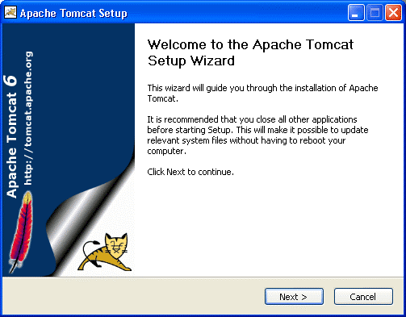

Click next for the welcome screen that appears. Click on the 'I Agree' button on the 'License Agreement' screen that appears next. The next screen asks for the 'installing location'.

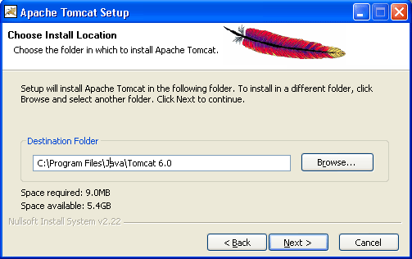

Click next. Configuration Options screen will get displayed.

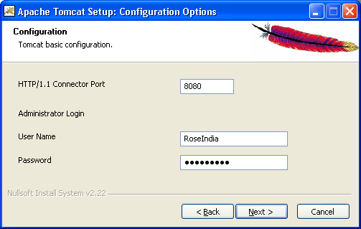

The default port where the Tomcat tries to run its service to listen the HTTP requests is 8080. If you want to run the Tomcat on a different port for some reason, you can do it here or can do it later by editing the **server.xml** file under the **conf** directory of Tomcat installation folder (Open **server.xml** file and edit **Connector** tag settings).

The administrator password can be set here if needed. If you prefer to set, then you have to use them to log-in to the administration console of the tomcat server.

Now, click on the 'Next' button to further proceed the installation process.

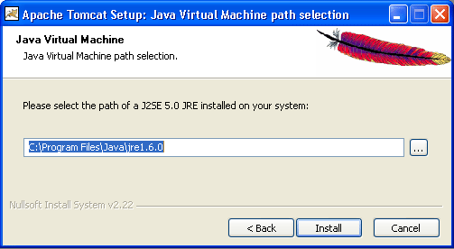

Browse the location of the JRE folder (under the JAVA_HOME) and click on the Install button. This will install the Apache tomcat at the location specified earlier.

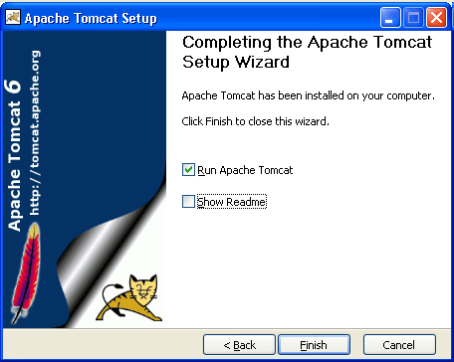

Click on the 'Finish' button. If the Run Apache Tomcat checkbox is selected while pressing Finish button, the Tomcat will start as a windows service.

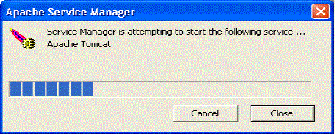

After the successful start, you can see the Tomcat Manager icon in the Task Bar Tray. You can do some basic operations such as stop the server, start the server, etc. by clicking this icon.

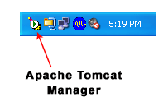

Now, you have done with the installation of Tomcat.

### Starting and Stopping the Tomcat Server

The Tomcat start type is by default set to **auto**, meaning that it starts when windows starts. If you change the default installation location, then Tomcat start type may be changed to **manual**, meaning that you have to start it explicitly.

You can change all these configuration settings by accessing the Tomcat Configuration Window which can be opened in many ways:

Double Click the tray icon of Tomcat

Start -> All Programs -> Apache Tomcat 6.0 -> Configure Tomcat.

Start -> Control Panel -> Administrative Tools -> Service ->Apache Tomcat 6

Tomcat can be started in many ways:

Start -> All Programs -> Apache Tomcat 6.0 -> Monitor Tomcat (You will see the icon in the tray) -> Start and stop the service using the icon.

Go to the **CATALINA_HOME (Tomcat installation root) and then to bin directory. Click on tomcat6.exe.** A command prompt window will open and tomcat service will start running. Here you will not see the icon in the tray. To stop the server, press **Ctrl +C** in the command prompt window.

### Other Information

**The CATALINA_HOME** environment variable should represent the root of your Tomcat installation.

Important Tomcat Directories:

* **/bin** - Startup, shutdown, and other scripts. The *.sh files (for Unix systems) are functional duplicates of the *.bat files (for Windows systems). Since the Win32 command-line lacks certain functionality, there are some additional files in here.
* **/conf** - Configuration files and related DTDs. The most important file in here is server.xml. It is the main configuration file for the container.
* **/logs** - Log files are here by default.
* **/webapps** - This is where your web applications go.

If you choose the port number 8080, you need the following URL to access Tomcat default page:

<http://localhost:8080/index.jsp>

If you choose port number as 80, which is the default web port, you do not need to specify any port number in the URL to access Tomcat default page.

<http://localhost/index.jsp>

Testing the service:

Go to browser and execute the index page of Tomcat. The URL depends on the port settings given earlier.

<http://localhost:8080/>

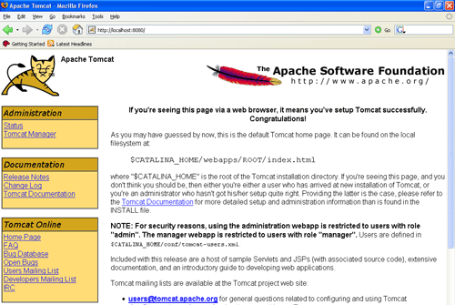

If this page comes up successfully, tomcat has been started and running.

## Apache HTTP Server Setup

This section talks about the setting up of Apache HTTP Server in the local machine.

### Introduction to Apache Http Server

The Apache HTTP Server Project is an effort to develop and maintain an open-source HTTP server for modern operating systems including UNIX and Windows NT. The goal of this project is to provide a secure, efficient and extensible server that provides HTTP services in sync with the current HTTP standards. Following are the most recent releases.

|  |  |  |
| --- | --- | --- |
| **Release** | **Version** | **Date** |
| Recommended current 2.2 release | 2.2.21 | 2011-09-13 |
| Development 2.3 beta release | 2.3.14-beta | 2011-08-09 |
| Legacy 2.0 release | 2.0.64 | 2010-10-19 |

### Download the Apache Http Server

Releases can be downloaded from <http://httpd.apache.org/download.cgi>

(Choose Win32 Binary including OpenSSL)

Access to the source code:

|  |  |
| --- | --- |
| Browse | <http://svn.apache.org/viewcvs.cgi/httpd/httpd/> |
| SVN Direct | <http://svn.apache.org/repos/asf/httpd/httpd/> |

### Installing the Apache Http Server

After downloading it, double click it to start the self-installation. For installation of the Apache HTTP server you need to have Administrator rights.

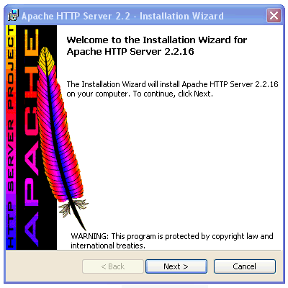

Click Next

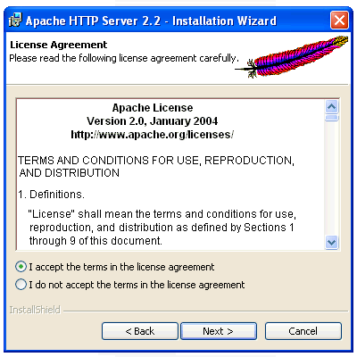

Accept the license agreement -> Click Next

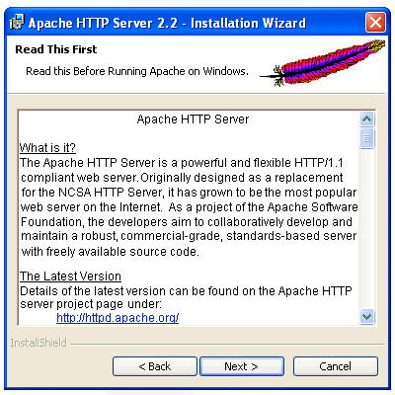

Read the Read Me File -> Click Next

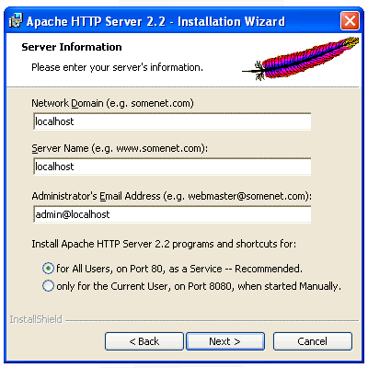

Fill in your Network Domain, Server Name, and Administrator's Email Address. If the server is not going to be hosted on the Internet, you can use **localhost** as the network and server name and choose for **All Users, on Port 80, as a Service** radio button.

Again, if you select a port other than default http port, you will need to stipulate this port when calling your network. Also avoid any port conflict with other servers/services running on the localhost.

Click Next

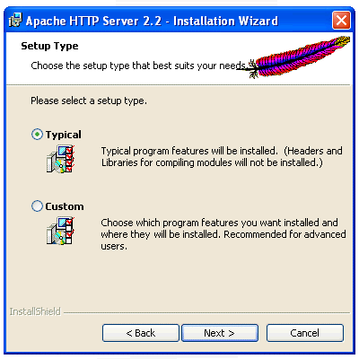

Choose **Typical** and Click Next

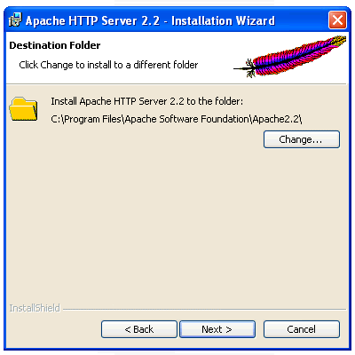

Click Next

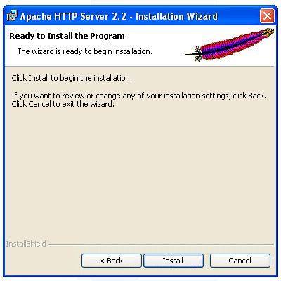

Click on the **Install** button. When completed click on **Finish.**

A new icon will get displayed in the system tray which will tell you if your server is in a running or stopped state.

The  icon in the system tray means it started. The  icon means the **Monitor Apache Servers** utility is running, but Apache2 isn't started.

### Starting and stopping the Apache Http Server

You can start/stop server using this icon. To see if Apache is started and serving the requests, open your browser and head to: <http://127.0.0.1/> or <http://localhost/>. If it shows “***It works!”*** then the server is running.

### Other Information

(If you have a problem with the **localhost** command, you can check your **hosts** file in the location C:\WINDOWS\system32\drivers\etc, open it with a text editor and make sure that the following line present uncommented there.

**127.0.0.1       localhost**

The **document root** is the location where you would place your index.html file and all other media you plan to test or serve from this server. By default it is the **htdocs** folder under the Apache installation home (ex. C:/Program Files/Apache Software Foundation/Apache2.2/htdocs/).

If want to change your document root:

* Open the ***httpd.conf*** file.

(ex. Under location C:\Program Files\Apache Software Foundation\Apache2.2\conf\)

* search for **DocumentRoot**
* locate **DocumentRoot "C:/Program Files/Apache Software Foundation/Apache2.2/htdocs"**

**(The second bold part may change depends on the installation root)**

* Change the location to your choice

(ex. **DocumentRoot “C:/myWebRoot”)**

* Then scroll down about one page and locate: **<Directory "C:/Program Files/Apache Software Foundation/Apache2.2/htdocs">**

**(Again, the second bold part may change depends on the installation root)**

* Change the location to the same location you set to the **DocumentRoot** above

(ex. **<Directory “C:/myWebRoot”>)**

Always restart Apache after configuration changes.

# DTS Side Environment Setups

## WebSphere Application Server setup

### Uninstall any already existing products

Perform this step if you have any version of WebSphere Application Server (like the trial versions / 6.1) set up already in your system which you want to clean up to bring the system to a ‘clean’ state for a fresh install.

#### Uninstall the feature pack

If any feature packs are installed on the WebSphere Application Server base, they need to be uninstalled first. Uninstall the Feature Pack for Web Services before you uninstall the application server

* Run the ‘uninstall.exe’ located in the ‘<WAS_HOME>’\uninstall_websv\uninstall.exe
* Click ‘Next’ through the screens to lead to the uninstall. Note that it mentions that the ‘DTSDomain’ profile would become unusable as the profile was created with the Web Service Feature Pack enablement. This is an expected behavior.

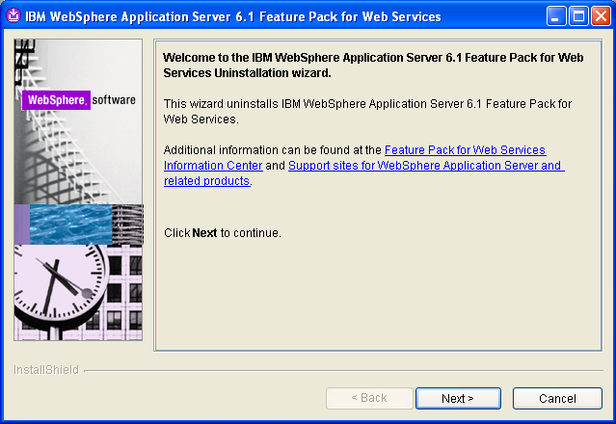

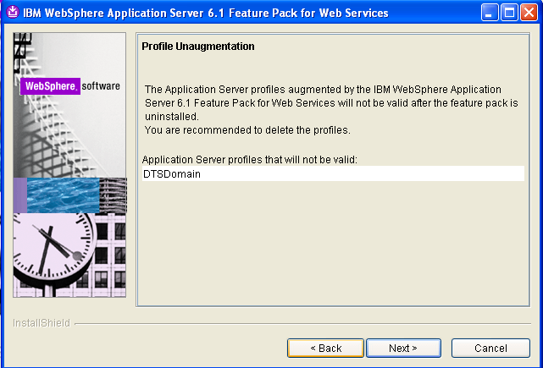

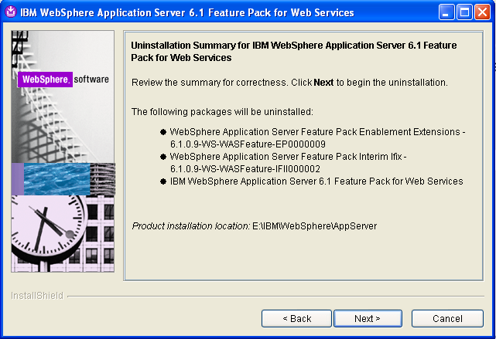

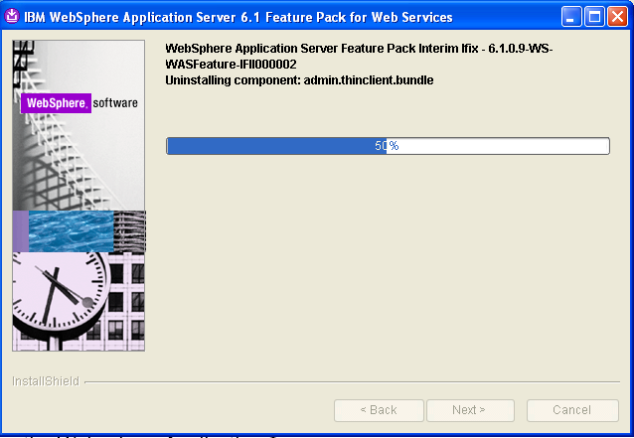

* This will take some time to uninstall all the components.
* Verify ‘Success’ in un-installation. Click ‘Finish’.

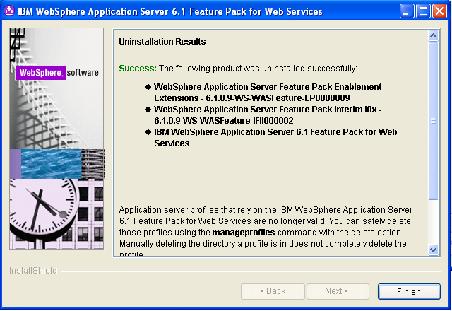

#### Uninstall the WebSphere Application Server

* Run the ‘uninstall.exe’ located in ‘<WAS_HOME>/uninstall’.

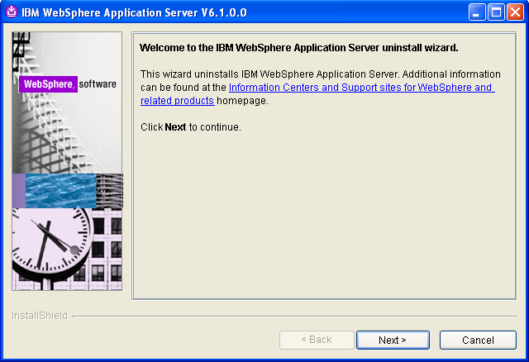

* Click ‘Next’ through the screens to complete the un-installation. Notice that the check box ‘Remove all profiles’ is checked. This would remove the profile ‘DTSDomain’ which is expected and necessary.

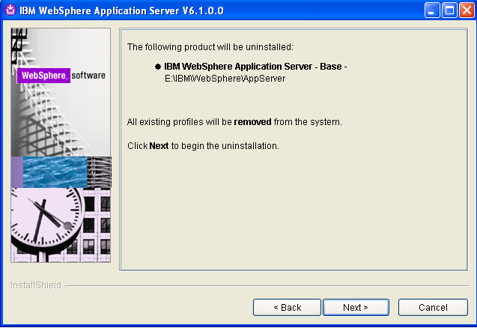

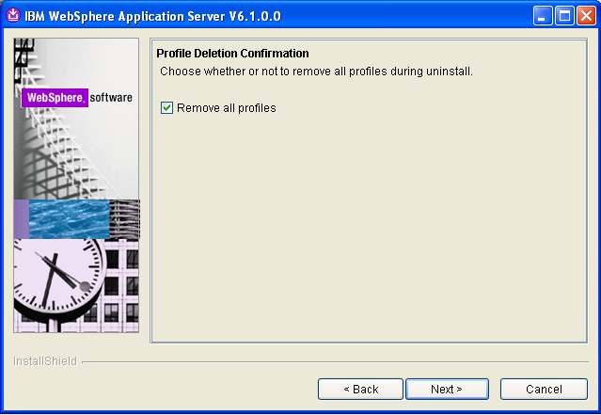

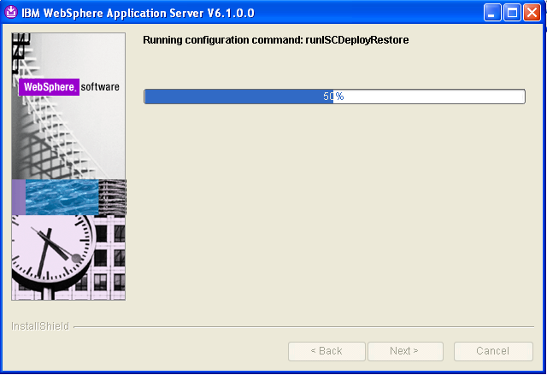

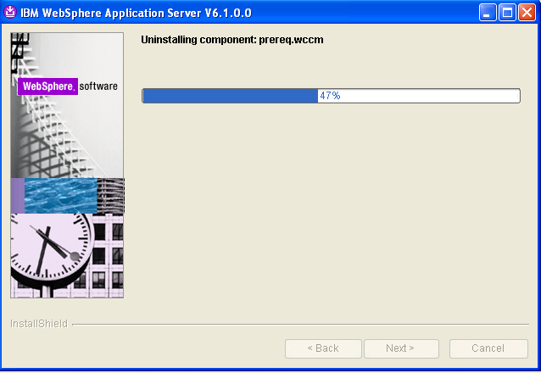

* Verify ‘Success’ in uninstall. Click ‘Finish’

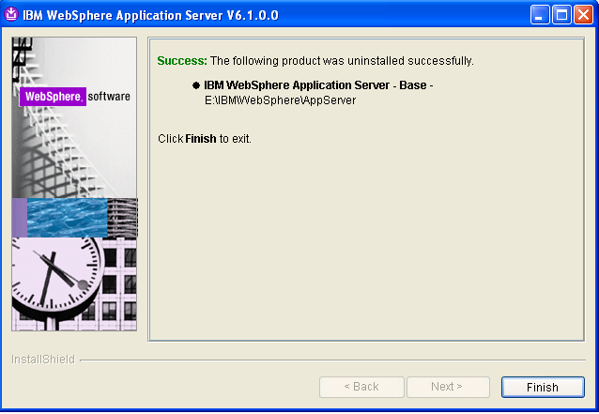

#### Uninstall ‘Update Installer’

* Run the ‘uninstall.exe’ located in the ‘Update Installer install folder’\uninstall. Ideally it would be in the same level as the folder of WAS_HOME. In our case, it is ‘E:\IBM\WebSphere\UpdateInstaller\uninstall.exe’

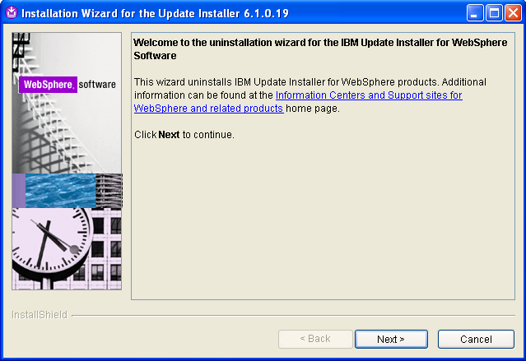

* Click ‘Next’ through the screens to proceed with the uninstallation.

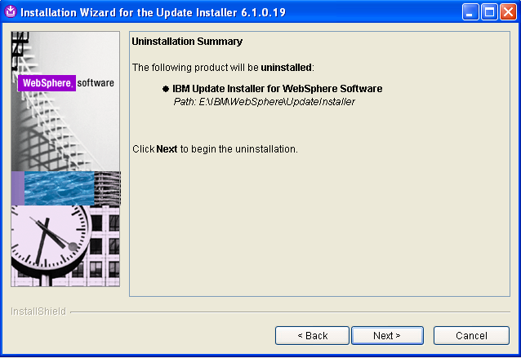

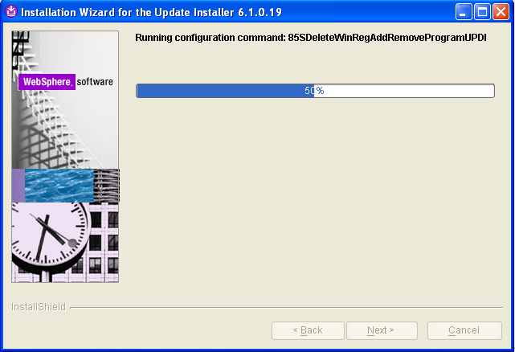

* Verify ‘Success’ of uninstall. Click ‘Finish’

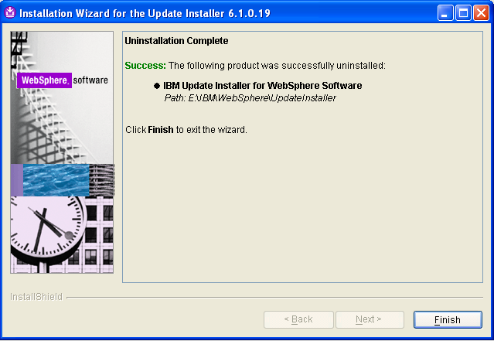

#### Clean up the old install folders.

* Delete the folder ‘E:\IBM’ and ‘E:\DTSDomain’. This would clean up the old install’s remains.

### Install WebSphere Application Server 7.0

NOTE: WebSphere 7.0 install being done is only the ‘base’. The information of the patch/fix/packs to be applied is not known yet and would be included as and when the information is available.

#### Download WebSphere 7.0

* Use the link <https://www14.software.ibm.com/webapp/iwm/web/pick.do?source=swg-wsasfd&lang=en_US>
* Select version 7.0; Click ‘Continue’

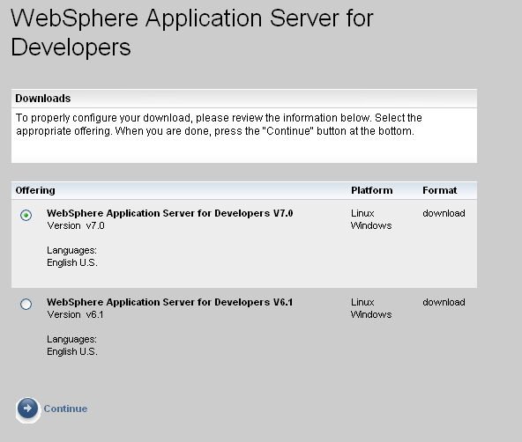

* Give the basic details, accept the license and confirm.

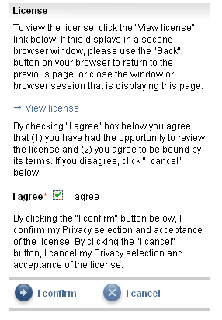

* Select the ‘was.cd.7000.wasdev.nocharge.windows.ia32.zip’ for windows. Click ‘Download Now’

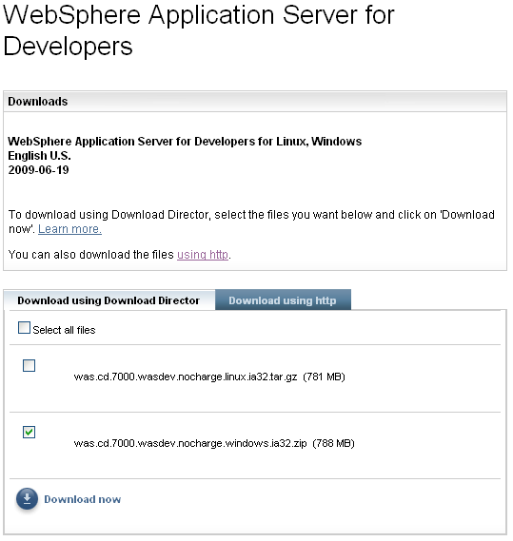

* For using ‘http’ download, click the ‘Download using http’ tab and click ‘Download Now’ next to the ‘was.cd.7000.wasdev.nocharge.windows.ia32.zip’

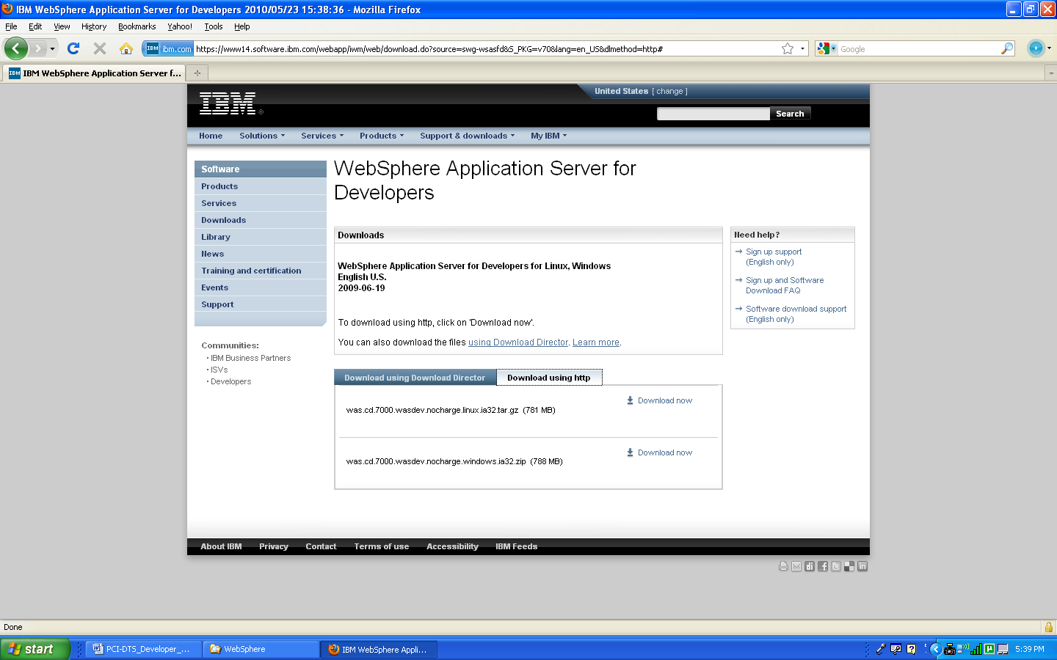

#### Extract and Install

* Extract the file ‘was.cd.7000.wasdev.nocharge.windows.ia32.zip’ and install running the ‘launchpad.exe’

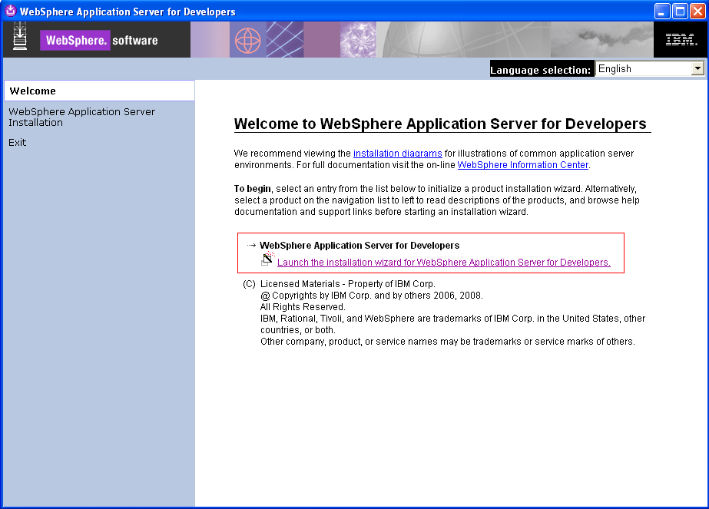

* Click on ‘Launch the installation wizard for WebSphere Application Server for Developers’. This will launch the wizard showing the screen below:

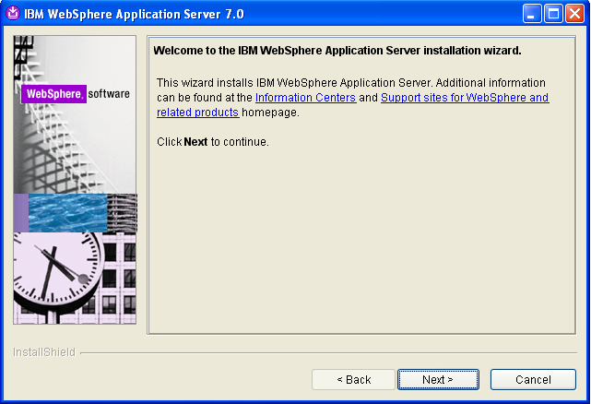

* Click ‘Next’
* Accept both IBM and non-IBM terms: then Click ‘Next>’

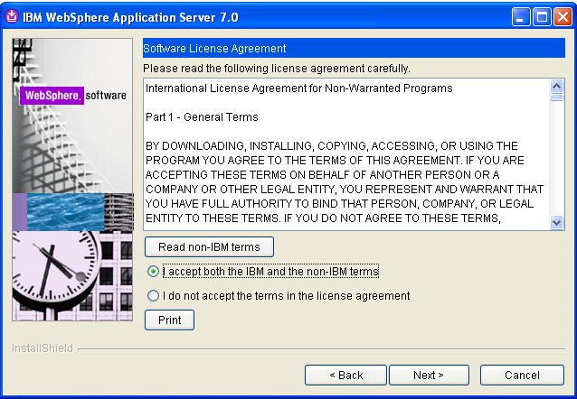

* Verify the ‘Passed’ of ‘System Prerequisites Check’. Click ‘Next>

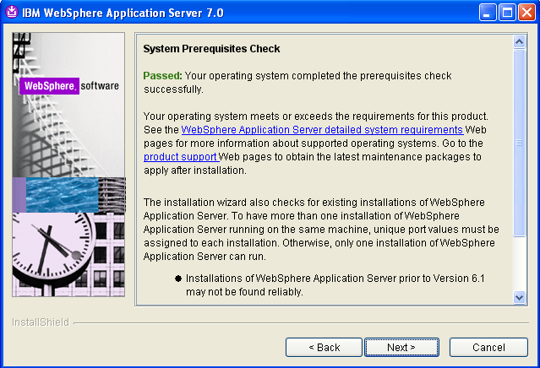

* You can shoose to ‘Install the Sample applications’ here: (Non – English Language packages are not needed): Click ‘Next>’

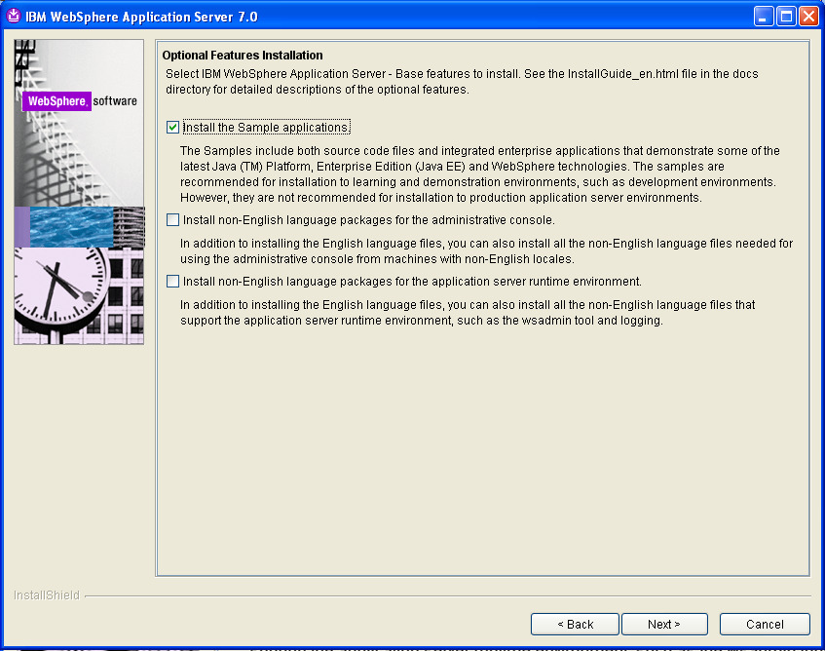

* Enter ‘E:\IBM\WebSphere\AppServer’ for the ‘Product Install Location’. Click ‘Next>’

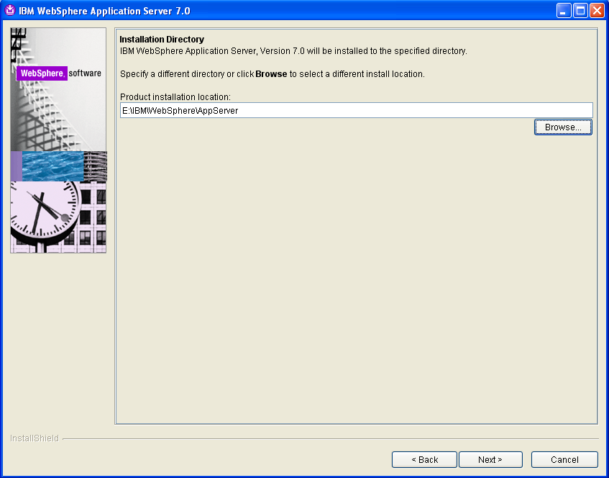

NOTE: It is recommended to use the same path so that the local build scripts which would be checked out and committed won’t have different entries for different users. If in case there is a need to change the path because of local drive configuration, the relevant changes have to be done in the local build scripts after the SVN checkout but it shouldn’t be committed to the SVN.

* Verify ‘Application server’ option (selected by default). Click ‘Next>’

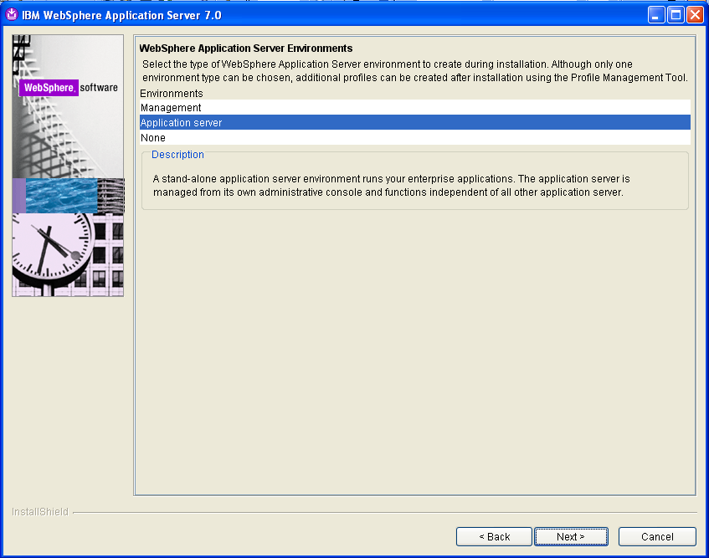

* Check ‘Enable administrative security’ and username: wasadmin and provide your own password. Note down the password as it is required later to access administrative pages of WebSphere.

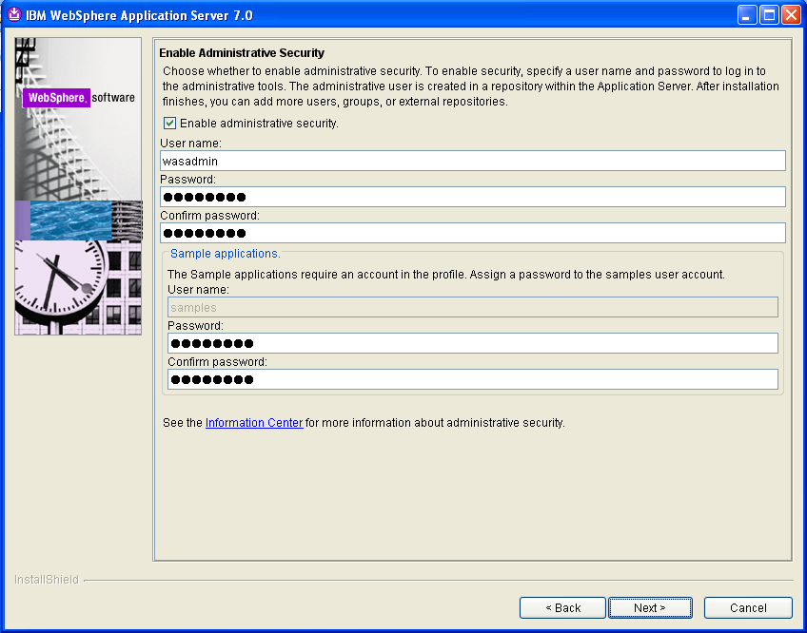

If sample applications option was selected in the relevant step before, provide the password for ‘samples’ also.

* Verify ‘Installation summary’. Click ‘Next>’

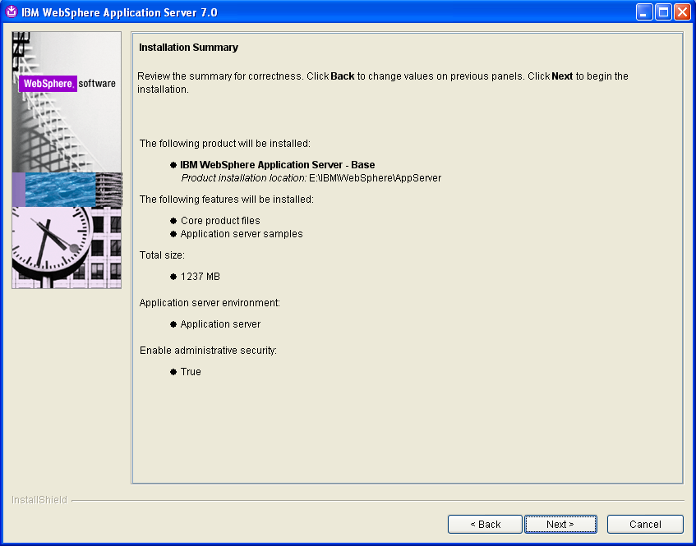

* Wait as the installation progresses

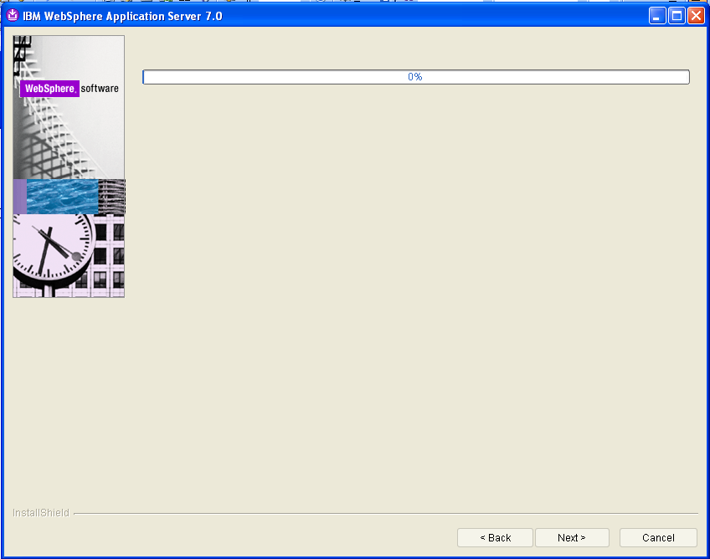

* Verify Installation Status ‘Success’. Observe the ‘Launch the First steps console’ checked by default. It is optional and can be used to verify the installation with the ‘First Steps’ console. Click ‘Finish’.

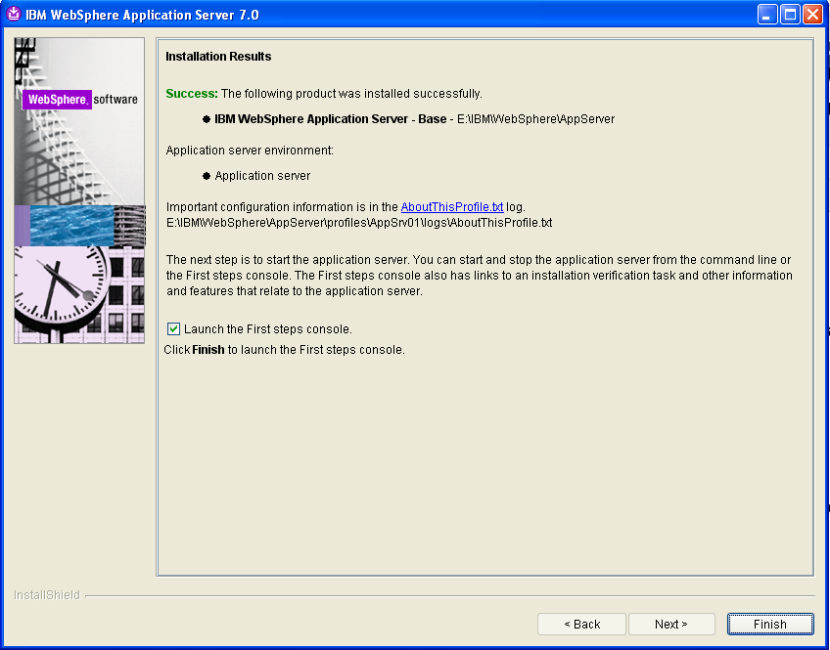

This finishes the base installation of WebSphere Application Server 7.0. This would bring up the ‘First steps console’ if the option above was checked.

#### OPTIONAL: Check the installation success by clicking ‘Installation Verification’.

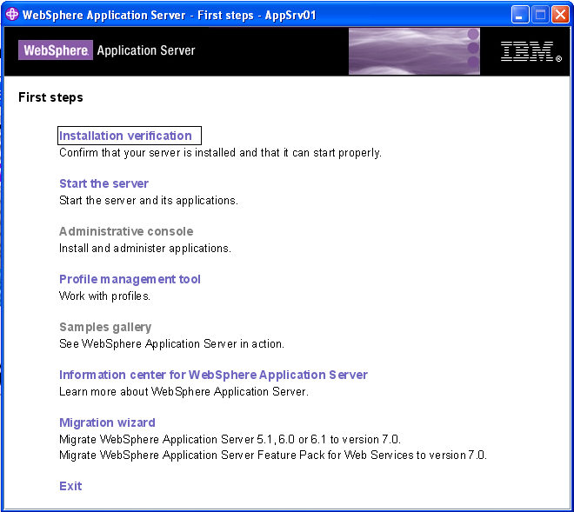

Clicking on the installation verification will start the WebSphere server in your local. You can see the message like ‘Server <server name> open for e-business on port <port number>’.

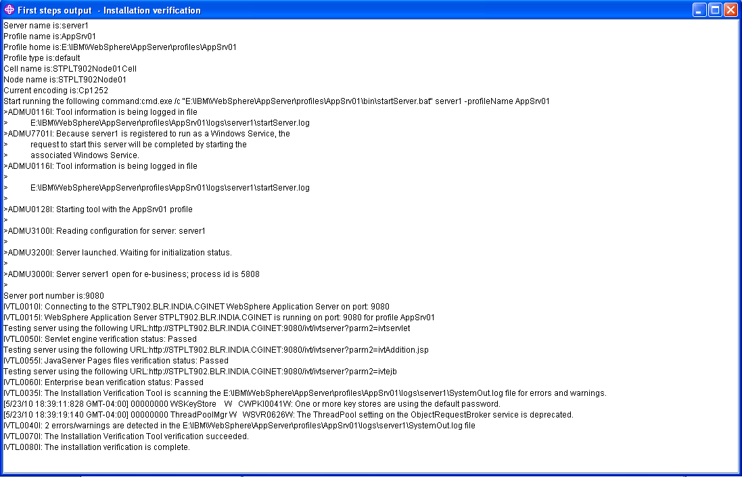

When installation verification is completed, close the window and click ‘Exit’ in the ‘First Steps’ window.

#### OPTIONAL: Disabling the Windows System Service

By default, when WebSphere Application Server is installed, the installer adds a Windows System Service to your system that runs WebSphere on boot automatically. This is typically only necessary on a production server, but on a development machine, starting an entire application server on startup not only slows down your startup but might start the server unnecessarily. This can be disabled as below:

On Windows XP you can simply click on the **Start Menu**, then **Control Panel** and then **Administrative Tools** and **Services** to find the list of system services. On Vista, you can open the **Start Menu** and immediately type "Services" into the filter box to find the link:

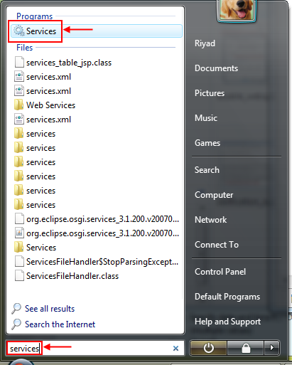

After bringing up the **Services** dialog, you want to scroll down and look for the service named something like: **IBM WebSphere Application Server V7.0 - and** likely the computer node name after that. After selecting the service, you can right-click and select **Properties** or double-click the entry to bring up its service properties.

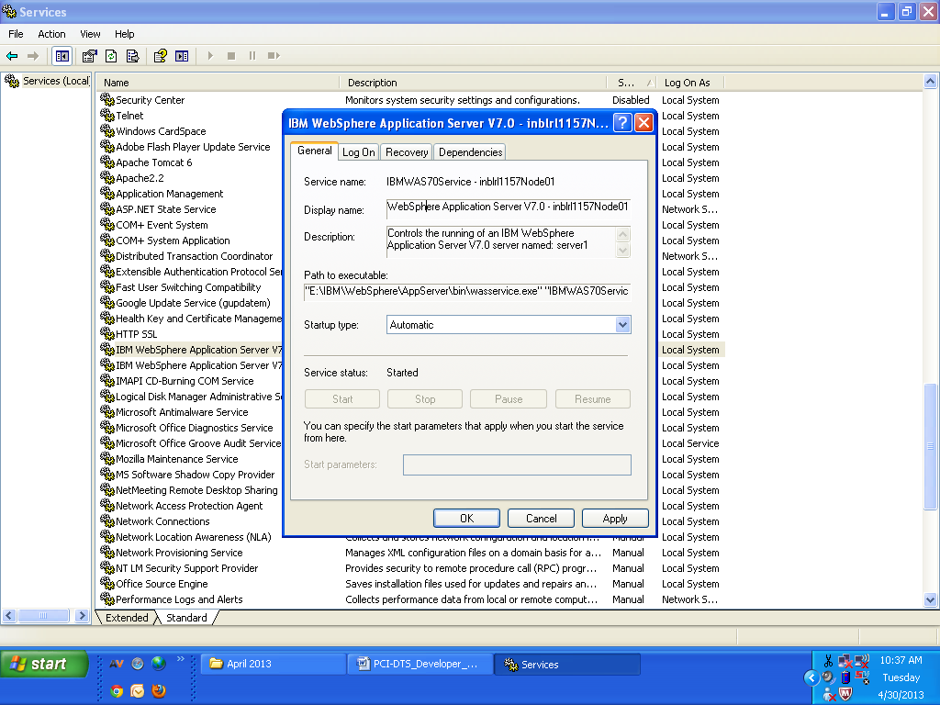

On the service properties dialog, you want to set the **Startup type** to ‘**Manual**’

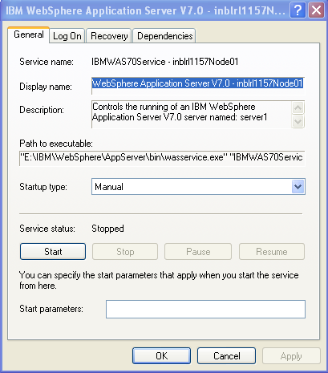



### Create a New Application Server Profile ‘DTSDomain’

#### Launch the ‘Profile Management Tool’

* Use ‘Start > All Programs > IBM WebSphere > Application Server v7.0 > Profile Management Tool’. The following screen shows up. Click ‘Launch Profile Management Tool’

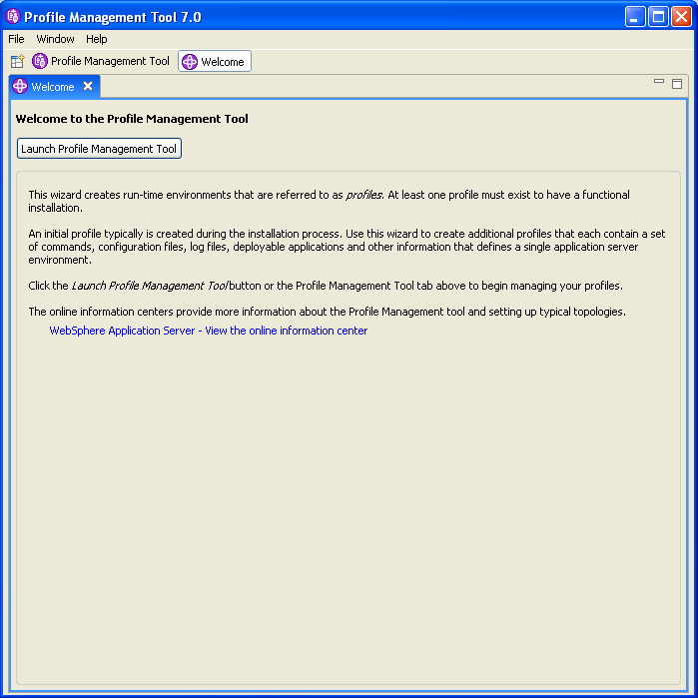

#### Create a new Profile

* Verify the existing profiles. Click ‘Create…’

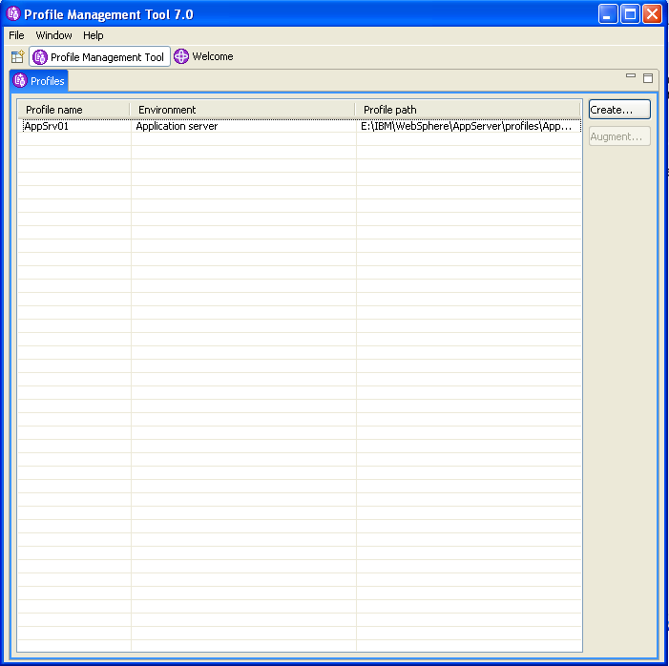

* Verify the default ‘Application Server’. Click ‘Next>’

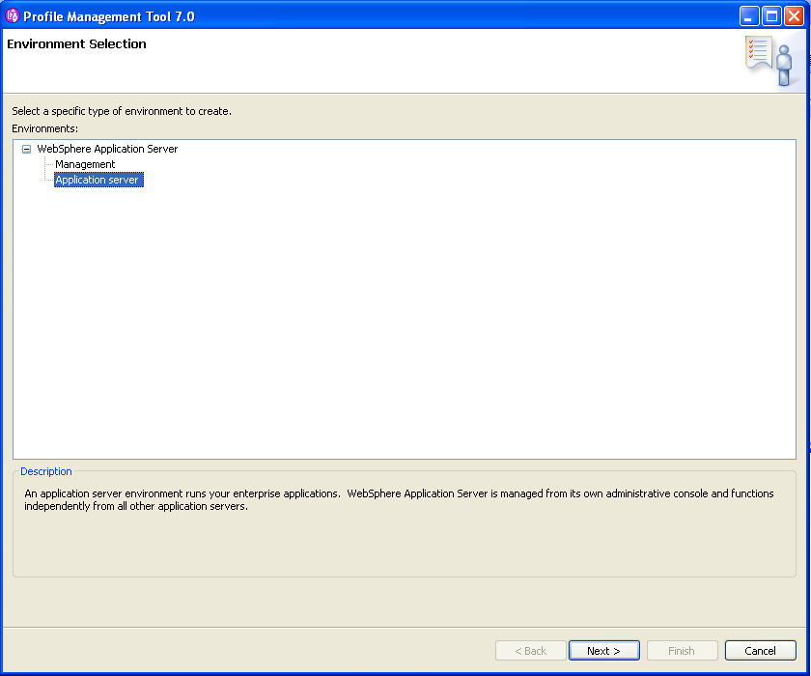

* Select ‘Advanced profile creation’ radio button. Click ‘Next>’

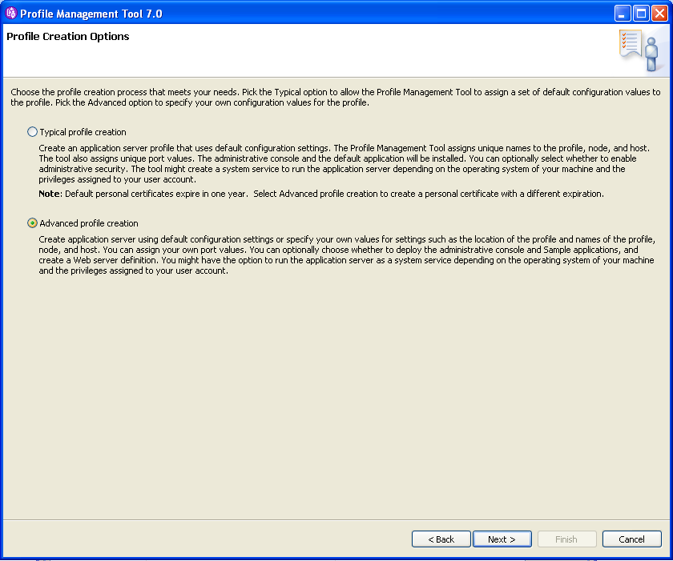

* Verify the options checked by default. Optionally check the ‘Deploy the Sample applications’. Click ‘Next>’

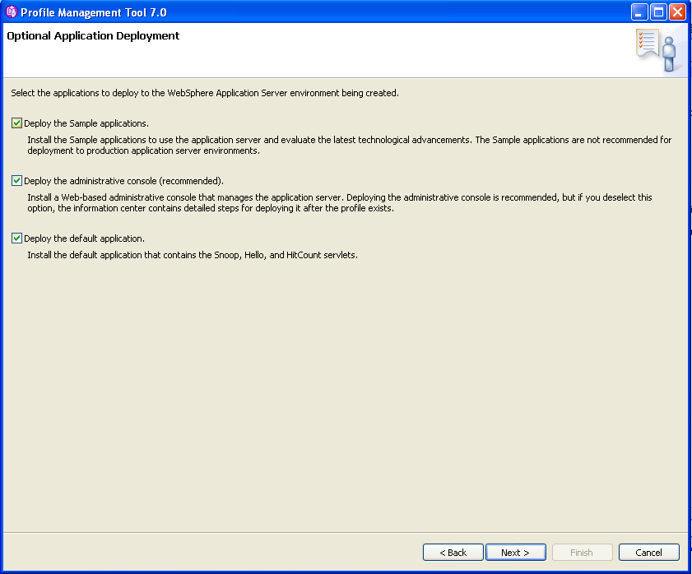

* Enter ‘DTSDomain’ for ‘Profile name:’ and ‘E:\DTSDomain’ for ‘Profile directory’. Check the radio button ‘Make this profile the default.’ Click ‘Next>’

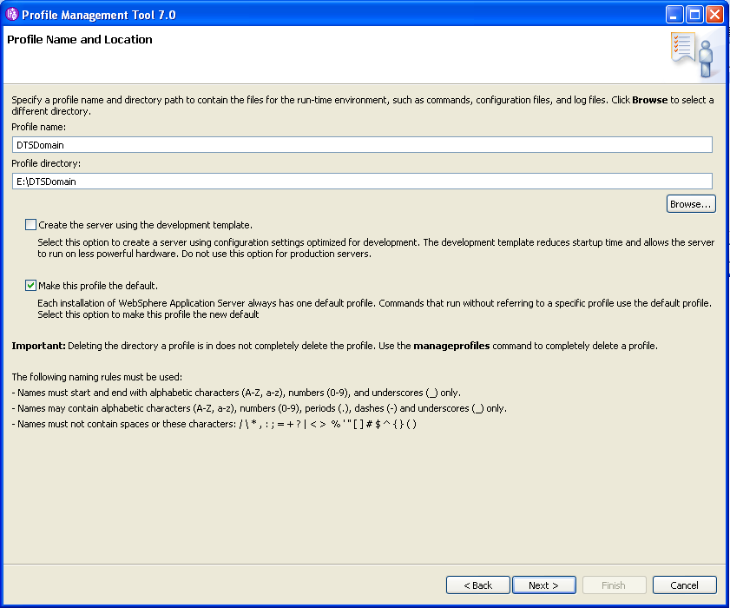

Please note that if your local hard drive configuration doesn’t have an E: drive, please go with your choice of location and remember to replace that location wherever the ‘E:\DTSDomain’ is used as your profile directory further in this document.

* Enter ‘dtsServer’ or ‘DTSServer’ for ‘Server name:’ and accept the remaining defaults. Click ‘Next>’

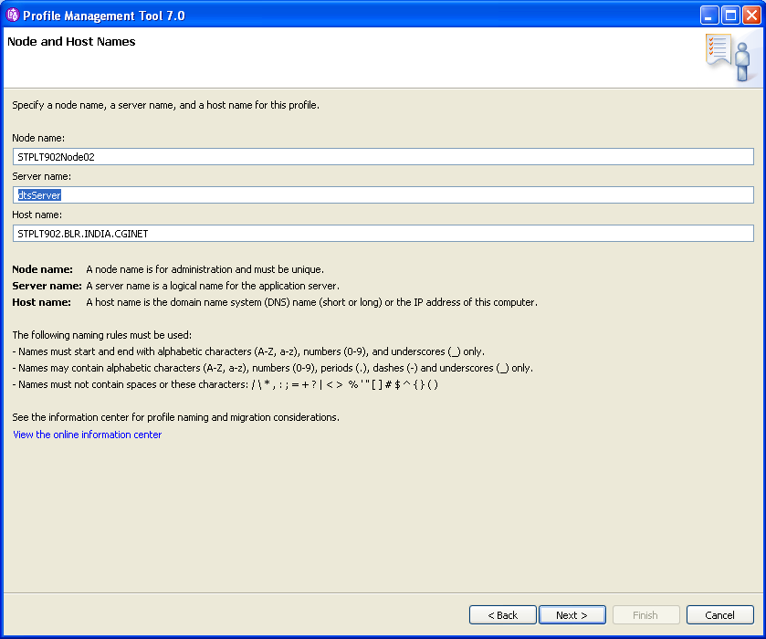

* Ensure ‘Enable administrative security’ is checked. Enter the values for ‘User name:’ wasadmin and ‘Password:’ <your password>. Similarly if the sample applications were chosen in the relevant step before, provided the password for that as well.

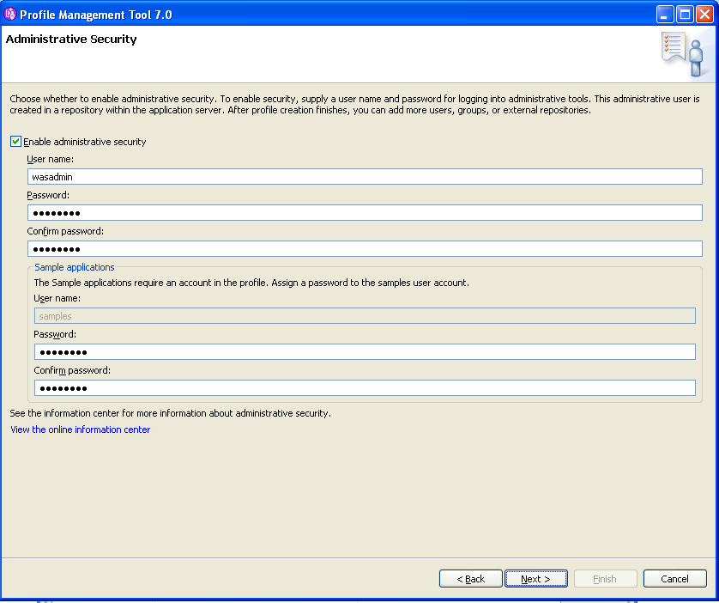

* Verify and accept the defaults as below. Click ‘Next>’

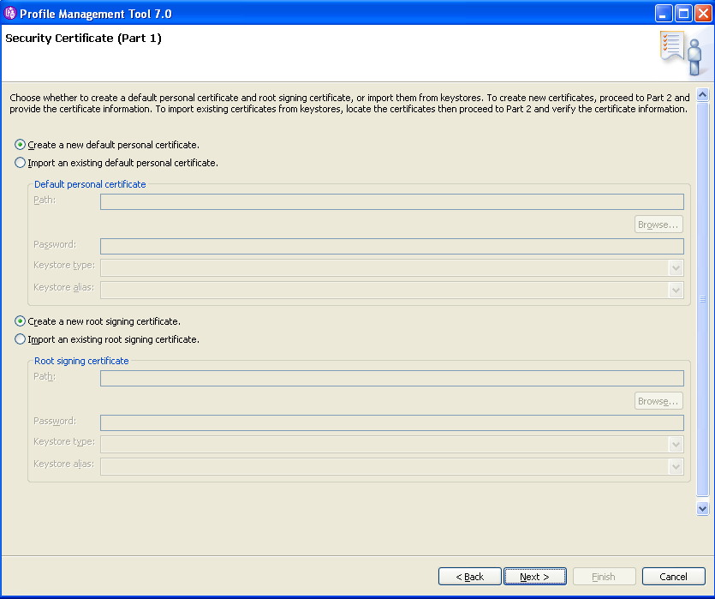

(This step doesn’t affect the WebSphere functionalities, but it would show up when accessing the administrative console about the certificate trust)

* Verify and accept the defaults as below. Click ‘Next>’

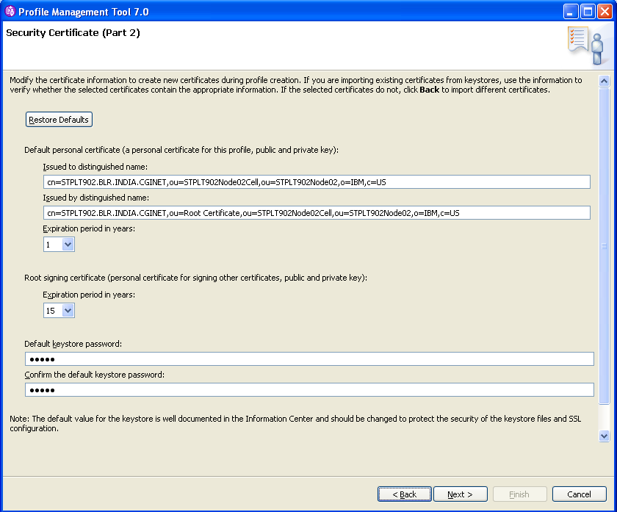

(This step doesn’t affect the WebSphere functionality but it would show up when accessing the administrative console about the certificate trust)

* Verify the default port values. Click ‘Next>’

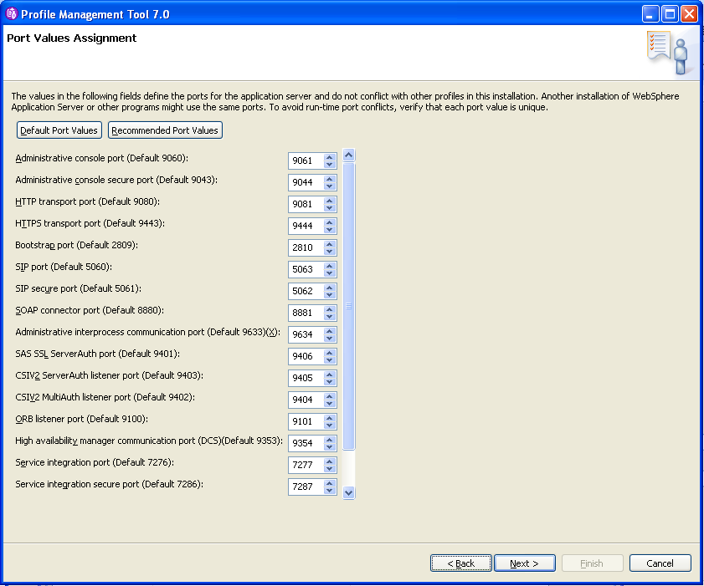

* Verify that the ‘Create a Web server definition’ is unchecked as we don’t need a web server now. Click ‘Next>’

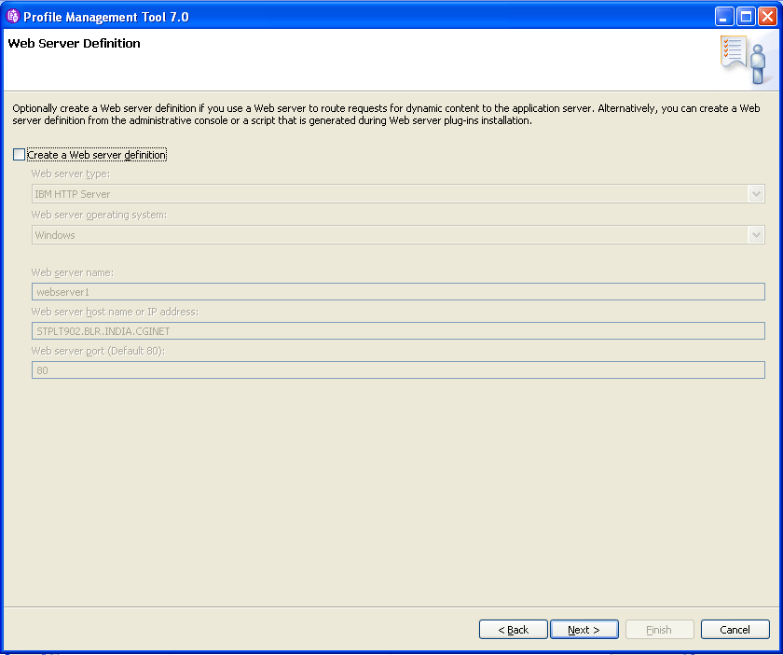

* Verify the details. Click ‘Create’.

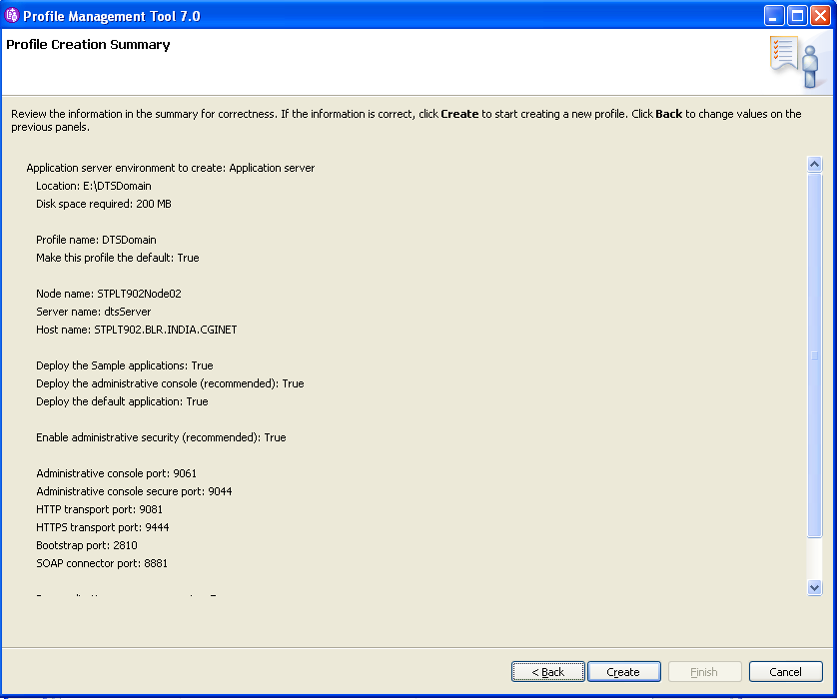

* Wait and see as the ‘Profile Management Tool’ progresses with profile creation.

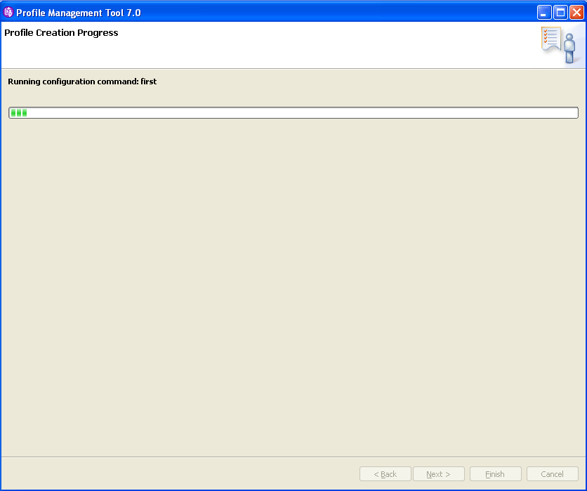

* Verify the creation status is successful. Click ‘Finish’.

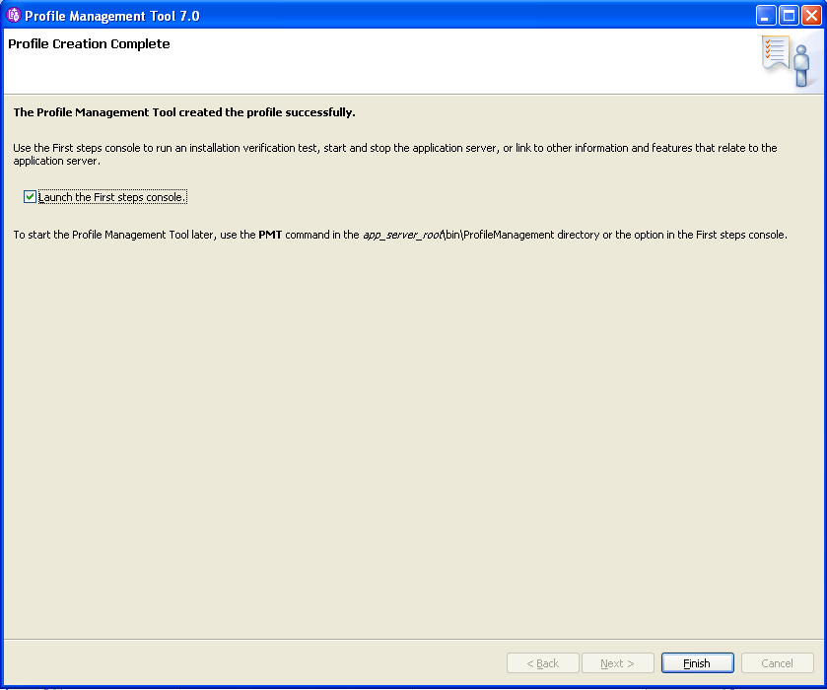

* The created profile gets displayed as shown below.

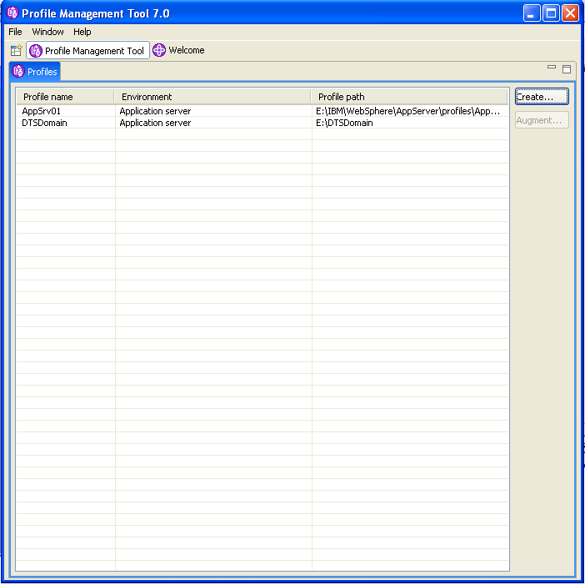

### Configure the Profile ‘DTSDomain’

This configuration of DTS Domain is specific to the DTS. It includes the JDBC, JNDI, JMS, shared library files and application configuration files (config-app files) to be configured.

It is proposed that the configuration files and shared library files would be maintained in a separate place out of the application in a location in the WebSphere profile. The config-app files can be placed in ‘<E:\DTSDomain>/config-app’.

Ideally while building the application locally should create the folder ‘config-app’ in the Profile Home (E:\DTSDomain) folder. If this folder is manually created, the local build should clear the folder contents first and then copy the new files inside.

#### Login to the admin console

* Start the Server by doing Start > All Programs > IBM WebSphere > Application Server V7.0 > Profiles > DTSDomain > Start the Server. (Through the ‘First Steps’ window also, one can start the server visually).

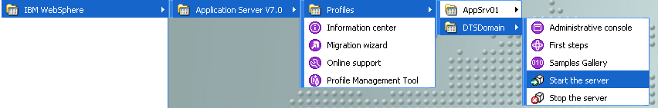

* Launch the WebSphere Administrative Console by doing Start > All Programs > IBM WebSphere > Application Server V7.0 > Profiles > DTSDomain > Administrative Console (Through the ‘First Steps’ window also, one can launch the admin console visually).

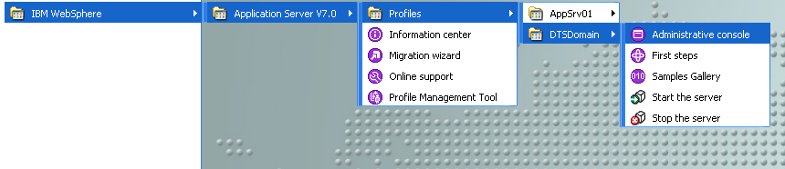

* As mentioned in the profile creation step above, the ‘certificate’ would report a problem. Click on ‘I Understand the Risks’

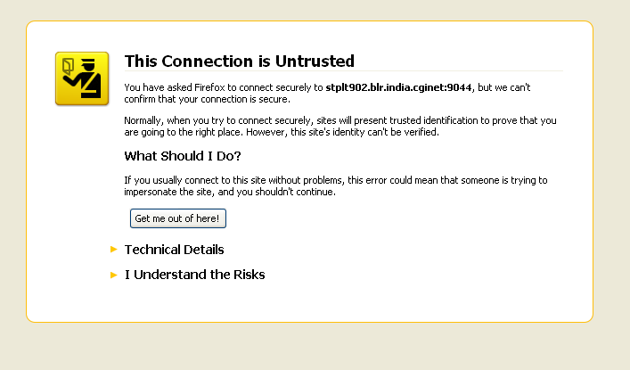

* Click on Add Exception button

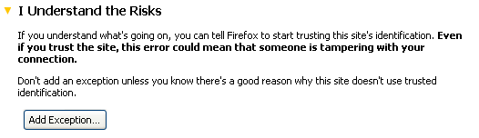

* Confirm the Security Exception.

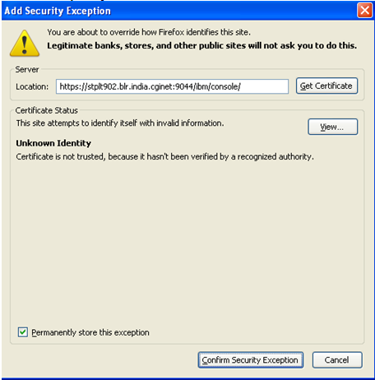

* The admin console login page gets displayed. Provide credentials (wasadmin as user name and your password that you have set earlier) and click on ‘Log In’ button.

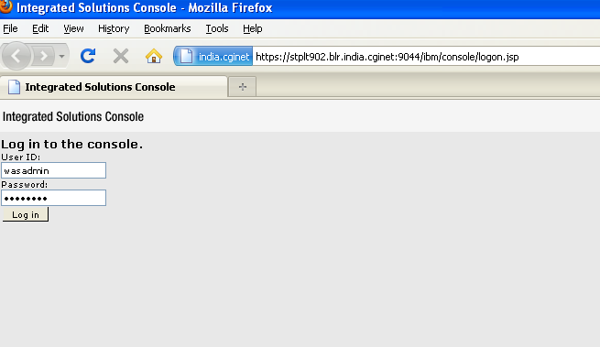

* If authenticated, the admin console gets displayed.

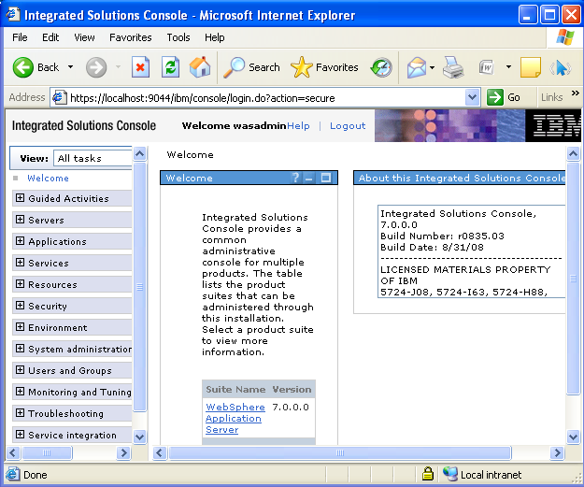

#### Create a shared library for configuration files

* Click on ‘Environment’ > Shared libraries

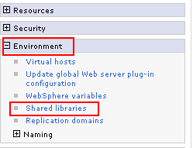

* Ensure that the appropriate Node and Server combination for local system is selected for the combo box under Scope section. Click on the ‘New’ button.

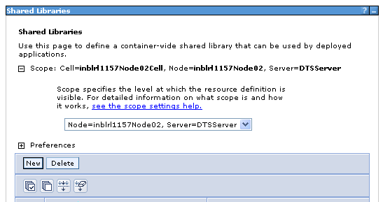

* Enter the following.

Name: DTSConfigurations

Classpath: ${USER_INSTALL_ROOT}/config-app

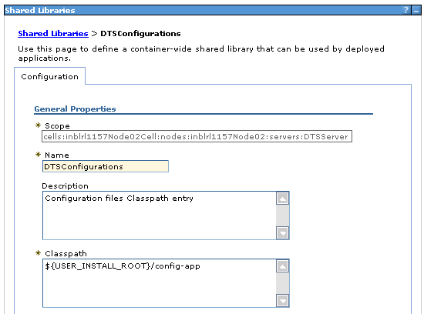

* Check the ‘Use an isolated class loader for this shared library’ checkbox. Click on ‘OK’ button.

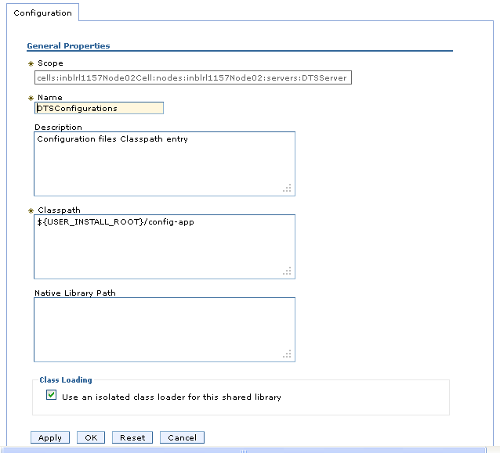

* When the following window appears, click on the link ‘Save’ to save the configuration.

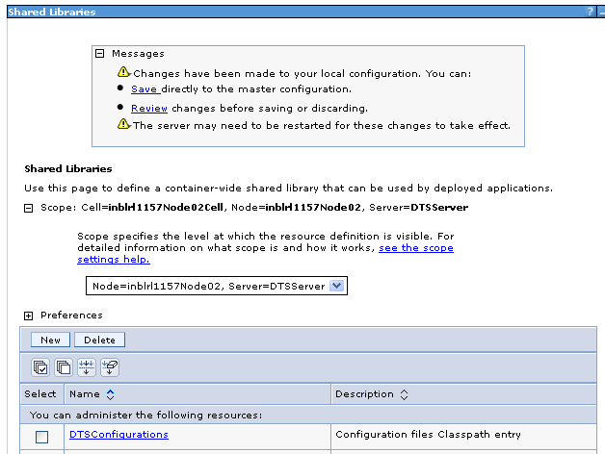

* When finished, the new shared library gets displayed as shown below.

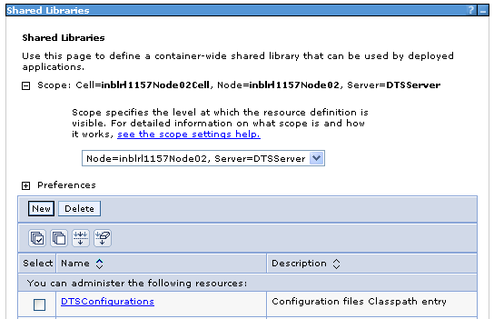

#### Setting a class loader for ‘DTSConfigurations’ shared library

* In ‘Servers >Server Types > Click ‘WebSphere application servers’.

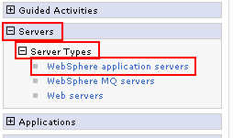

* The presently configured servers get listed in the window.

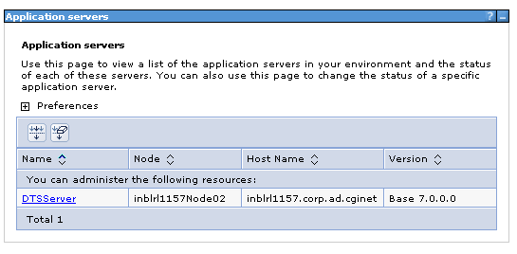

* Click on the link ‘dtsServer’ or ‘DTSServer’. In the new window that appears, click on the ‘Java and Process Management > Class loader’ as shown below.

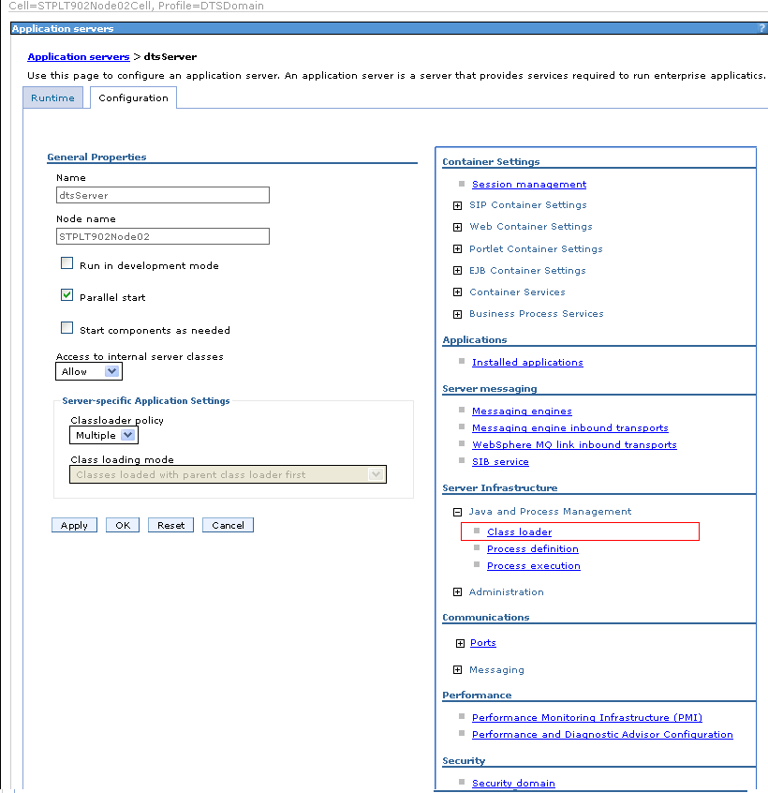

* The following window gets displayed. Click on New.

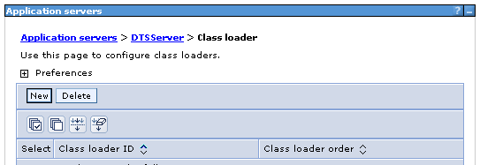

* In the ‘Class loader order’ combo box, select option with ‘(parent last)’ as shown below. Click ‘OK’.

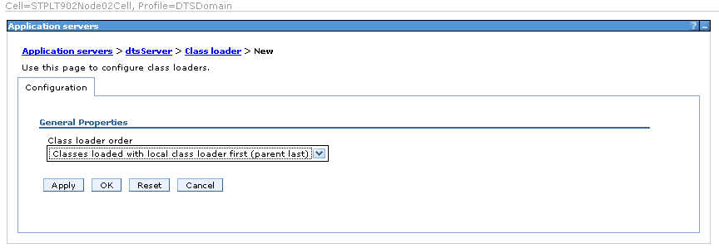

* Save the changes. The new class loader created gets displayed as shown below.

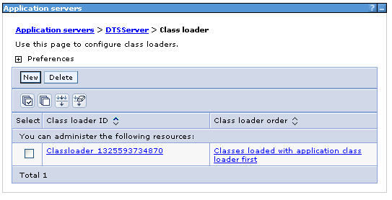

* Click on the newly created ‘Class loader’. Then click on the ‘Shared library references’ link on the right side pane.

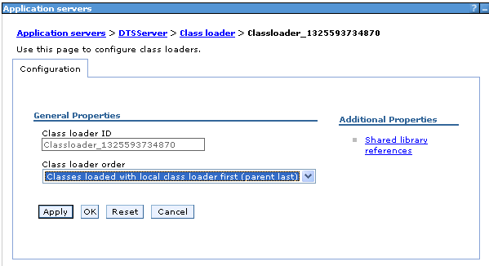

* Following window gets displayed. Click on the ‘Add’ button.

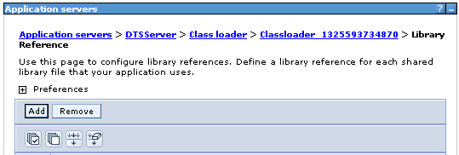

* Select the shared library ‘DTSConfigurations’ and Click ‘OK’.

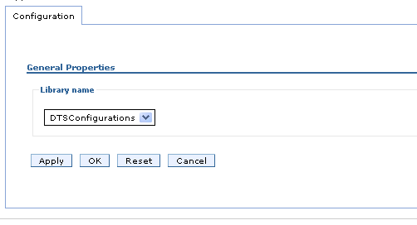

This completes the configuration for ‘DTS configurations’ shared library (known as config-app files).

#### Creating a Shared Library for ‘DTSSharedLib’

This is the shared library for all the class file dependencies for DTS Application (jar file path for all third party libraries)

* For setting up a new Shared Library for application dependencies or third party libraries/jar files, navigate to Environment > Shared libraries.



* Ensure that the appropriate Node and Server combination for local system is selected for the combo box under Scope section. Click on the ‘New’ button.



* Enter the following. Also check the 'Use an isolated class loader for this shared library’ check box.

Name: DTSSharedLib

Classpath: E:\IBM\WebSphere\sharedLib

(The server installation path may differ in your local system. Use your local path settings)

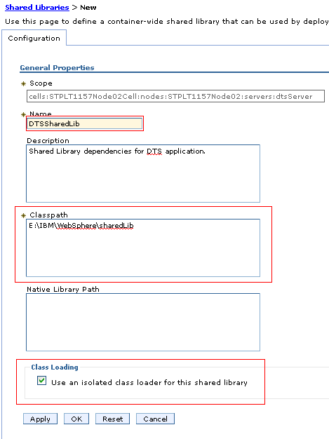

* Click ‘OK’ and save the changes.

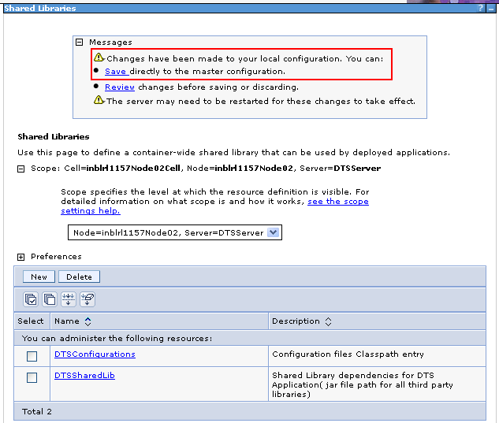

#### Setting a class loader for ‘DTSSharedLib’ shared library

* In ‘Servers >Server Types > Click ‘WebSphere application servers’.



* The presently configured servers get listed in the window.



* Click on the link ‘dtsServer’ or ‘DTSServer’. In the new window that appears, click on the ‘Java and Process Management > Class loader’ as shown below.



* The available class loaders list gets displayed.



* Click on the ‘Class loader’. Then click on the ‘Shared library references’ link on the right side pane.



* Following window gets displayed. Click on the ‘Add’ button.

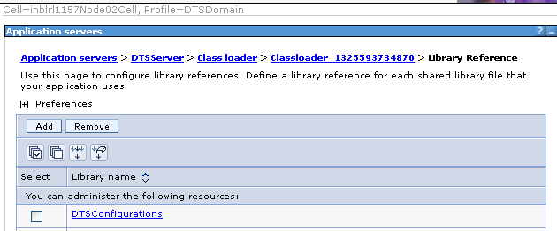

* Select the library name as “DTSSharedLib” created earlier and click “OK”

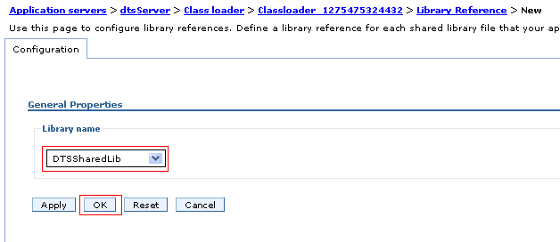

* Remember to save the changes

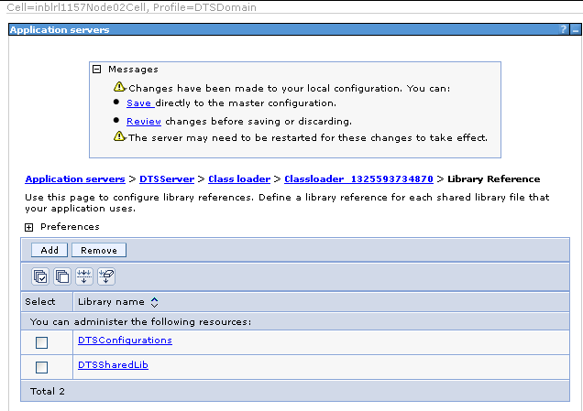

### Create a New Data Source

#### Creating an Authentication Alias for data source

* Click on the Security link and then click on the Global Security link on the left panel.

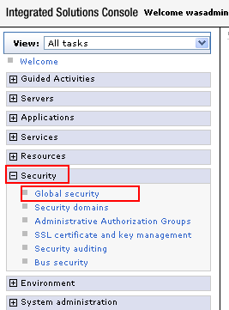

* Click on the ‘Java Authentication and Authorization Service’ link in the right panel and then click on the ‘J2C authentication data’ link.

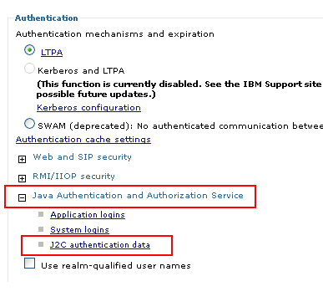

* Click on the ‘New’ button.

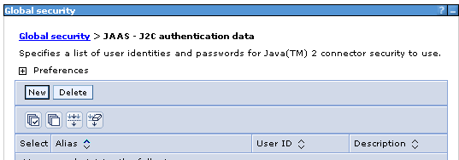

* Fill in the following details.

Alias: dtsdev_admin_alias

User ID: dtsdev_admin

Password: dtsdev4cgi

Description: DTS DB ADMIN ALIAS

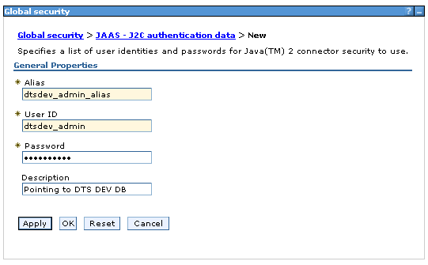

Note: Current password for DTS DEV DB is given. But this password changes periodically. Coordinate with DTS DB Team / DTS DEV Team to get the latest password.

* Click ‘OK’ and then click on the link ‘Save’. The newly created authentication alias gets displayed as shown below.

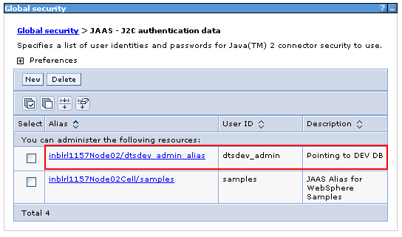

#### Creating a JDBC Provider for data source

* Create a folder named ‘oracleDriver’ in the domain ‘E:\DTSDomain’
* Copy the following file to the ‘oracleDriver’ folder. This jar file is also available in the dts latest branch code checkout folder (dts_release5\lib\j2ee\ojdbc6.jar).



* In ‘Resources > JDBC’ click on the ‘JDBC Providers’ link.

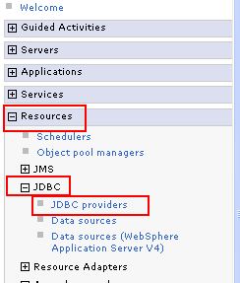

* Ensure that the appropriate Node and Server combination for local system is selected for the combo box under Scope section. Click on the ‘New’ button.

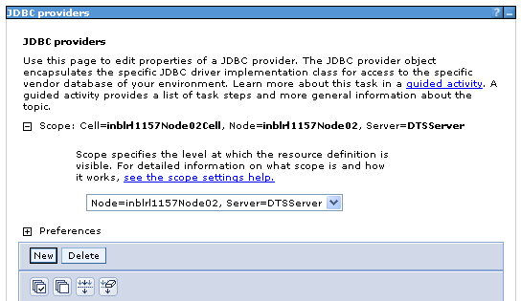

* Fill in the following details and click on the ‘Next’ button.

Database type: Oracle

Provider type: Oracle JDBC Driver

Implementation type: Connection pool data source

Name: Oracle JDBC Driver

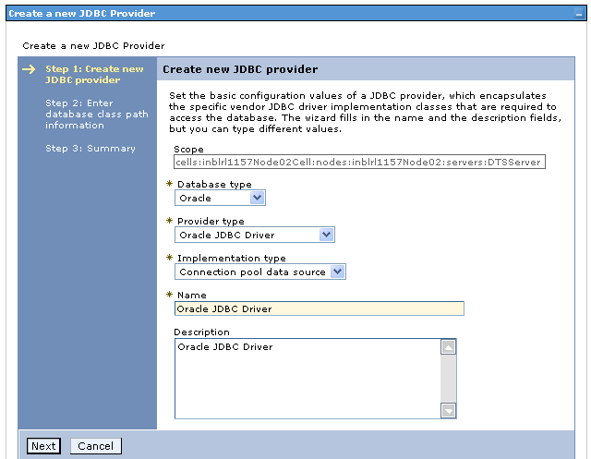

* In the new window appears, provide the value ‘${USER_INSTAL_ROOT}/oracleDriver’ in the text box as shown below. This path value will be saved as ‘${ORACLE_JDBC_DRIVER_PATH}‘ in WebSphere. Click on the ‘Next’ button.

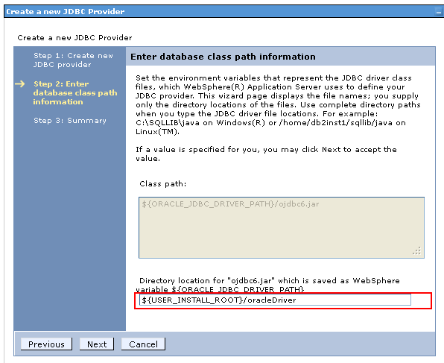

* Review the details and click on the ‘Finish’ button.

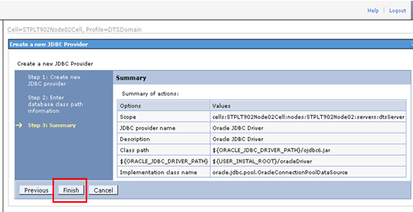

* Remember to save the changes.

#### Creating the new data source

* In Resources > JDBC, click on the ‘Data sources’ link.

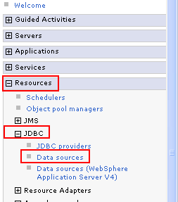

* Ensure that the appropriate Node and Server combination for local system is selected for the combo box under Scope section. Click on the ‘New’ button.

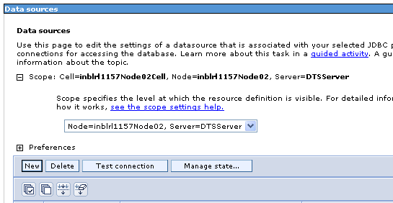

* Fill in the following values and click on the ‘Next’ button.

Data source name: DTS Data Source

JNDI name: jdbc/DTSDatasource

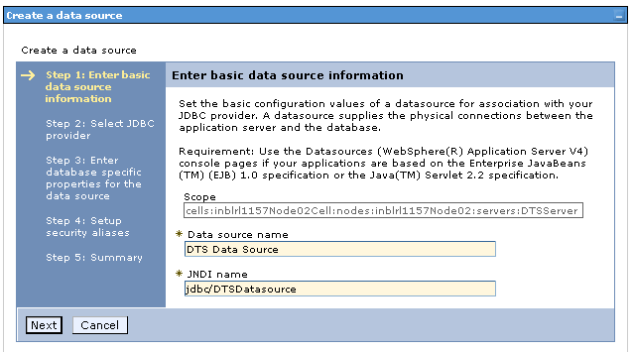

* Check ‘Select an existing JDBC provider’ and select ‘Oracle JDBC Driver’ from the drop down and click on the ‘Next’ button.

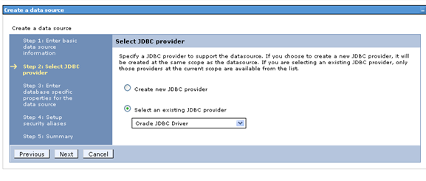

* Fill in the URL textbox with the URL value of the target DTS oracle DB. By default, use DEV DB URL which is **jdbc:oracle:thin:@142.117.202.19:1521:DVPCI01**. Then select the option ‘Oracle 11g data store helper’ for the Data store helper class name combo box. Also check the checkbox named ‘Use this data source in container managed persistence (CMP)’. Then click on the ‘Next’ button.

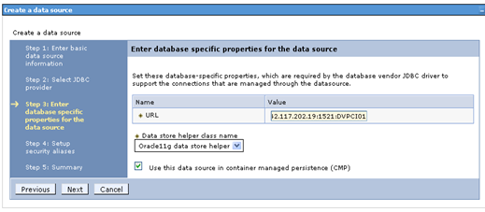

Note: The URLs for the different DTS test environments are given below.

|  |  |
| --- | --- |
| DTS DEV | jdbc:oracle:thin:@142.117.202.19:1521:DVPCI01 |
| DTS SIT | jdbc:oracle:thin:@142.117.202.19:1523:STPCI01 |
| DTS UAT | jdbc:oracle:thin:@142.117.202.19:1522:UTPCI01 |

* Select the ‘Component-managed authentication alias’ combo box value as ‘<node name>/dtsdev_admin_alias’ created earlier for the ‘J2C authentication data’. Click on the ‘Next’ button.

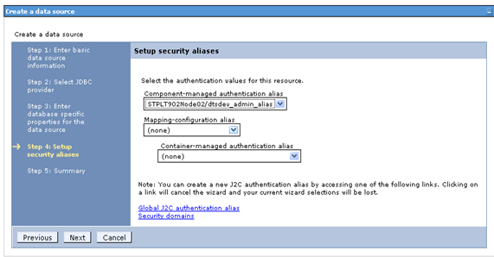

* Verify the details and click on the ‘Finish’ button.

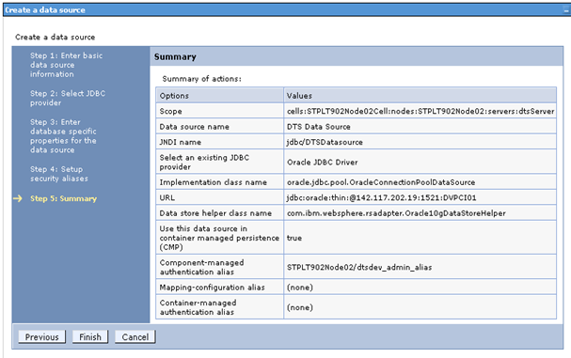

* Remember to save the changes.

### JMS Setup for DTS Batch and Online MDBs: (Optional)

#### Why this setting is optional?

* DTS JMS setup that needs to be done in WebSphere Server can be avoided if you don’t need to use any one of the MDBs available in DTS. This facilitates quick code deployment in WebSphere.
* An example is to test a batch code change that is neither related to any of the MDB flow nor requires any of the MDB services to test the modified code.

#### Is there any risk for not setting DTS JMS in WebSphere Server?

* Yes. By default, the DTS build comes with the DTS MDBs. If the server is not ready with the DTS JMS settings, the deployment of DTS ear file cannot be completed.
* If you bypass setting-up the JMS in WebSphere, you must switch off the MDBs in the DTS ear file in order to complete the deployment successfully.

#### How to switch on/off the MDBs from the DTS build artifacts?

* It is possible to switch on/off the MDBs in the DTS by setting a DTS environment property (ship.module.batchJMS) to true/false. If set to false, it prevents the MDBs to go inside the ear file while performing a DTS build.

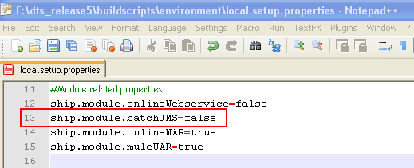

Note that if you switch this flag off, all the DTS JMS MDBs (batch and online) will be turned off in the ear file.

#### Is there any way for selectively send MDBs with DTS builds?

* Yes. It is possible to send MDBs selectively with the DTS ear file.
* First enable the DTS environment property **ship.module.batchJMS**. Set its value to true. This results in enabling all the DTS JMS MDBs, both batch and online.
* Then adjust another DTS environment property **dts.ejb.mdb** to appropriate values before performing a build.
* The value **dts.ejb.mdb=all** results in setting all the MDBs (batch and online) in the DTS ear file, while performing a DTS build.

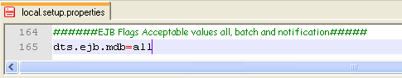

* The value **dts.ejb.mdb=batch** results in setting only the batch MDBs in the DTS ear file, while performing a DTS build.

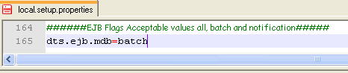

* The value **dts.ejb.mdb=notification** results in setting only the online MDB in the DTS ear file, while performing a DTS build.

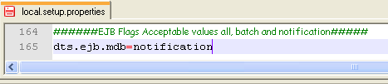

Remember, if you selectively send MDBs with DTS builds, you should set up the corresponding MDB settings in the WebSphere Server also. Else the deployment of ear will fail in WebSphere.

#### Is there exists a documentation for JMS setup in WebSphere?

* Yes. Here it is, embedded.



### Integration of JCE Unlimited Strength files for WAS JRE

History behind JCE Unlimited Strength Files can be read here.

#### Why DTS WAS need JCE Unlimited Strength files?

The WAS internal JDK comes with 128-bit encryption strength by default. DTS design uses 256-bit encryption. So it is necessary to have the JCE Unlimited Strength files for WAS copied to the corresponding folder of WAS installation, for DTS to run successfully.

#### How to integrate JCE Unlimited Strength files in WAS JDK?

Go to the <DTS Checkout folder>\docs folder and extract the content of jce_policy_WAS.zip file. This zip file is also embedded below.



Copy and paste it somewhere, then extract the zip file and when extracted, copy the **US_export_policy.jar** and **local_policy.jar** files to WAS JDK installation directory’s JRE’s **security** folder.

If WebSphere got installed to E:\IBM\WebSphere then copy and paste the jar files to E:\IBM\WebSphere\AppServer\java\jre\lib\security folder by replacing the existing files.

# Eclipse IDE Setup for Code Development

Download Eclipse Galileo 3.5 (Eclipse IDE for Java Developers). It can be downloaded from the following location.

<http://www.eclipse.org/downloads/packages/eclipse-ide-java-developers/galileosr2>

Unzip the eclipse-java-galileo-SR2-win32.zip file. Locate the eclipse.exe under the eclipse folder. Double click that to launch Eclipse in ideally a new workspace (like ‘E:\DTSWorkspace’ or ‘<Eclipse_folder>\DTSWorkspace’)

## IDE Configuration Setup

### Import Order Set-up

* From Eclipse IDE, go to ‘Window > Preferences.

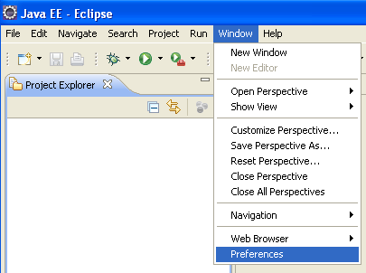

* Go to ‘Java > Code Style > Organize Imports’.

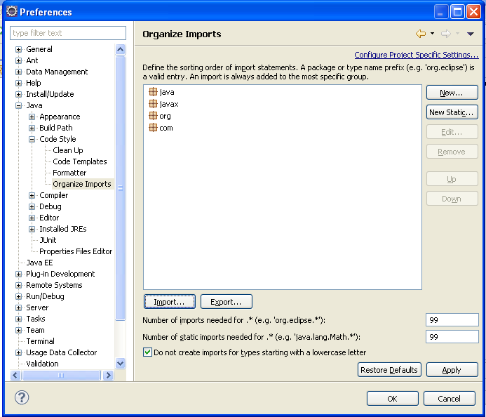

* Select all the existing values. Click ‘Remove’
* Click ‘Import…’
* Browse to the **dts.importorder** file which is available in the DTS checkout directory, E:\dts_release2\docs\ide. Click ‘Open’.

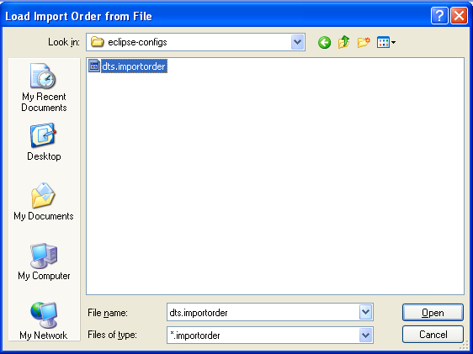

* Click Ok. The following order will get displayed.

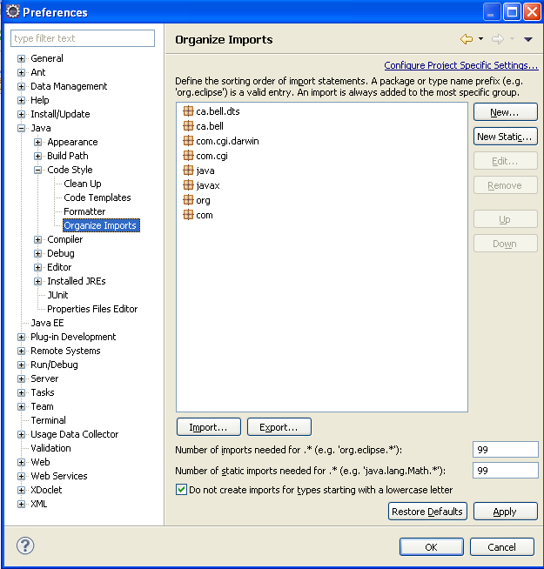

### Code Formatter Set-up

* From Eclipse IDE, go to ‘Window > Preferences



* Go to ‘Java > Code Style > Formatter’. Click ‘Import…’

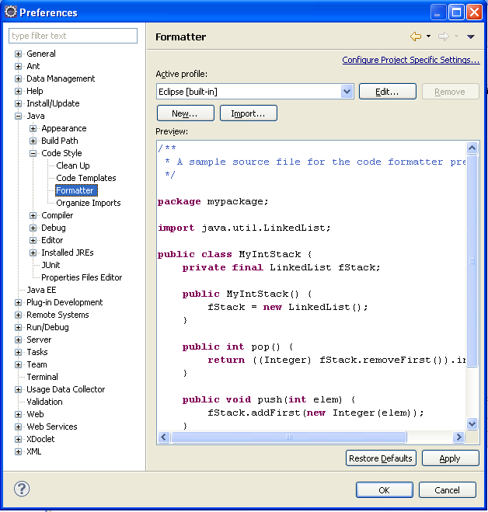

* Browse to the **Java_dts.xml** file which is available in the DTS checkout directory, E:\dts_release2\docs\ide. Click ‘Open’.

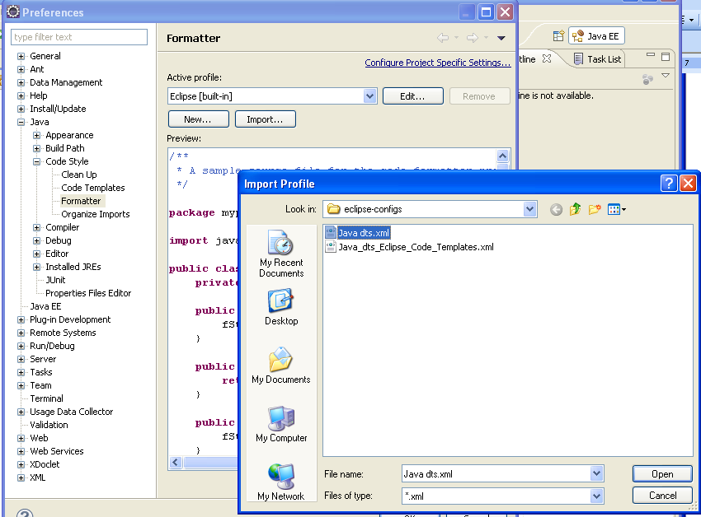

* Select / Verify the Active profile as ‘Jave bellca’. Click ‘Apply’ and ‘OK’

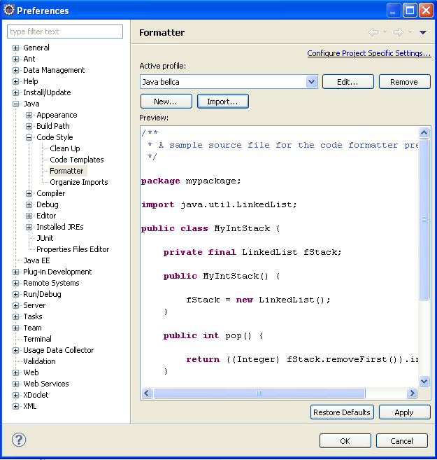

* Code formatter set-up completed.

### Code Templates Set-up

* From Eclipse IDE, go to ‘Window > Preferences.



* Go to ‘Java > Code Style > Code Templates’. Click ‘Import…’

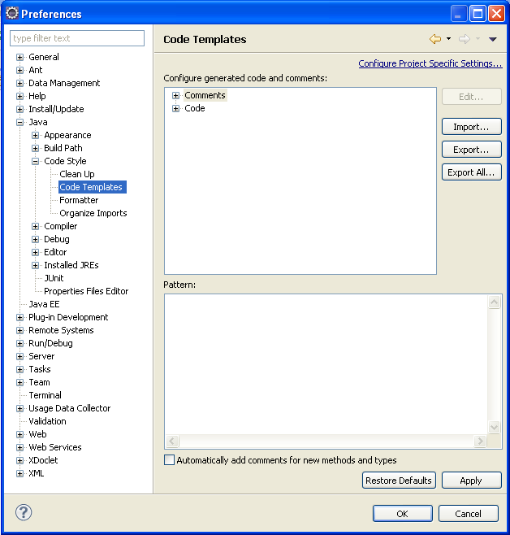

* Browse to the **Java_dts_Eclipse_Code_Templates.xml** file which is available in the DTS checkout directory, E:\dts_release2\docs\ide and click ‘Open’.

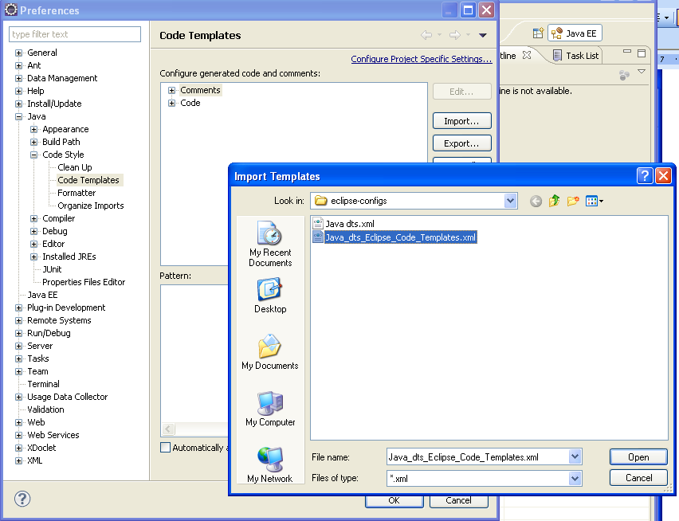

* Click ‘Apply’ and ‘OK’.

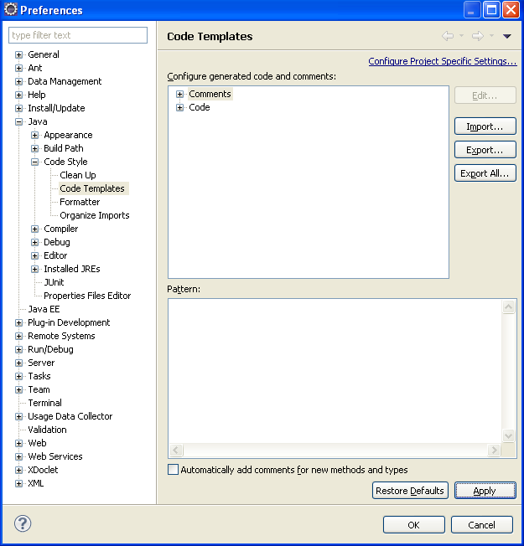

* Code templates set-up completed.

## Java Runtime Setup for Eclipse IDE

The IBM WebSphere and Sun JDK 1.6 update 21 or later need to be installed in your system before you execute this step. IBM WAS JRE is needed for DTS project execution in Eclipse and SUN JRE is needed for DTS RP Project execution in Eclipse.

### Adding WAS Java Runtime for Eclipse

* From Eclipse IDE, go to Window > Preferences



* Go to Java and then Installed JREs. Click on ‘Add’ button.

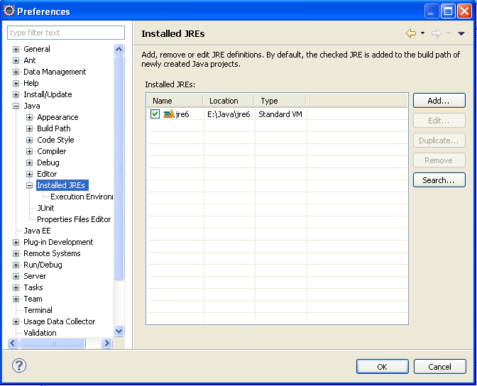

* Select ‘Standard VM’ and click on ‘Next’ button.

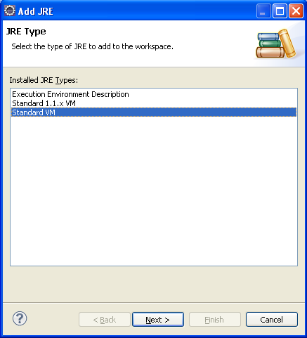

* Enter ‘E:\IBM\WebSphere\AppServer\java\jre’ (WAS installation JRE folder) for ‘JRE home’ and ‘WAS java’ or ‘WAS jre’ for the ‘JRE name:’ Click Finish:

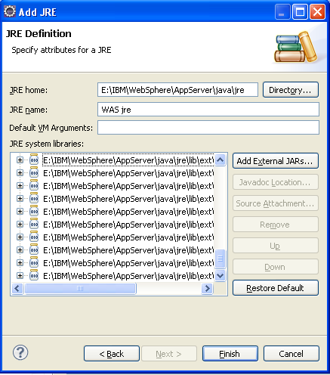

* Select ‘WAS Java’ as the default JRE. Click ‘OK’.

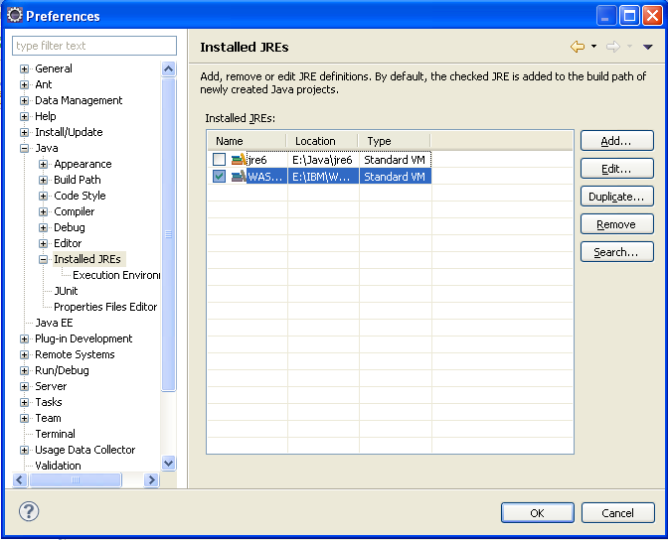

### Adding Sun Java Runtime to Eclipse

If sun JRE (of JDK 1.6 update 21 or later) is not present in the list of installed JREs of eclipse IDE, create a new JRE entry which points to Sun Java JDK installation version 1.6 update 21 or later. Name it as ‘Sun Java’ as shown below:

* From Eclipse IDE, go to Window > Preferences



* Go to Java and then Installed JREs. Click on ‘Add’ button.



* Select ‘Standard VM’ and click on ‘Next’ button.



* Browse to the ‘C:\Program Files\Java\jdk1.6.0_21\jre’ (sun java installation JRE path ) for ‘JRE home’ and ‘Sun jdk1.6.0_21’ or ‘Sun jre’ for the ‘JRE name:’ Click Finish:

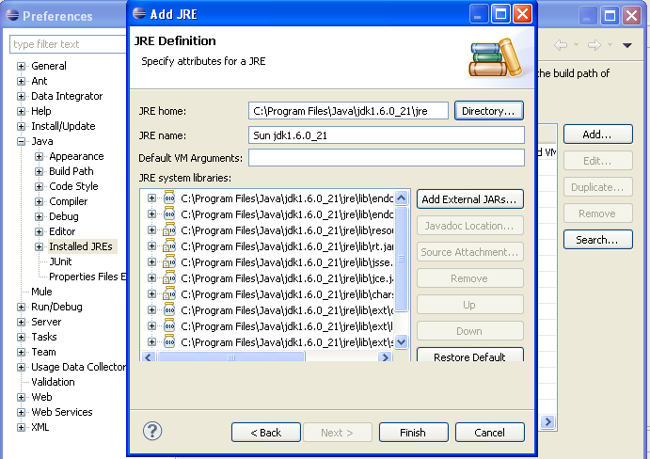

* Select ‘WAS Java’ as the default JRE. Click ‘OK’.

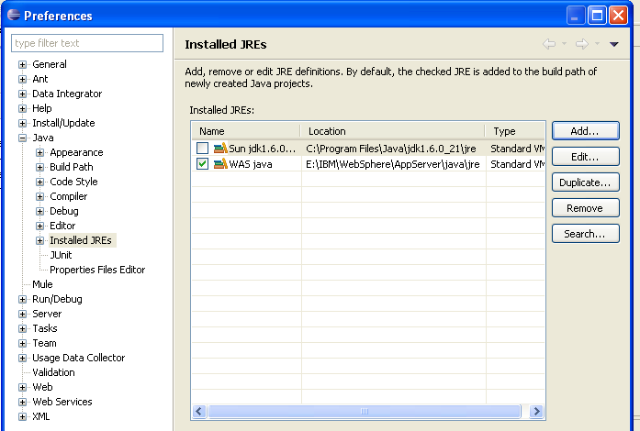

* Java Runtime Setup for Eclipse IDE is completed.

## Importing DTS Projects into Eclipse IDE

The ‘DTS code base’ has existing DTS projects inside it. Those projects can be straightly imported to eclipse in order to start development.

### Import DTS Project into Eclipse

* In Eclipse IDE, Click on File => Import. Then expand the ‘General’ section => select ‘Existing Project into Workspace’ section and click on the ‘Next’ button.

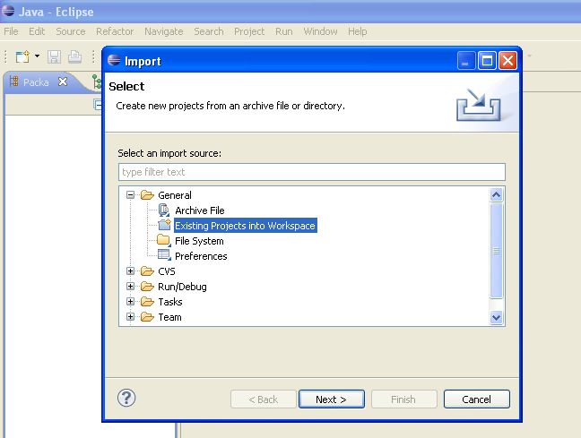

* In the next section, select the radio button named ‘Select root directory’ and click on the ‘Browse’ button to browse to the latest DTS branch’s checkout folder (E:\dts_release5) as shown below in order to open the projects in the DTS Code checkout. Once you select the root directory, all the projects inside this folder get displayed on the Projects section.

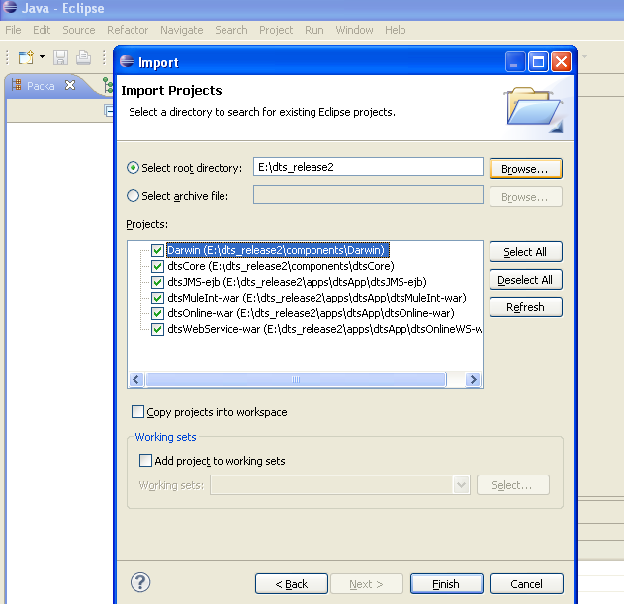

* Select the projects you want to open and click **Finish** (You may select all but dtsWebService-war)**.**
* This will open the selected DTS projects in your eclipse IDE.

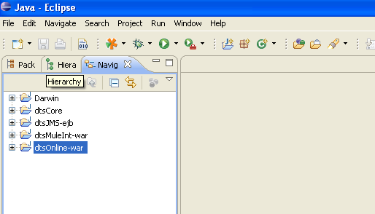

### Import DTS RP Project into Eclipse

* In Eclipse IDE, Click on File => Import. Then expand the ‘General’ section => select ‘Existing Project into Workspace’ section and click on the ‘Next’ button.

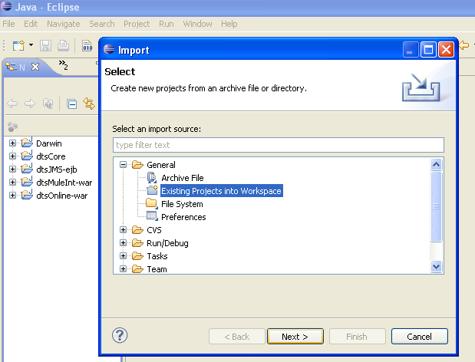

* In the next section, select the radio button named ‘Select root directory’ and click on the ‘Browse’ button to browse to the latest DTS branch’s checkout folder (E:\dts_release5) as shown below in order to open the projects in the DTS Code checkout. Once you select the root directory, all the projects inside this folder get displayed on the Projects section.

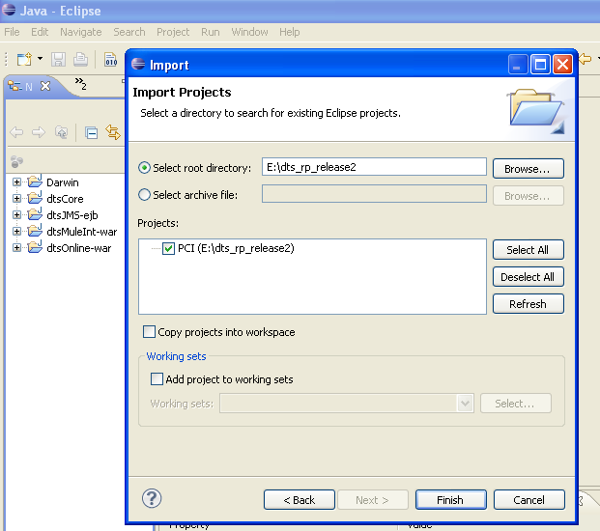

* As there is only one project there, select that and click **Finish**.

* This will open that selected project in your eclipse. Here both the DTS and the DTS RP projects are opened in the same Eclipse instance. This is possible as the names of all the projects are different.

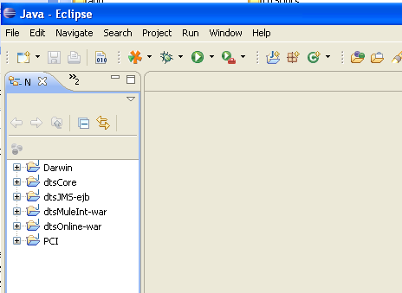

Note: You can open the DTS and the DTS RP projects in the same eclipse workspace or in different eclipse workspaces. If you are using two workspaces, you need to configure both the eclipse workspaces as mentioned in the document. And import DTS projects into first eclipse workspace and import DTS RP projects into the second eclipse workspace. In that case, you can also add only the IBM JRE to the first eclipse workspace and only the Sun JRE to the second eclipse workspace.

# Building, Token Replacing and Deploying of DTS Projects

## Building and Token replacing DTS Projects in Local Server

For building the projects, the Apache ANT installation step, mentioned earlier in this section has to be completed.

### Build DTS Projects in Local Server

* Open the file <latest DTS checkout folder>\buildscripts\build-local.cmd in a text editor. As of now the dts_release5 is the latest DTS branch.

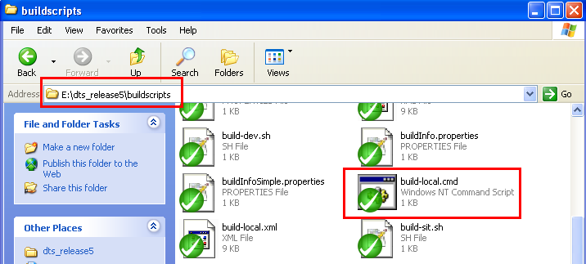

* Set the JAVA_HOME variable to the IBM WAS Java directory. Also set ANT_HOME to your ANT installation directory as shown above. Save and close the file.

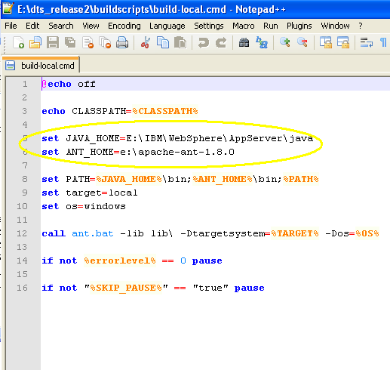

* Before building the application, make sure that you have **build.local.number** file in your <DTS Checkout folder>\buildscripts folder. If not copy it from <DTS Checkout folder>\docs folder and paste it in the buildscripts folder.

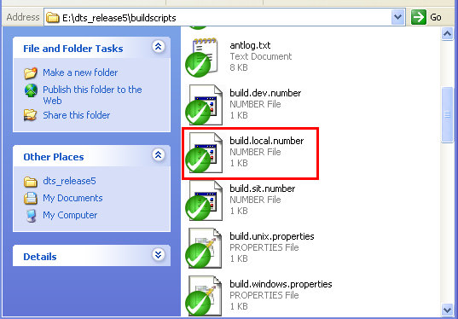

* Open the **local.setup.properties** file from <DTS Checkout folder>\buildscripts\environment folder and verify the path for all the tokens which has file path as values. Set those values to local folder paths (Example token: **server.deployment.dir**).

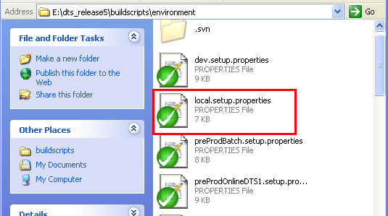

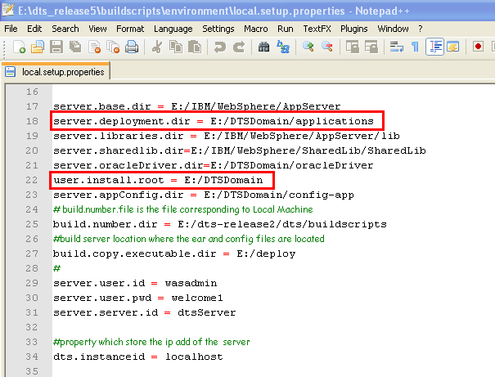

* After saving the **local.setup.properties** file, double click the **build-local.cmd** to build all the DTS projects.

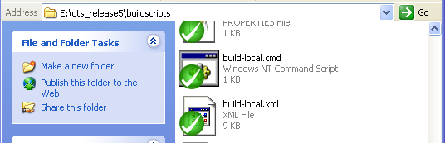

* This will trigger the build process for DTS projects in the local code base. The status of the build gets displayed in the command prompt window. See the ‘BUILD SUCCESSFUL’ message.

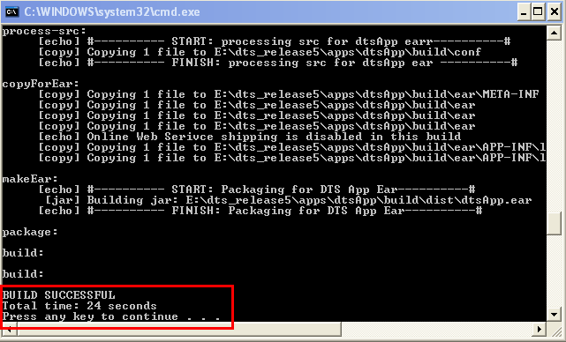

### Token Replace DTS Projects in Local Server

Deploying the third party shared library jar files and the oracle driver jar file are one time activity until there is a change in the version of oracle library jar file used by DTS or until an addition/change in the third party shared library jar files used by DTS. In this case, we can say that the main output of the DTS build is the DTS config-app files and the DTS ear file.

* Open the file <DTS Checkout folder>\buildscripts\**ReplaceTokens-CopyBuildFiles-local.cmd** in a text editor.

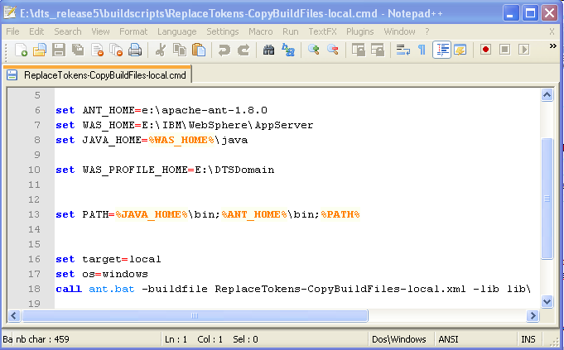

* Set the JAVA_HOME variable to the IBM WAS Java directory. Also set ANT_HOME to your ANT installation directory as shown above. Save and close the file.
* Double click the **ReplaceTokens-CopyBuildFiles-local.cmd** to replace the tokens and copy the files to configured locations.

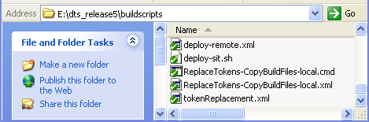

* The token replaced configuration files will be copied to the ‘config-app’ folder of domain profile. This is the same location configured in WebSphere local server for DTS configuration files.

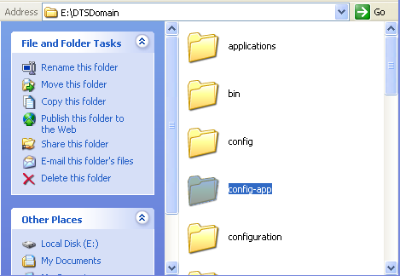

* The ear file will be copied to the ‘applications’ folder of domain profile.

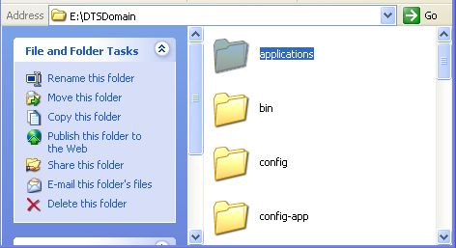

* Select the ear file from this location while deploying DTS in WebSphere local server.

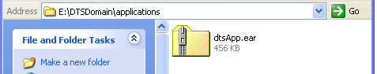

## Deploying DTS Projects in Local Server

### Uninstall DTS Application if already Deployed

* Login to the WebSphere.
* Click on Applications 🡪 Applications Types 🡪 WebSphere enterprise applications

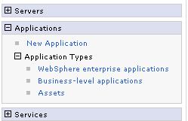

* Select the DTSApplication by selecting the combo box against it and click on the ‘Uninstall’ button.

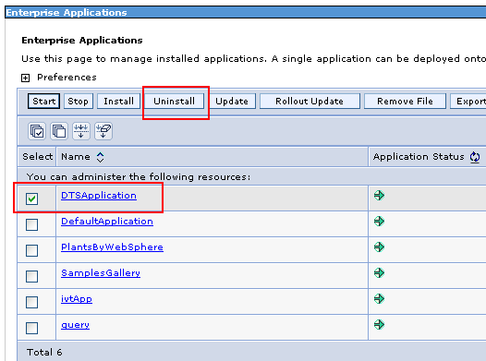

* Click ‘OK’ button to confirm un-installation.

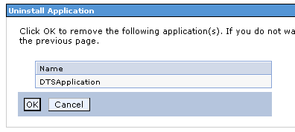

* Remember to save the changes.

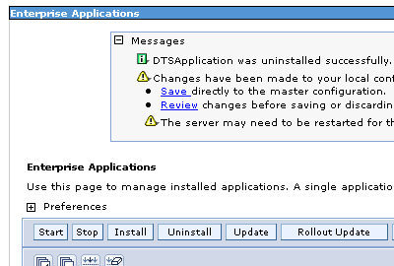

### Deploy DTS Projects in Local Server with no MDBs in DTS EAR

If all the MDBs are been switched off while taking a DTS build, the DTS ear will not contain any MDB. In this case, the deployment of ear in WebSphere is an easy task with only few steps to be done. Refer here to know what is switching on/off of MDBs means.

* Login to the WebSphere admin console.
* Click on Applications 🡪 Applications Types 🡪 WebSphere enterprise applications



* Uninstall the DTSApplication if already installed. Refer here to know how to do this.
* Click on the ‘Install’ button to install the application.

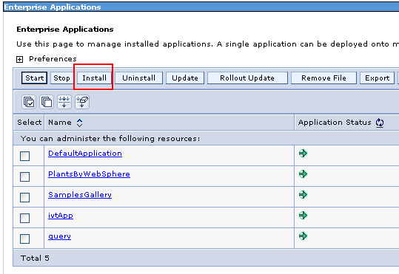

* Select the ‘Local File System’ radio button. Browse to the ear file (E:\DTSDomain\applications). Click ‘Next’.

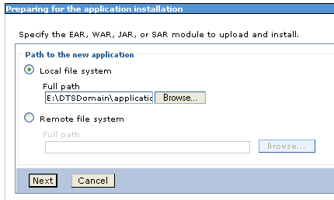

* Accept the default ‘Fast Path’ selection and click ‘Next’.

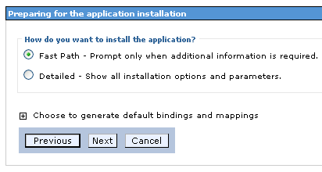

* Make sure that the ‘Application Name’ entry is correct. Accept other defaults and click ‘Next’.

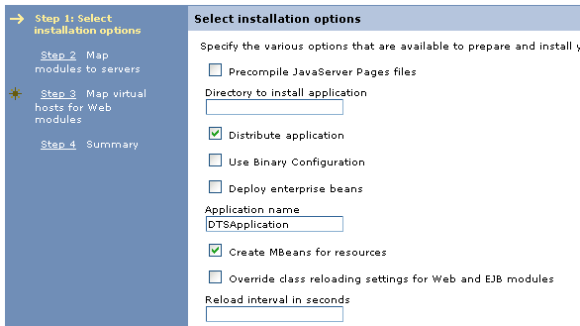

* Select the DTS Application (Checkbox) and then select the DTS Server entry from the ‘Clusters and servers’ list. Click on ‘Apply’ button. Then click ‘Next’.

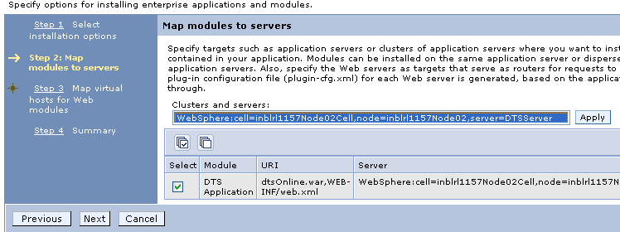

* Select the DTS Application (checkbox). Then select ‘default_host’ from combo box (select ‘dts_host’ instead of default_host’ if available in the list). Then click ‘Next’.

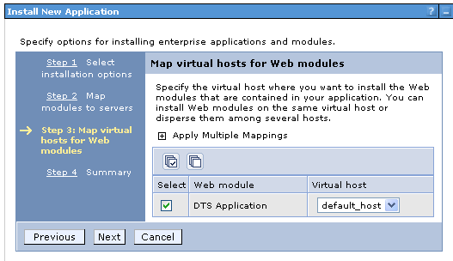

* In the Summary Page, accept the defaults and click ‘Finish’.
* Remember to save the changes when prompted.

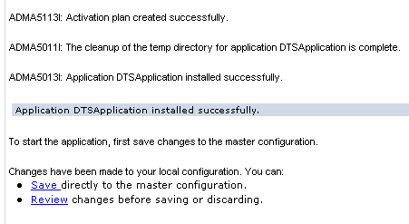

* With this, the installation gets completed and the DTS Application gets listed in the ‘Enterprise Application’ section.

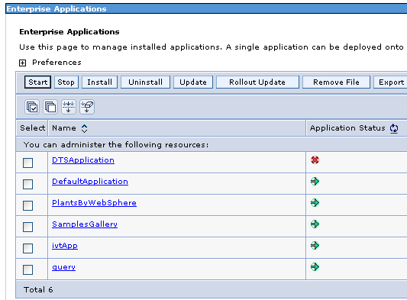

* The installed application needs to be started manually. This can be done by selecting the DTS Application checkbox and by pressing the ‘Start’ button.
* After the installation of the DTS Application, the DTS Server can be restarted and this will trigger all the applications deployed under it, including the DTS Application, to start automatically.

### Deploy DTS Projects in Local Server with all MDBs in DTS EAR

If all the MDBs are been switched on while taking a DTS build, the DTS ear will contain all the MDBs. In this case, the deployment of ear in WebSphere has some additional settings to be done. Refer here to know what is switching on/off of MDBs means.

* Login to the WebSphere admin console.
* Click on Applications 🡪 Applications Types 🡪 WebSphere enterprise applications



* Uninstall the ‘DTSApplication’ if already installed. Refer here to know how to do this.
* Click on the ‘Install’ button to install the application.



* Select the ‘Local File System’ radio button. Browse to the ear file (E:\DTSDomain\applications). Click ‘Next’.



* Accept the default ‘Fast Path’ selection and click ‘Next’.



* Make sure that the ‘Application Name’ entry is correct. Accept other defaults and click ‘Next’.



* In the ‘Map modules to servers’ section, select ‘DTSMDB’, ‘DTSApplication’ and ‘dtsMuleInt.war’ checkboxes and then select the DTS Server entry from the ‘Clusters and servers’ list. Click on ‘Apply’ button. Then click ‘Next’.

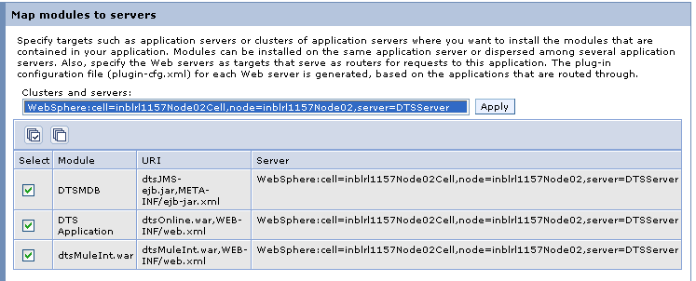

* In the 'Bind listeners for message-driven beans’ section, select the checkbox corresponding to the ‘DTSBatchMDB’ only and then expand the ‘Apply Multiple Mappings’ section.

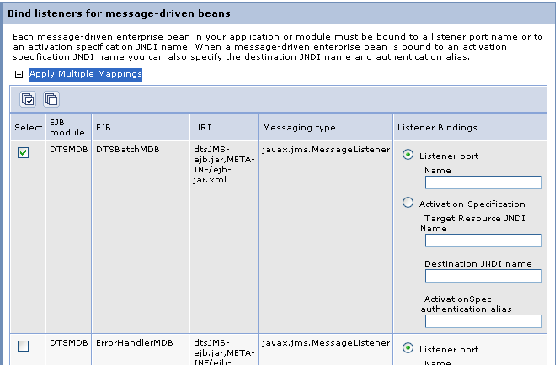

* When expanded, in the ‘Activation Specification’ section, select ‘eis/DTSBatchMDB’ entry from the first combo box and then click on the ‘Apply’ button.

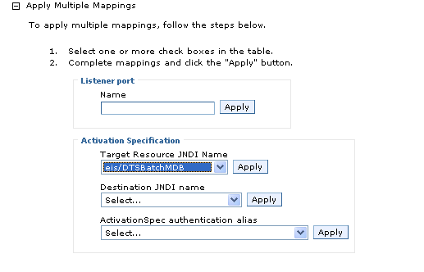

* Select the checkbox corresponding to the ‘DTSBatchMDB’ and then expand the ‘Apply Multiple Mappings’ section again.

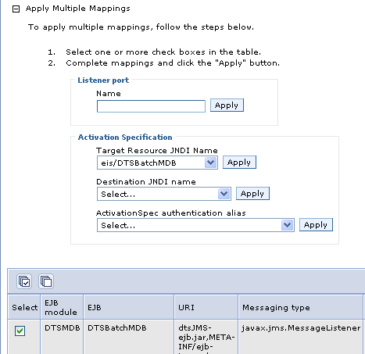

* When expanded, in the ‘Activation Specification’ section, select ‘jms/DTSBatchQueue’ entry from the second combo box and then click on the ‘Apply’ button.

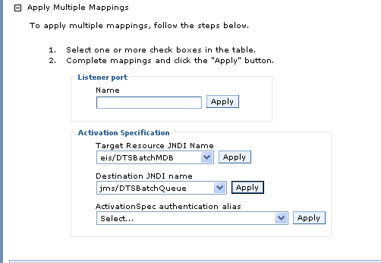

* Select the checkbox corresponding to the ‘DTSBatchMDB’ and then expand the ‘Apply Multiple Mappings’ section again.

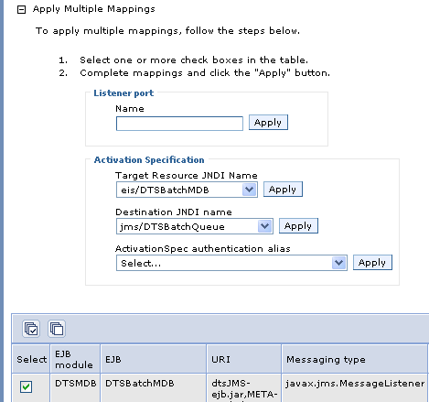

* When expanded, in the ‘Activation Specification’ section, select ‘<local node>/JMSUser’ entry from the third combo box and then click on the ‘Apply’ button.

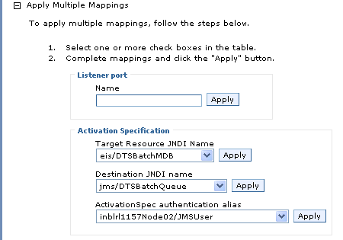

* Verify the Activation Specification entries populated for ‘Listener Bindings’ section of ‘DTSBatchMDB’.

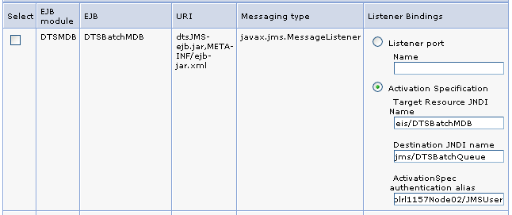

* Now select the checkbox corresponding to the ‘ErrorHandlerMDB’ only and then expand the ‘Apply Multiple Mappings’ section.

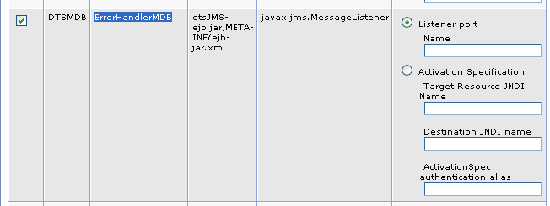

* When expanded, in the ‘Activation Specification’ section, select ‘eis/ErrorhandlerMDB’ entry from the first combo box and then click on the ‘Apply’ button.

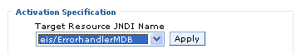

* Select the checkbox corresponding to the ‘ErrorHandlerMDB’ and then expand the ‘Apply Multiple Mappings’ section again.

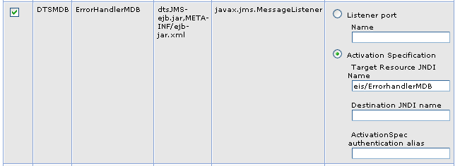

* When expanded, in the ‘Activation Specification’ section, select ‘jms/ErrorHandlerQueue’ entry from the second combo box and then click on the ‘Apply’ button.

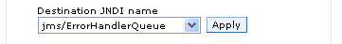

* Select the checkbox corresponding to the ‘ErrorHandlerMDB’ and then expand the ‘Apply Multiple Mappings’ section again.

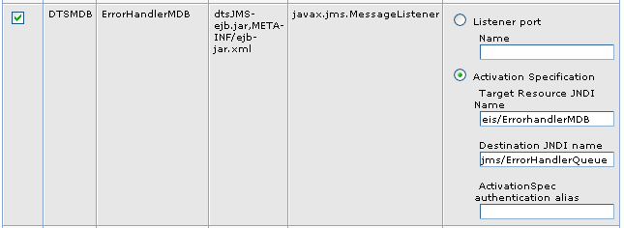

* When expanded, in the ‘Activation Specification’ section, select ‘<local node>/JMSUser’ entry from the third combo box and then click on the ‘Apply’ button.

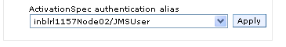

* Verify the Activation Specification entries populated for ‘Listener Bindings’ section of ‘ErrorHandlerMDB’.

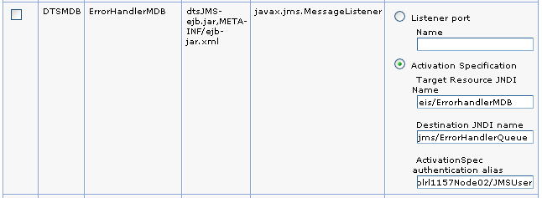

* Now select the checkbox corresponding to the ‘DTSNotificationMDB’ only and then expand the ‘Apply Multiple Mappings’ section.

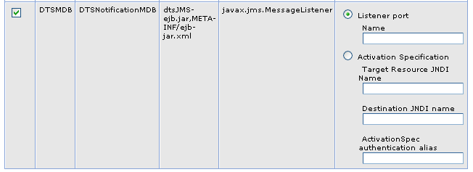

* When expanded, in the ‘Activation Specification’ section, select ‘eis/DTSNotificationMDB’ entry from the first combo box and then click on the ‘Apply’ button.

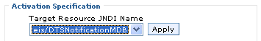

* Select the checkbox corresponding to the ‘DTSNotificationMDB’ and then expand the ‘Apply Multiple Mappings’ section again.

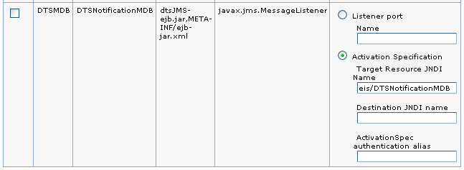

* When expanded, in the ‘Activation Specification’ section, select ‘jms/DTSNotificationQueue’ entry from the second combo box and then click on the ‘Apply’ button.

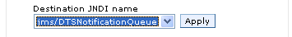

* Select the checkbox corresponding to the ‘DTSNotificationMDB’ and then expand the ‘Apply Multiple Mappings’ section again.

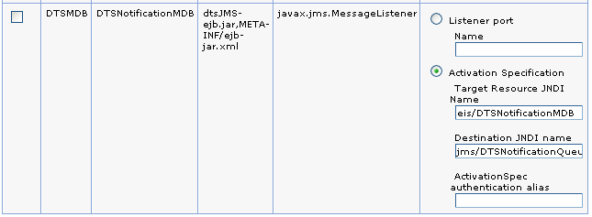

* When expanded, in the ‘Activation Specification’ section, select ‘<local node>/JMSUserForNotification’ entry from the third combo box and then click on the ‘Apply’ button.

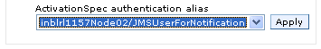

* Verify the Activation Specification entries populated for ‘Listener Bindings’ section of ‘DTSNotificationMDB’.

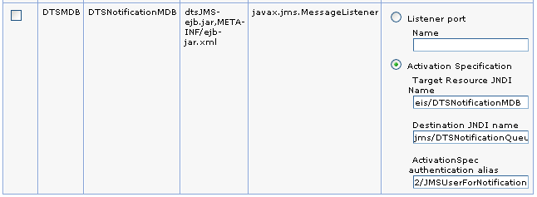

* In the ‘Map resource references to resources’ section, first select only the checkbox corresponding to the ‘DTSBatchMDB’.

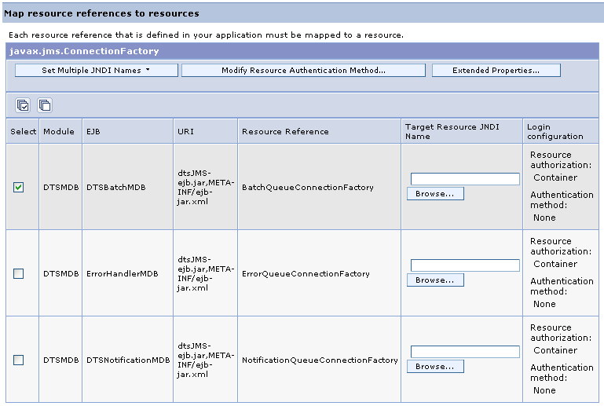

* Then click on the ‘Select Multiple JNDI Names’ button. Select the ‘jms/BatchQueueConnectionFactory’ entry.

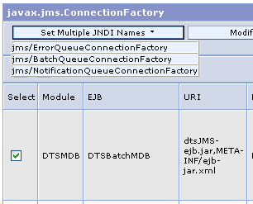

* Again select the checkbox corresponding to the ‘DTSBatchMDB’.

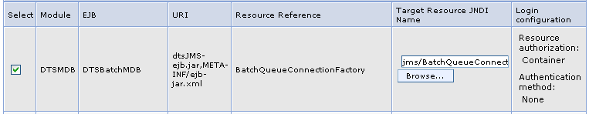

* Then click on the ‘Modify Resource Authentication Method…’ button. Select the ‘Use default method (many-to-one mapping)’ radio button and under that ' Authentication data entry’ needs to be set to ‘<local node>/JMSUser’. Then click on the ‘Apply’ button.

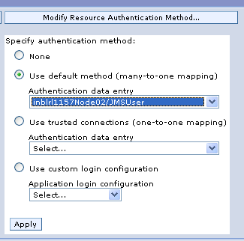

* Verify the entries for ‘DTSBatchMDB’

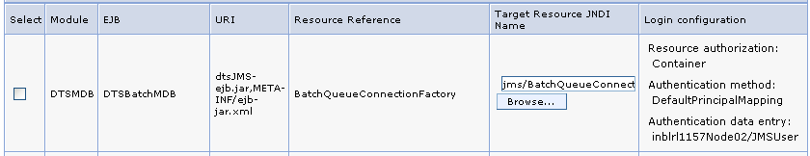

* Now select only the checkbox corresponding to the ‘ErrorHandlerMDB’.

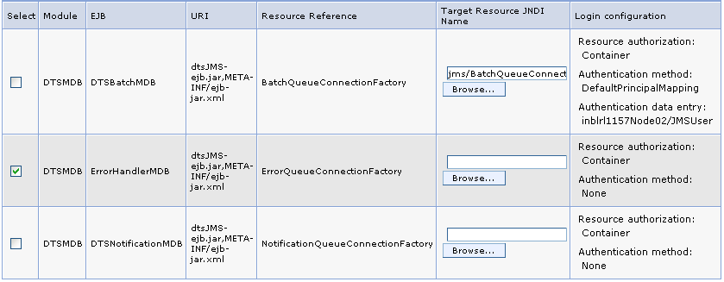

* Then click on the ‘Select Multiple JNDI Names’ button. Select the ‘jms/ErrorQueueConnectionFactory’ entry.

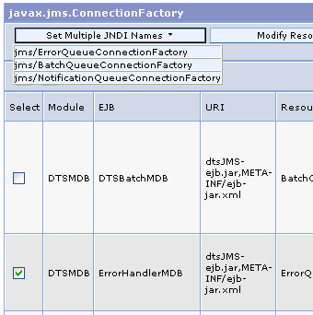

* Again select the checkbox corresponding to the ‘ErrorHandlerMDB’.

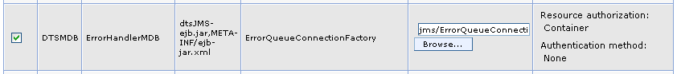

* Then click on the ‘Modify Resource Authentication Method…’ button. Select the ‘Use default method (many-to-one mapping)’ radio button and under that ' Authentication data entry’ needs to be set to ‘<local node>/JMSUser’. Then click on the ‘Apply’ button.



* Verify the entries for ‘ErrorHandlerMDB’

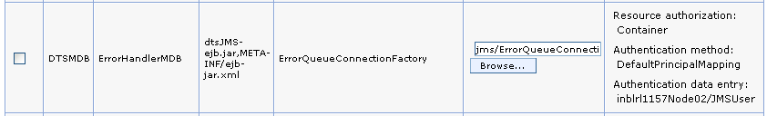

* Now select only the checkbox corresponding to the ‘DTSNotificationMDB’.

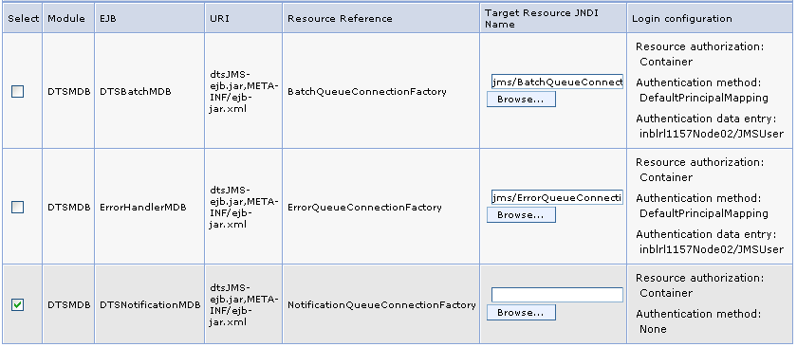

* Then click on the ‘Select Multiple JNDI Names’ button. Select the ‘jms/NotificationQueueConnectionFactory’ entry.

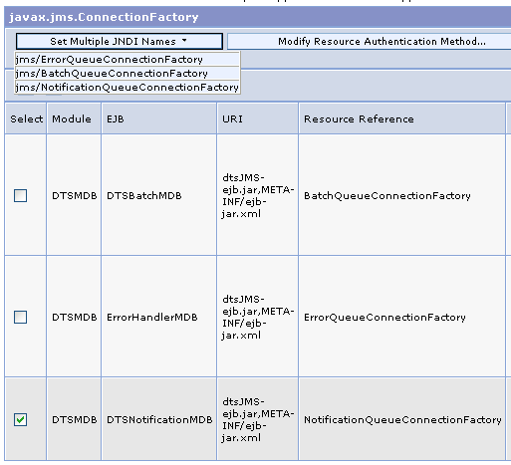

* Again select the checkbox corresponding to the ‘DTSNotificationMDB’.

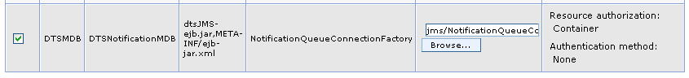

* Then click on the ‘Modify Resource Authentication Method…’ button. Select the ‘Use default method (many-to-one mapping)’ radio button and under that ' Authentication data entry’ needs to be set to ‘<local node>/JMSUserForNotification’. Then click on the ‘Apply’ button.

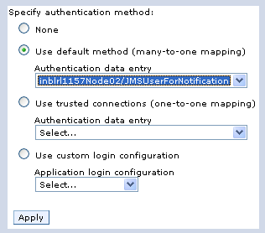

* Verify the entries for ‘DTSNotificationMDB’

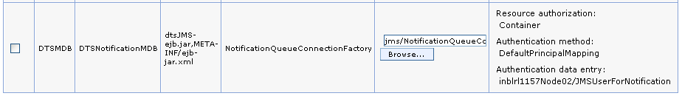

* Click on the ‘Next’ button.
* In the ‘Map resource environment entry references to resources’ section, fill in the text boxes in the column named 'Target Resource JNDI Name’.

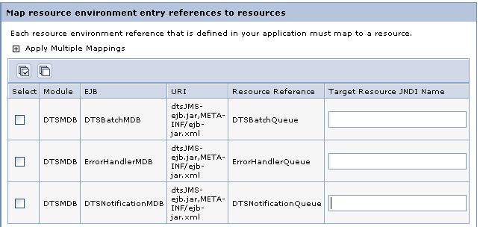

* In the textbox corresponding to the ‘DTSBatchMDB’, fill in the following value.

jms/DTSBatchQueue

* In the textbox corresponding to the ‘ErrorHandlerMDB’, fill in the following value.

jms/ErrorHandlerQueue

* In the textbox corresponding to the ‘DTSNotificationMDB’, fill in the following value.

jms/DTSNotificationQueue

* Verify the entries on this section and click ‘Next’.

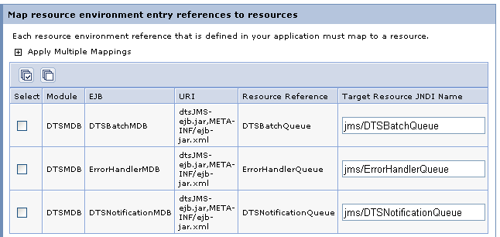

* In the ‘Map virtual hosts for Web modules’ section, select the DTS Application and dtsMuleInt.war checkboxes. Then select ‘default_host’ from both the combo boxes (select ‘dts_host’ instead of default_host’ if available in the list). Then click ‘Next’.

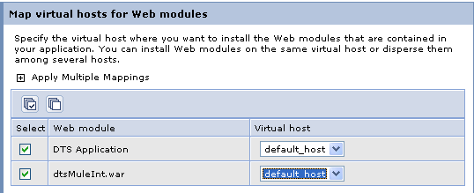

* In the Summary Page, accept the defaults and click ‘Finish’.
* Remember to save the changes when prompted.



* With this, the installation gets completed and the DTS Application gets listed in the ‘Enterprise Application’ section.



* The installed application needs to be started manually. This can be done by selecting the DTS Application checkbox and by pressing the ‘Start’ button.
* After the installation of the DTS Application, the DTS Server can be restarted and this will trigger all the applications deployed under it, including the DTS Application, to start automatically.

### Deploy DTS Projects in Local Server with only selected MDBs in DTS EAR

If all the MDBs are been selectively switched on while taking a DTS build, the DTS ear will contain only the selected MDBs. In this case, follow the deployment steps listed earlier for the DTS ear, with all MDBs switched on, but exclude the steps for the MDBs which are been avoided.

Refer here to know the deployment steps listed earlier for the DTS ear with all MDBs switched on.

Refer here to know what is selectively switching on/off of the MDBs means.

# Building and Deploying of DTS RP Projects

## Building DTS RP Projects in Local Server

For building the projects, the Apache ANT installation step, mentioned earlier in this section has to be completed. While building the RP Project, there is a special requirement. DTS Java Applet needs to be compiled by Java compiler version javac1.5. So the JDK 1.5 needs to be pre-installed in the local system.

### Build DTS RP Projects in Local Server

* Open the file <latest DTS RP checkout folder>\build.windows.properties in a text editor. As of now (May 2013) the dts_rp_release5 is the latest DTS RP branch.

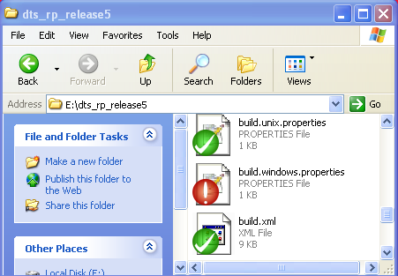

* Make sure that the value for the token svnant.latest.url is pointing to the latest DTS RP branch URL. Also note that the value for token jdkbin points to the JDK 1.5 installation folder’s bin directory.

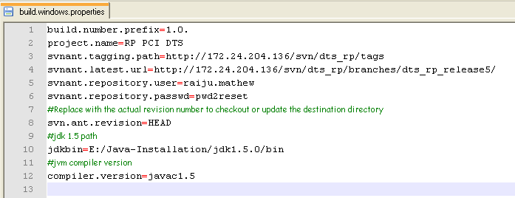

* Open the file <latest DTS RP checkout folder>\build-local.cmd in a text editor.

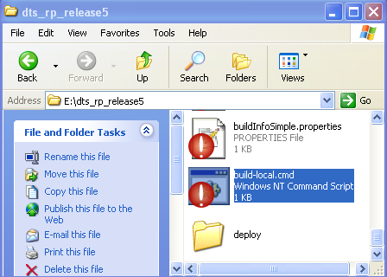

* Make sure that the JAVA_HOME and ANT_HOME variables have proper values

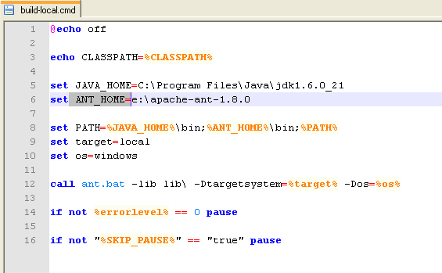

* Open the file <latest DTS RP checkout folder>\environment\local.setup.properties and verify the path/folder where the build artifacts should get copied.

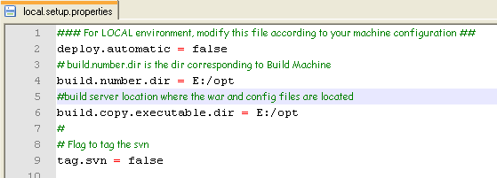

* Make sure that you have ‘build.rp.number’ file in ‘build.number.dir’ path. Else Copy it from ‘<DTS RP Checkout folder>\docs’ folder and paste it in the build.number.dir folder.

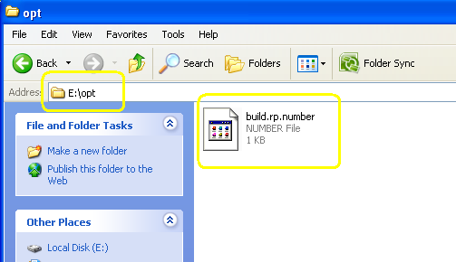

* In the same ‘local.setup.properties’ file, verify the paths for tokens which has local file path as values. Tune the values according to your local drive configuration. (example token : dtsrp.dtsService.wsdlPath)

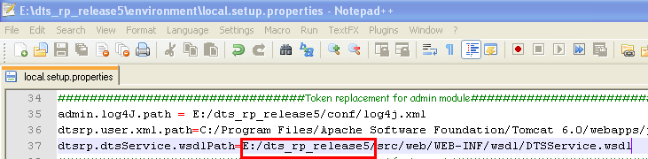

* Double click on the <latest DTS RP checkout folder>\build-local.cmd file. It will start the local RP build. Verify that the build is successful.

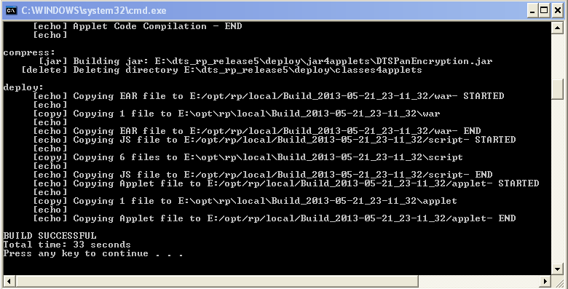

* Note down the path/folder where the build artifacts have been copied. Open the folder and find the DTS RP war file, scripts files and the applet jar file.

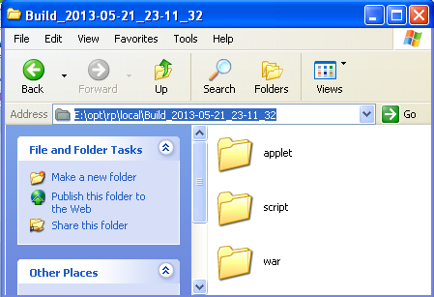

## Deploying the DTS RP Project in Local Server

The following steps need to be completed to deploy the DTS RP Project in Local Server. The war file should get deployed in Tomcat Server.

The script files and jar files need to be copied to Apache Server only if there is a change happened to these files.

If there is only a code change, the war file alone can be deployed in Tomcat Server. Server needs to be bounced if a change happened to the files under it.

### Deploy DTS RP Project in Tomcat Server

The Tomcat Server needs to be pre-installed in the local system in order to perform a deployment. Please refer here to know how to installed Tomcat Server.

* Stop the local Tomcat Server if running. To know how to stop the Tomcat, refer here.
* Open the webapps directory of Tomcat. This directory is inside Tomcat’s installation folder.

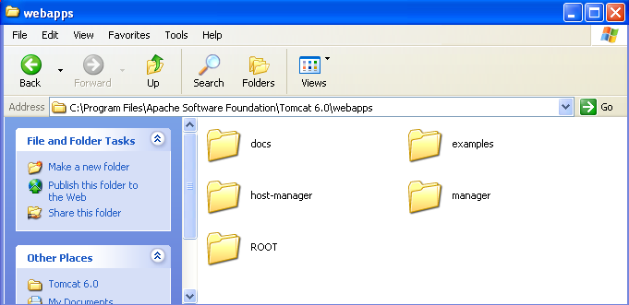

* Delete the folder named pci_proxy if exists. Also delete the pci_proxy.war file if exists there (you may take a backup of these files if needed before deleting it).
* Copy the pci_proxy.war file from the output folder of the latest DTS RP build.

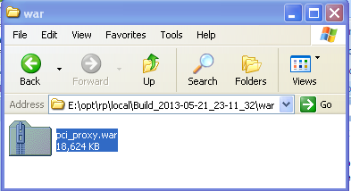

* Place it inside the webapps directory of Tomcat.

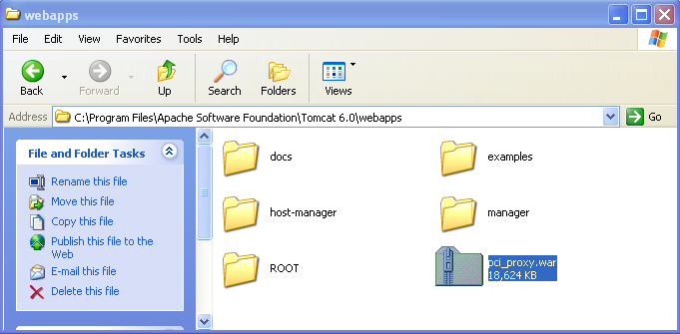

* Start the Tomcat. To know how to start the Tomcat, refer here. Verify that the pci_proxy folder gets created inside the webapps directory when Tomcat gets started.

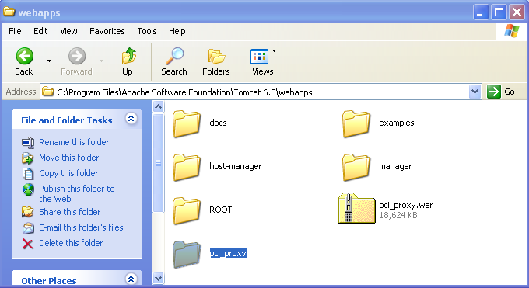

### Deploy DTS RP Project in Apache Server

The Apache Server needs to be pre-installed in the local system in order to perform a deployment. Please refer here to know how to install Tomcat Server.

* Stop the local Apache Server if running. To know how to stop the Apache, refer here.
* Open the htdocs directory of Tomcat. This directory is inside Apache’s installation folder.

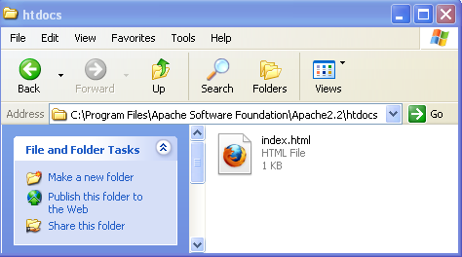

* Check whether the scripts, applet, images and css folder paths exist in the htdocs directory. These folders should be under the path <Apache Installation Directory>\htdocs\dtsApp\dtsOnline.
* If these path and folders do not exists, create it by following the below steps.
* Create a folder named dtsApp inside htdocs folder. Open it.

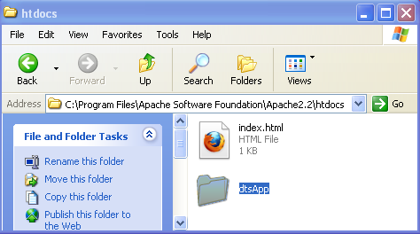

* Create a folder named dtsOnline inside dtsApp folder. Open it.

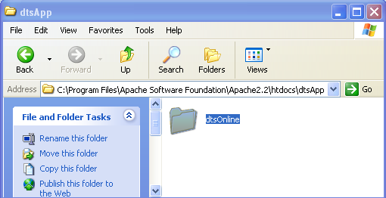

* Create 4 new folders named scripts, applet, images and css inside dtsOnline folder.

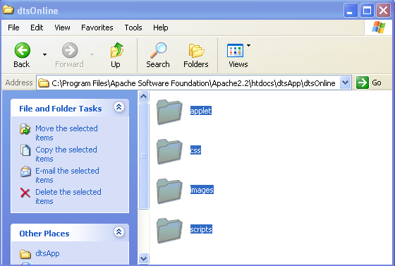

* Now the folder structure is ready for installation.
* If these path and folders already exist, no need to create them, instead you may take a backup of the existing htdocs directory.
* Open the scripts folder. Copy only the scripts that have a change/modification from the build artifact’s script folder and paste it here and accept overwriting. If the script is newly introduced in the project, always introduce it.

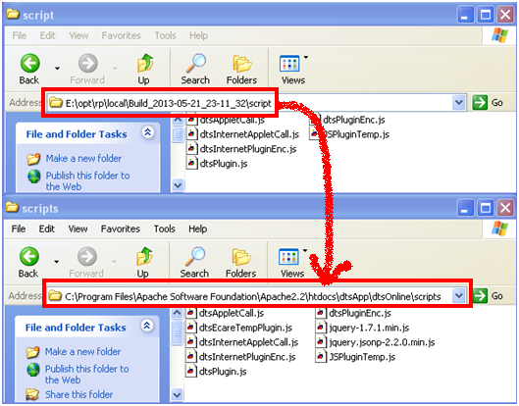

* If there is a change in the applet class files, then the applet should be copied to Apache Server. Else there is no need to copy the applet.
* Open the applet folder. Copy the DTSPanEncryption.jar file from the build artifact’s applet folder and paste it here and accept overwriting.

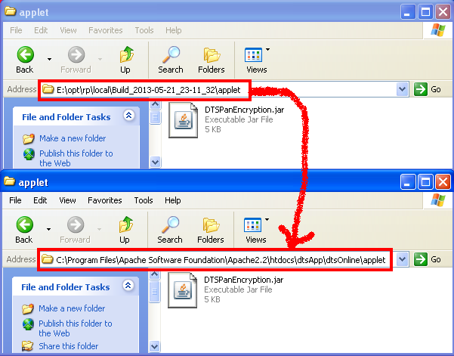

* The CSS (including fonts) and image files are not part of DTS code base. So these files, if do not exists, can be downloaded from any one of the DTS environment. The current versions of these files (as of May 2013) are embedded below.



* Place the CSS files inside the css folder.

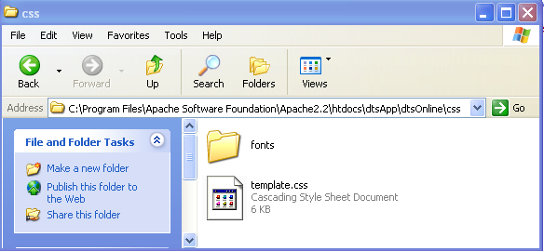

* Place the image files inside the image folder.

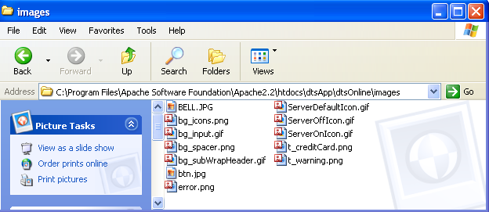

* Starting the Apache is the next step. But before starting it, the proxy pass settings for DTS need to be configured in **httpd.conf** file of Apache. If this is already done, proceed with starting the Apache Server. To know how to start the Apache, refer here.

### Setting Proxy Pass configuration for DTS RP in Apache Server

This is a one-time setting in most cases unless otherwise a new proxy pass to a DTS URL has to be configured.

* Access to the DTS resources at WAS side are restricted using the reverse proxy mechanism. In the Apapche’s httpd.conf file, set the proxy pass to the necessary DTS URLs which needs to be exposed outside.
* There are multiple ways to do the proxy pass. DTS follows <LocationMatch> with ProxyPass mechanism. A sample extract is given below.

|  |
| --- |
| <**LocationMatch** "/dtsApp/dtsOnline/dtsTestPanEncryptionV1.jsp">  **ProxyPass** https://172.24.204.137:9451/dtsApp/dtsOnline/dtsTestPanEncryptionV1.jsp  </**LocationMatch**> |

* Note that certain configuration settings may not be possible in local server. For example, the SiteMinder authentication mechanism’s settings in httpd.conf file. So this settings, if present, needs to be avoided while configuring the httpd.conf file. By default, httpd.conf file doesn’t have these settings.
* Some configuration like the https communication and SSL engine can be avoided between local servers if required. See the main SSL settings are been commented out.

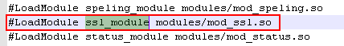

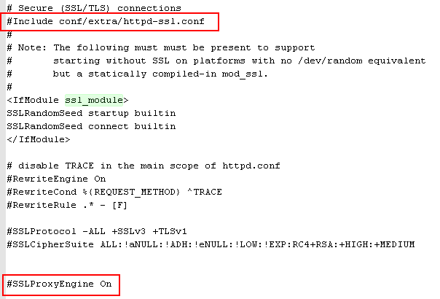

* An example **httpd.conf** file from ICN DEV environment (with site minder and SSL configurations switched on) is embedded here below for the reference. Also embedded here an example **httpd.conf** file for local server in order to see the difference between them.

 

# Testing of DTS Services

## Testing DTS RP Services in Local Server

When the deployments in local Apache and Tomcat Servers and other necessary configurations are completed, we need to make sure that all the DTS WSDL services are up and running as per the local implementation.

### Testing of DTS Services through RP

The testing of the DTS services (Web Services, Web Page and JS Plug-in) through RP can be done on the local machine on the http protocol. So, all the URLs should be exposed using the http protocol.

* Make sure that the RP WSDL URLs are using http.

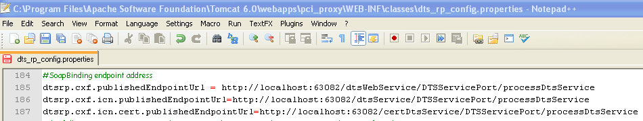

* Make sure that the RP Authentication URLs are using http.

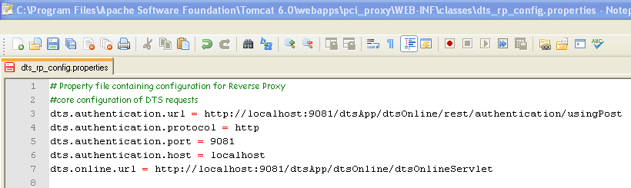

* Make sure that the RP Mule engine using http.

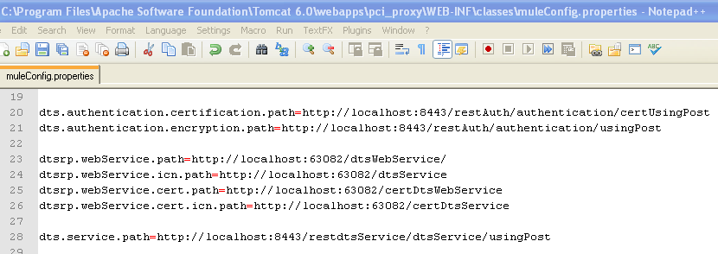

* Make sure that the DTS Mule engine using http.

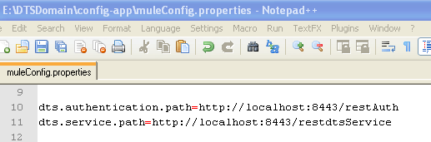

### Testing Example: The DTS RP WSDL URLs

To verify the WSDL URLs published in tomcat using the Mule Engine, make sure that the necessary proxy pass settings for the WSDL URLs have been added to the httpd.conf file of Apache.

* The first WSDL URL to be tested is given below

<http://localhost:63082/dtsService/DTSServicePort/processDtsService?wsdl>

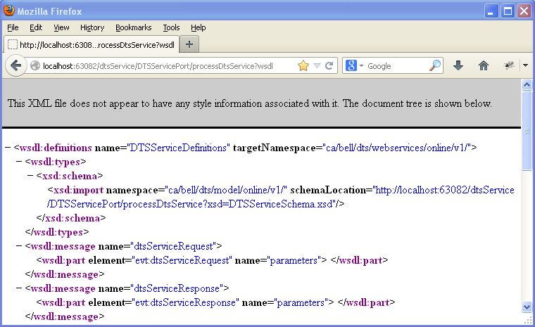

* The second WSDL URL to be tested is given below

<http://localhost:63082/dtsWebService/DTSServicePort/processDtsService?wsdl>

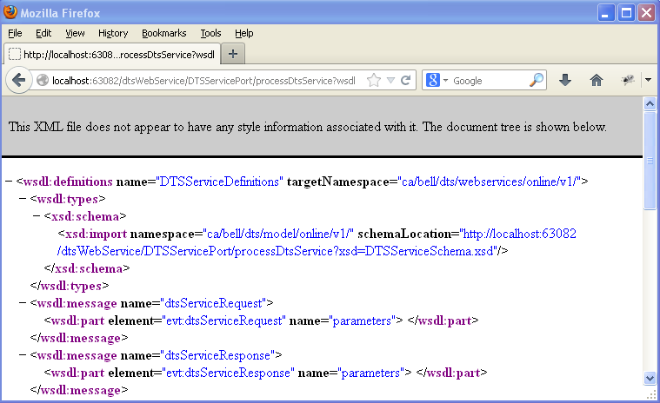

* The third WSDL URL to be tested is given below

<http://localhost:63082/certDtsService/DTSServicePort/processDtsService?wsdl>

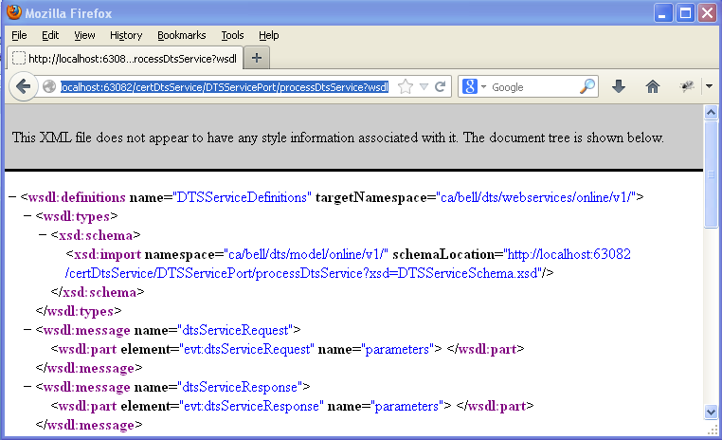

### Testing Example: JavaScript, CSS and JAR Files Download

Testing can be done to make sure that the JavaScript and CSS files are available to download.

* Download the JavaScript using the local URL.

<http://localhost:4343/dtsApp/dtsOnline/scripts/dtsPluginEnc.js>

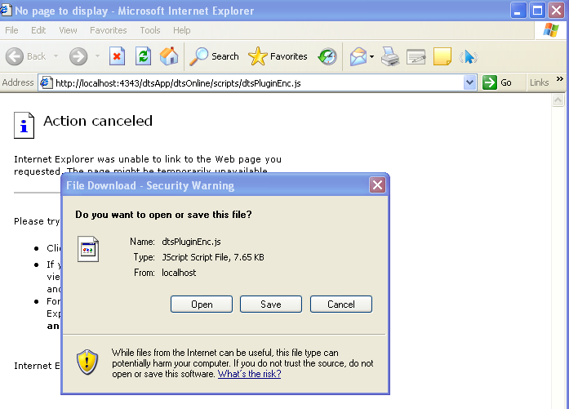

* Download the CSS using the local URL.

<http://localhost:4343/dtsApp/dtsOnline/css/template.css>

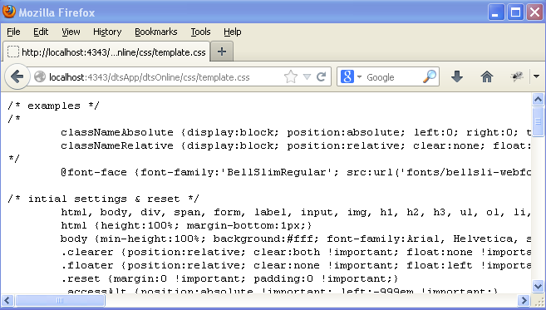

* Download the Applet JAR file using the local URL.

<http://localhost:4343/dtsApp/dtsOnline/applet/DTSPanEncryption.jar>

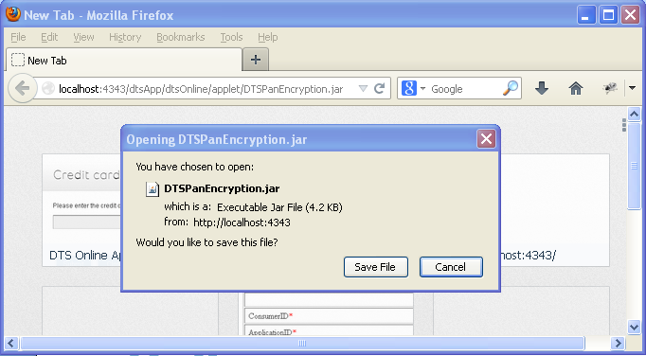

### Testing Example: DTS Rest Service

The DTS service is up or not can be checked by just running the DTS Service Rest URL from the browser. It should return a JSON response if the service is up.

* Try the DTS Service Rest URL from the browser.

<http://localhost:8443/restdtsService>

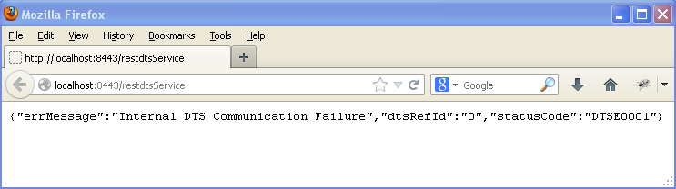

# Running DTS and DTS RP Services from Eclipse

Running DTS Services from Eclipse is different from running it using Apache, tomcat and WAS servers. In this case, pure Java API will be used to start the DTS services for testing during the development phase. Before continue with this section make sure that you have completed the Eclipse Setup Section.

## Running DTS Services from Eclipse

When we run DTS project from within eclipse, we actually run the DTS Mule flow by starting the Mule engine. The Mule will expose two web services, the DTS Authentication Service and the actual DTS Service as configured in the DTS Mule flow (dts-mule-config.xml).

### Solving Project Dependencies

The project dependencies should be resolved before proceeding further with running DTS Services from Eclipse. The DTS projects have interdependency. So, open all the DTS projects (if not opened already) in Eclipse and solve the project dependencies if any. Note that this section is only for DTS projects and not DTS RP projects.

The ‘Darwin’ project has no dependency on any other project. The ‘dtsCore’ has dependency on the ‘Darwin’ project. All other projects have dependencies on both ‘dtsCore’ and ‘Darwin’ projects.

* Make sure that all the projects of DTS are opened in Eclipse.

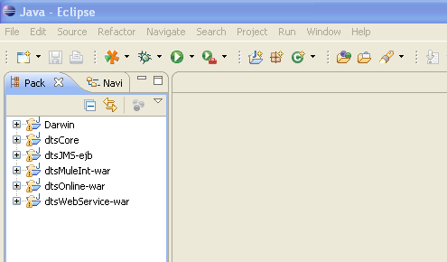

Note: The dependency of the projects can be set in order as per the SDS. Darwin is the core dependency. Since the jars would be built in order with the build script, some dependency jars might not be available if the build is not run (example: darwin.jar in dtsCore library). In such a case, exit eclipse and do the build and come back to see the jar there or delete the jar entry in library class path and add the relevant project as a dependency.

* Right click the ‘dtsCore’ project and select ‘Properties’

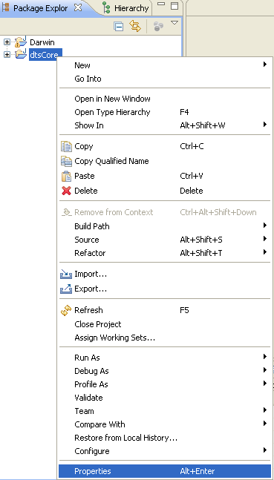

* Select ‘Java Build Path’ and ‘Projects’ Tab. Click ‘Add…’

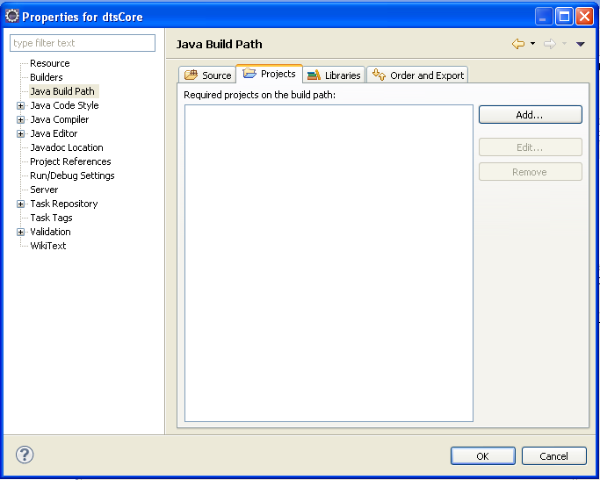

* Select the required project ‘Darwin’ which should be in class path for ‘dtsCore’ project to execute. Click OK.

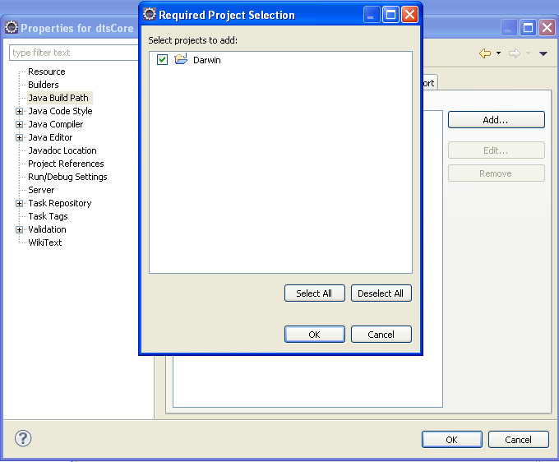

* Click OK again to finish. Now the ‘dtsCore’ project’s dependency got resolved.

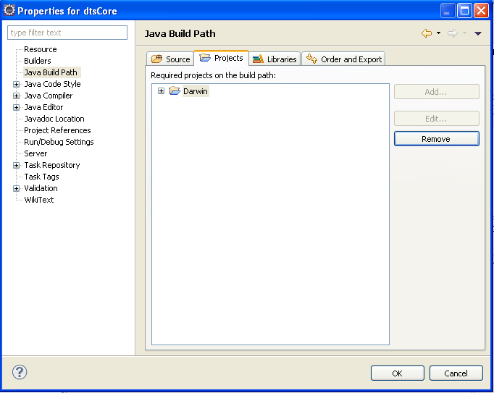

* In the same way make sure that the dependencies for ‘dtsJMS-ejb’ project are resolved. Add both ‘Darwin’ and ‘dtsCore’ projects to the Java build Path.

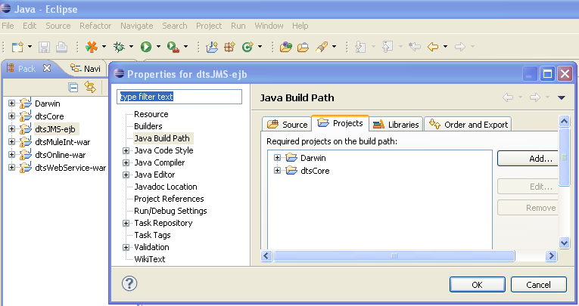

* Next resolve the dependencies for ‘dtsMuleInt-war’ project. Add both ‘Darwin’ and ‘dtsCore’ projects to the Java build Path.

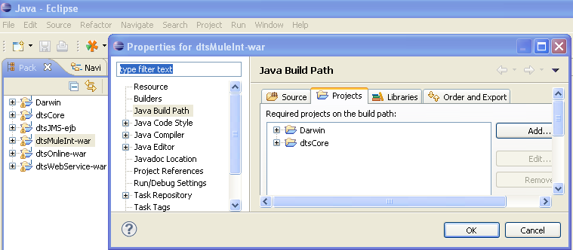

* Next are the dependencies for ‘dtsOnline-war’ project. Add both ‘Darwin’ and ‘dtsCore’ projects to its Java build Path.

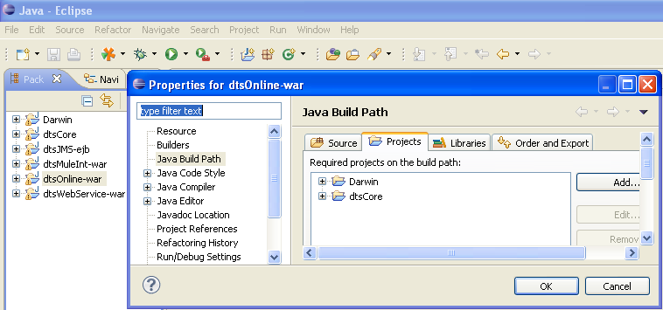

### Setting Java Runtime for DTS Projects

The Java Runtime Environment (JRE) needs to be set up for all the DTS Projects. Because the DTS ear should be deployed in IBM WebSphere Server, the IBM Java Runtime needs to be set up for all the DTS projects.

Before doing this, make sure that you have added the IBM WAS JRE to the Eclipse IDE as specified earlier in the Adding WAS Java Runtime for Eclipse section.

* Right click on the ‘Darwin’ project. Open the properties. Select ‘Java Build Path’ from the properties window. Click on the Libraries tab.

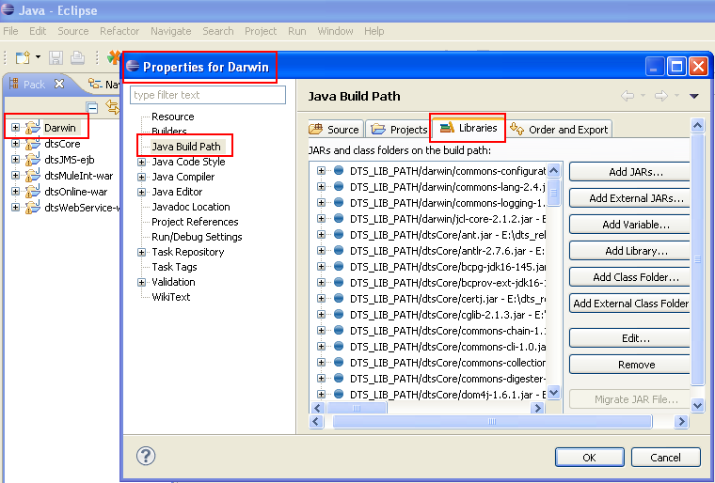

* Make sure that the ‘JRE System Library entry points to IBM WAS Java.

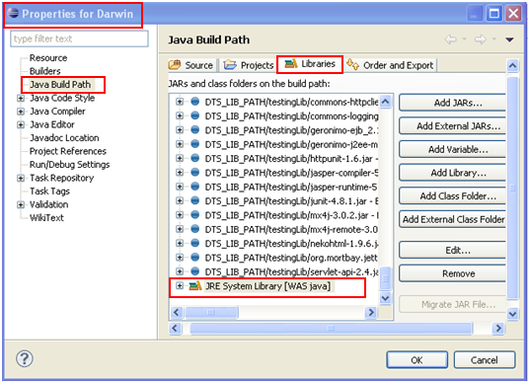

* If it is not pointing to IBM WAS Java, select it and click on the ‘Edit’ button. Select the WAS Java entry (radio button). Click on the ‘Finish’ button.

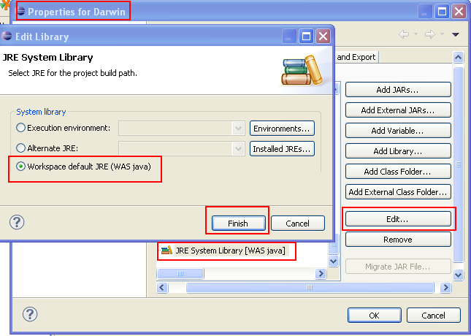

* Click the ‘OK’ button on the properties window to set the WAS JRE to the selected project.

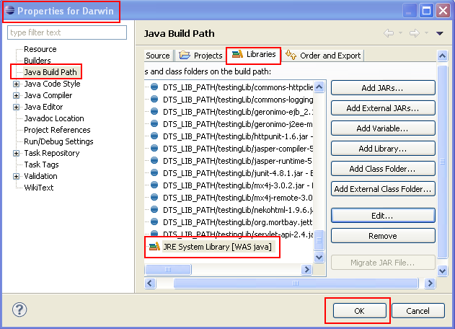

* If the ‘JRE System Library’ entry is not at all present in the Libraries List, add library by clicking on the ‘Add Library’ button.

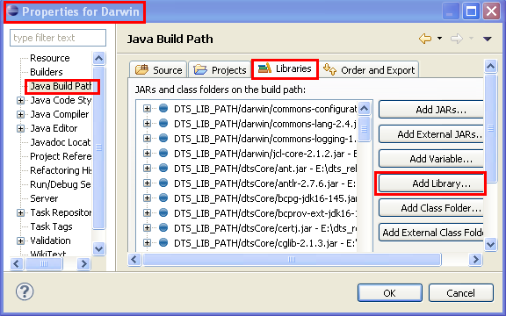

* Select ‘JRE System Library’ from the list and click on the ‘Next’ button.

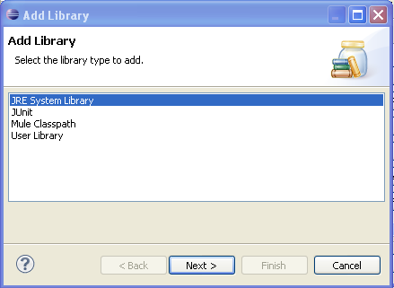

* Then select the WAS Java option and click on the ‘Finish’ button.

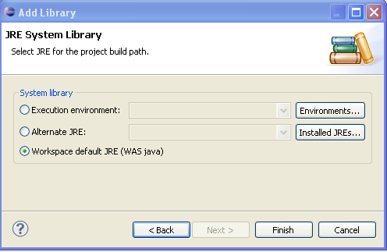

* In the same way, add the WAS JRE to the ‘dtsCore’ project.

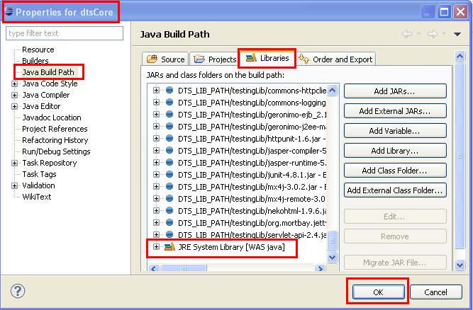

* Next, add the WAS JRE to the ‘dtsJMS-ejb’ project.

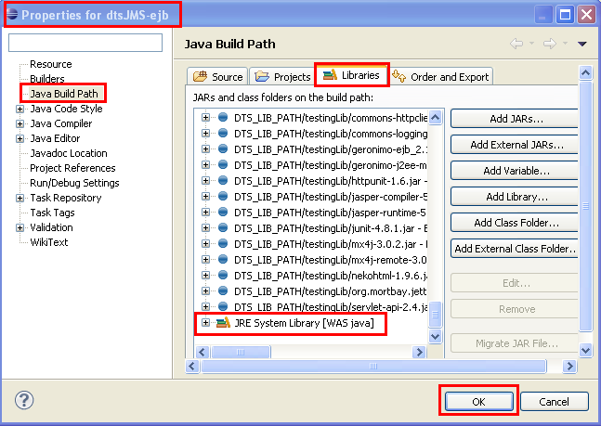

* Next, add the WAS JRE to the ‘dtsMuleInt-war’ project.

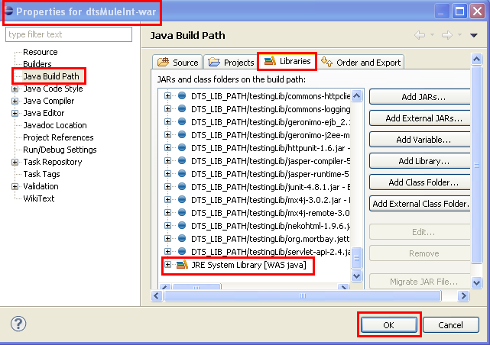

* Add the WAS JRE to ‘dtsOnline-war’ too.

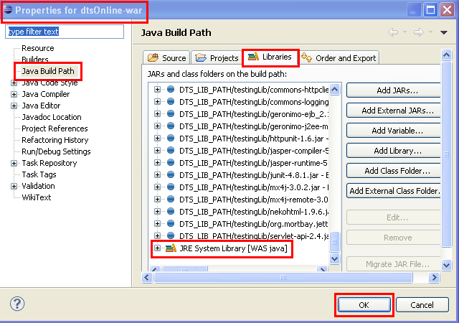

### Setting Classpath Variable for Third party Libraries

The Library Classpath Variable needs to be set so that all required third party libraries are available in the classpath.

* In the Eclipse menu, click on the Windows 🡪 Preferences

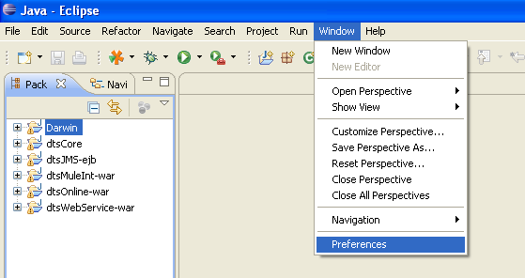

* Select the Java 🡪 Build Path 🡪 Classpath Variables from the left pane. Click on the ‘New’ button to add a classpath variable.

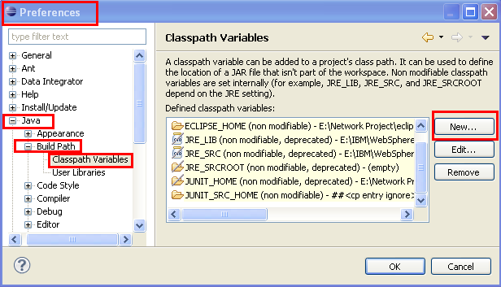

* Enter the name as DTS_LIB_PATH. Give the lib folder path of the DTS checkout directory of the latest DTS branch. Click on the ‘OK’ button.

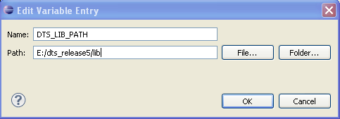

* Verify the classpath variable entry and click on the ‘OK’ button.

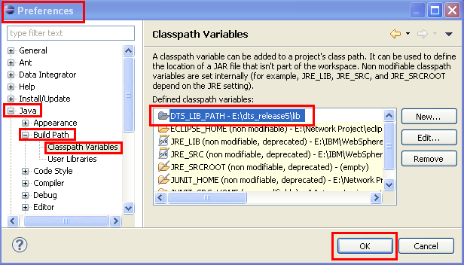

### Extending the Third party Libraries Classpath Variable for DTS Projects

Add the external jar files to DTS projects by extending the classpath variable created for Third party Libraries in the previous step.

* Right click the ‘dtsCore’ project and select ‘Properties’



* Select ‘Java Build Path’ and ‘Libraries’ Tab. Click on ‘Add Variable’ button.

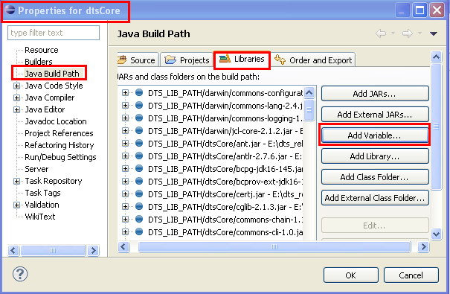

* Select DTS_LIB_PATH variable. Click on Extend button.

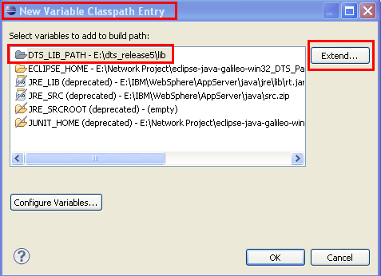

* Expand all yellow marked folders except ‘dtsOnlineWS-war’ node.

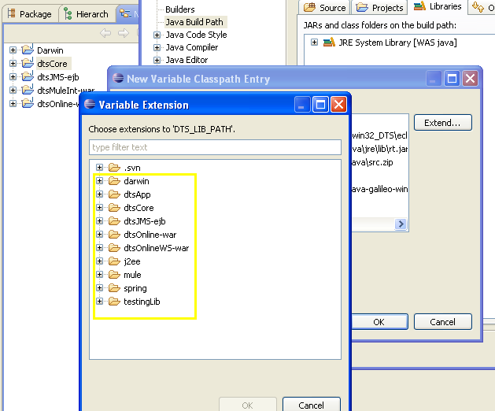

* Select all jars available within the expanded nodes and click OK to all three windows opened.

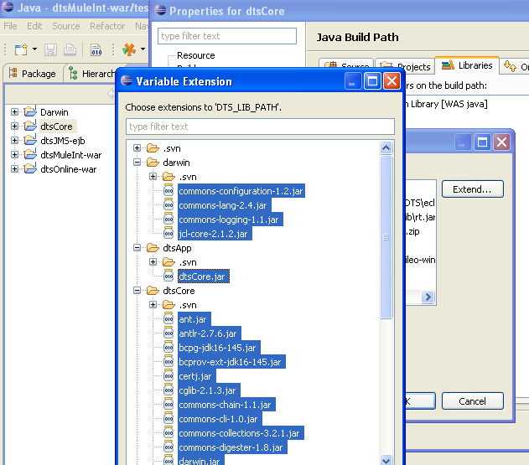

* In a similar way, add the library files reference to ‘dtsJMS-ejb’ DTS projects by adding and extending the DTS_LIB_PATH library variable.

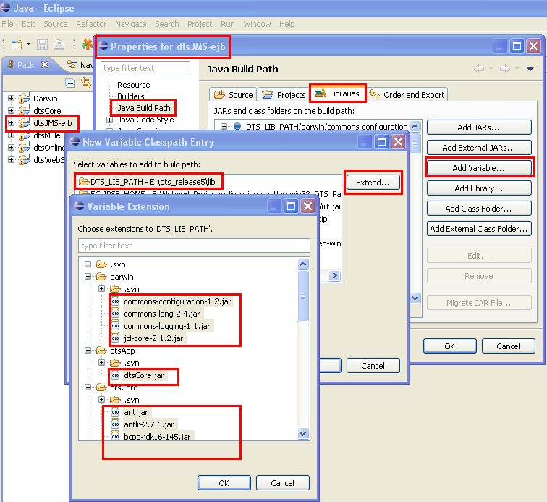

* Next, add the library files reference to ‘dtsMuleInt-war’ DTS projects by adding and extending the DTS_LIB_PATH library variable.

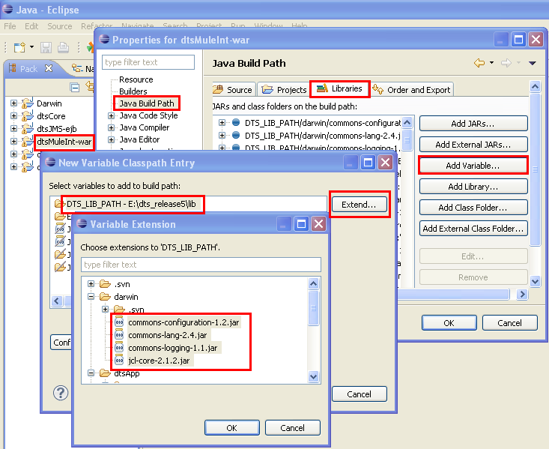

* Next, add the library files reference to ‘dtsOnline-war’ DTS projects by adding and extending the DTS_LIB_PATH library variable.

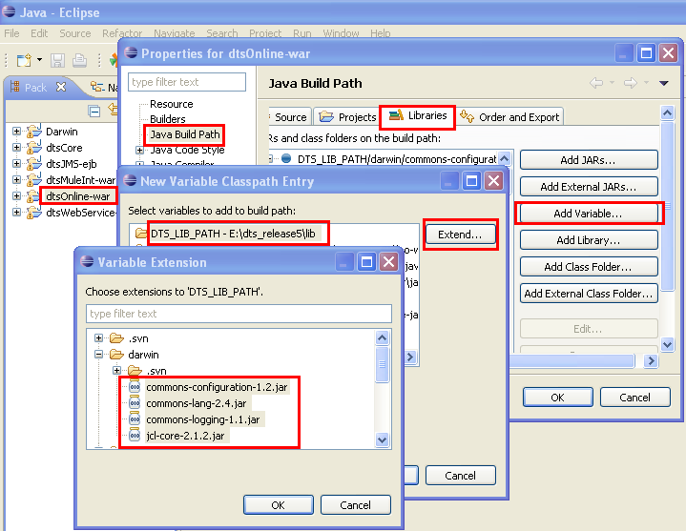

* Add the library files reference to ‘Darwin’ DTS projects too by adding and extending the DTS_LIB_PATH library variable.

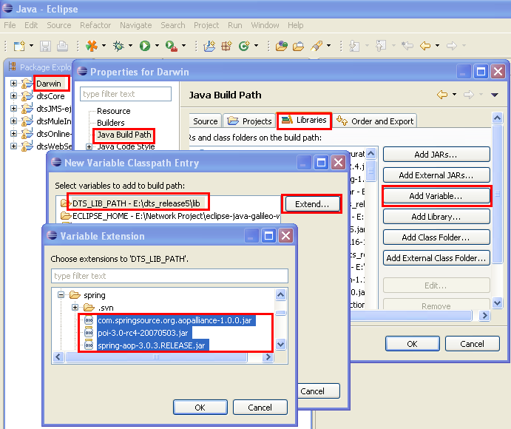

### Cleaning and Building the DTS Projects

In order to clean and build the DTS projects, follow the steps given below. While building the projects, any unresolved references get listed by the eclipse.

* To build projects individually, make sure that the ‘Build Automatically’ option is unchecked under the ‘Project’ menu option.

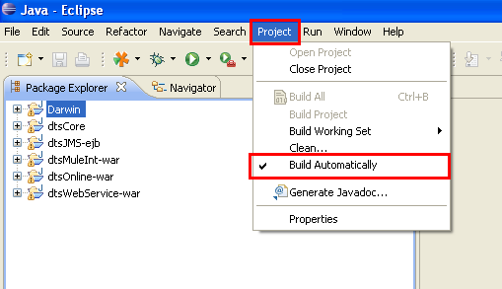 🡪 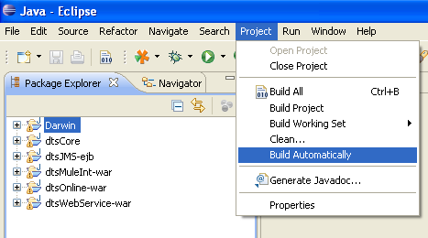

* Select ‘Project’ Menu 🡪 Clean. Select the projects you need to clean and build. Choose the ‘Clean projects selected below’ radio button. Select the ‘Start a build immediately’ checkbox. Opt the ‘Build only the selected projects’ radio button. Click OK.

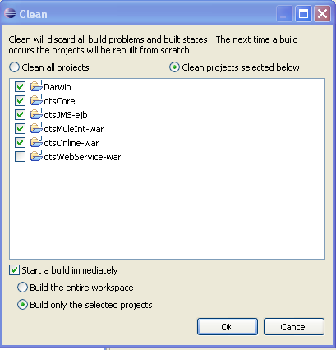

* This will start the clean and build from eclipse for the selected projects. Status for the same can be seen in the Eclipse status bar on the bottom of the IDE.

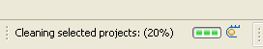 🡪 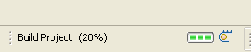

* The errors/problems/warnings during the build get listed in the ‘Error Log’ and ‘Problems’ windows. Open them if not done already.

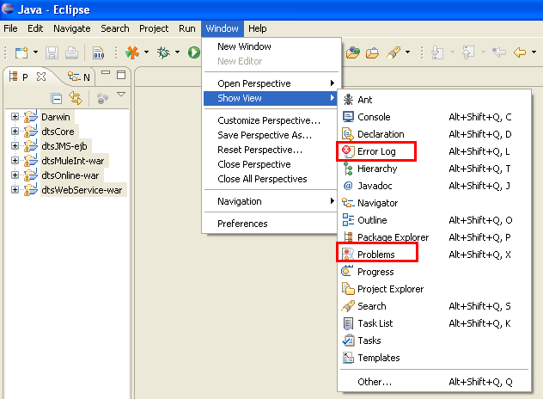

* These windows get displayed in the right bottom pane if the IDE.

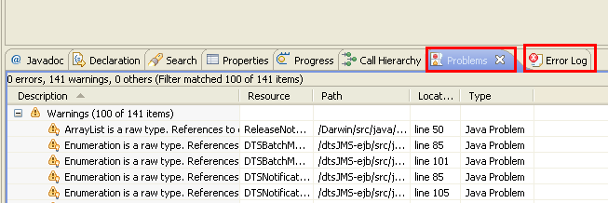

* Resolve all the errors and take a build again. Warnings can be avoided depends on the context.

### Token Replacing in DTS Projects

After completing the build process successfully, the environments tokens need to be replaced in DTS projects. For doing this, we need to run a utility class as specified below.

* Open the Java class named ‘TokenReplacementForConfigurations.java’. Right click anywhere in the class and run it as ‘JUnit Test’ from Eclipse for updating the ‘conf’folder with token replaced property files.

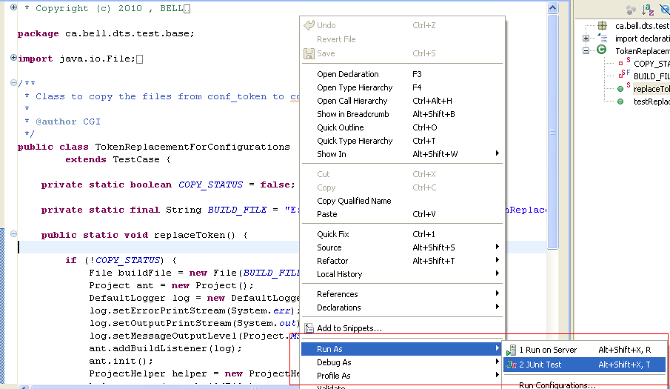

* This will replace the tokens if executed successfully.

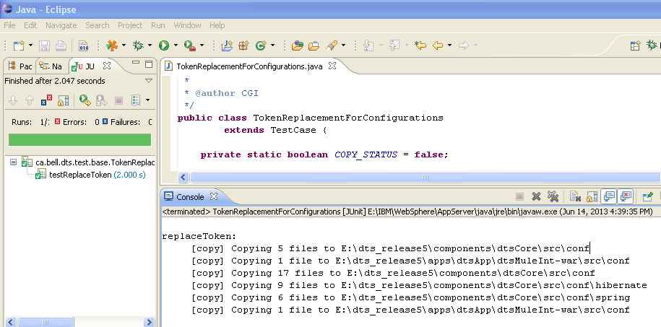

### Setting up the DTS DB for the DTS Projects

The DTS projects should point to one of the DTS DB test environments (DEV/SIT). This can be achieved by setting the data source bean configuration of the application as specified below.

* Open the application-context.xml file (inside dtsCore\src\conf\spring folder) in eclipse.

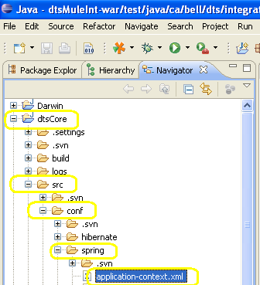

* Locate the ‘loadLogger’ section and ‘dataSource’ bean configuration sections.

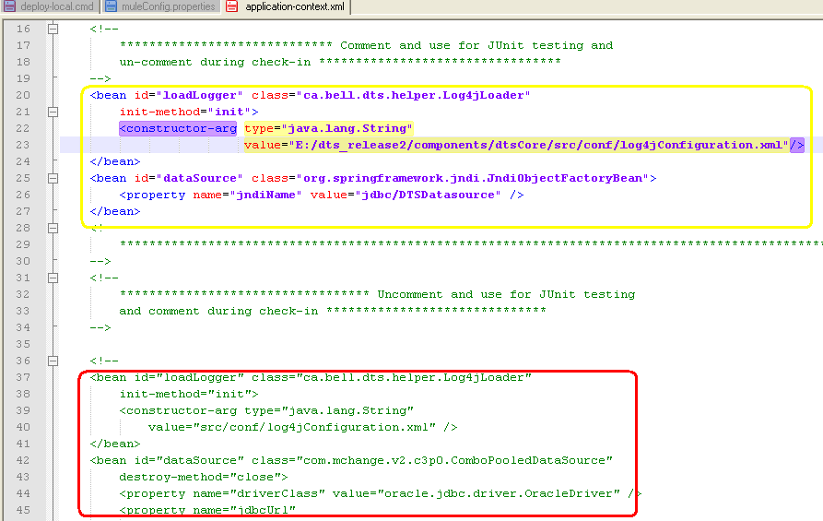

* Comment the yellow part and uncomment the red part.

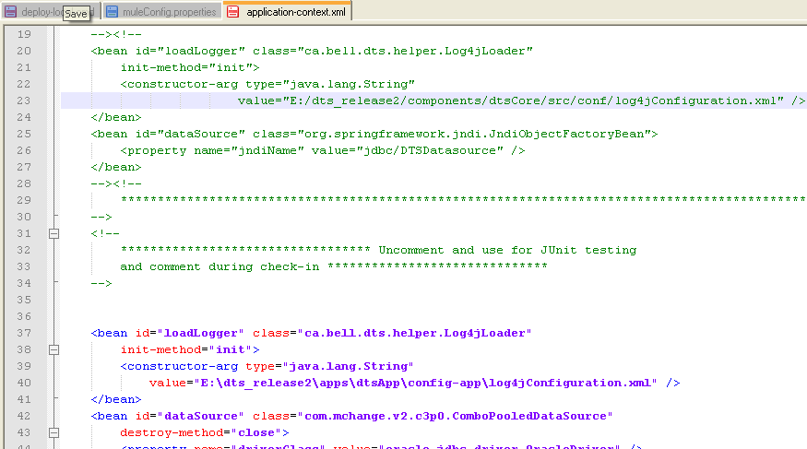

\

* Make sure that the ‘log4jConfiguration.xml’ file path in the above section is relevant and correct according to the latest DTS branch.
* Next, in the ‘dataSource’ bean configuration section, configure the DTS database you want to point to.

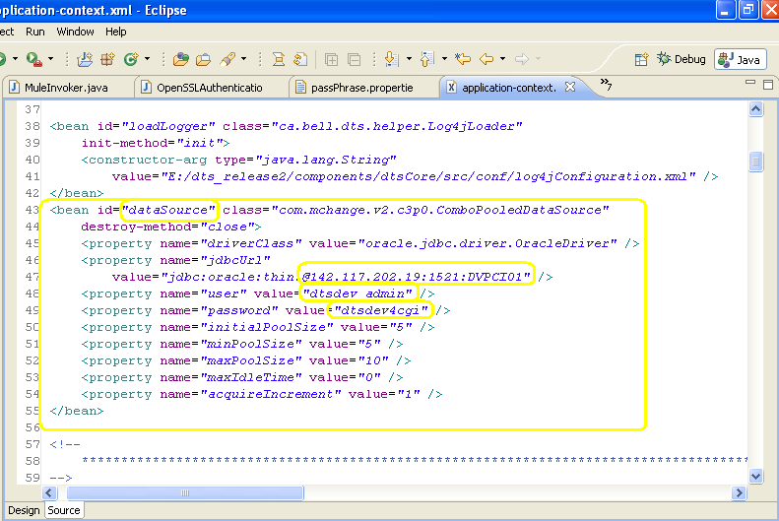

For the current DEV / SIT database configuration values and credentials (host name, port, SID, username and password), please contact your team leader. The example ‘dataSource’ bean configuration shown below points to DTS DEV database.

### Setting up the RTS DB for the DTS Projects

The DTS projects should point to one of the RTS DB test environments (DEV/SIT). This can be achieved by configuring RSA properties as specified below.

* Open the rsa_config.rsa file (inside dtsCore\src\conf folder) in eclipse.

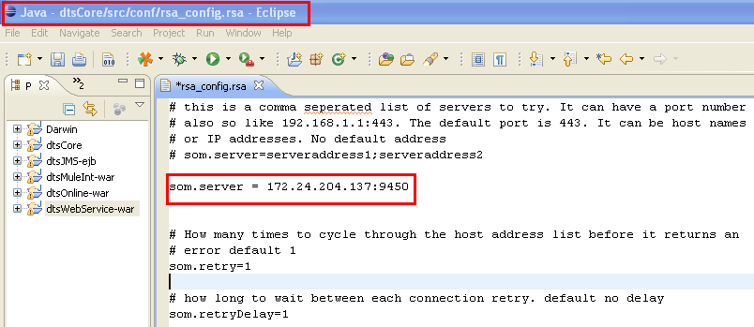

* The token ‘som.server’ decides which RSA database machine and port, your application tries to connect to. You can point to any one of the DEV / SIT RSA Databases as per the requirement. Above, it is pointing to DEV RSA DB.

To get the RSA DB configuration values for any particular environment, open that environment property file(under <DTS Checkout directory>\ buildscripts\environment folder), locate the ‘som.server’ token, fetch the value from there and paste it in this place(rsa_config.rsa file) so that your local DTS will point to that RSA Server. Example shown below is ‘dev.setup.properties’ file and yellow marked tokens point to same RSA Server database as one using IP address and other using host name. Similarly, you can find out the SIT RSA database values.

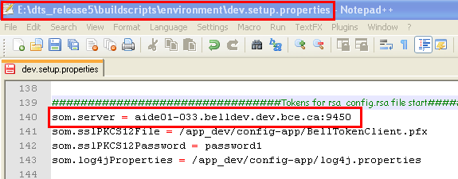

### Setting up the Log File Location for the DTS Projects

Log file location of DTS projects can be set using the ‘log4jConfiguration.xml’(inside **dtsCore\src\conf** folder).

* Open the ‘log4jConfiguration.xml’. Find the log file location values and modify as per your requirement. There are multiple log files. So you need to set it for each one separately. Here you can see the log files in ‘E:\DTSDomain\logs’ folder.

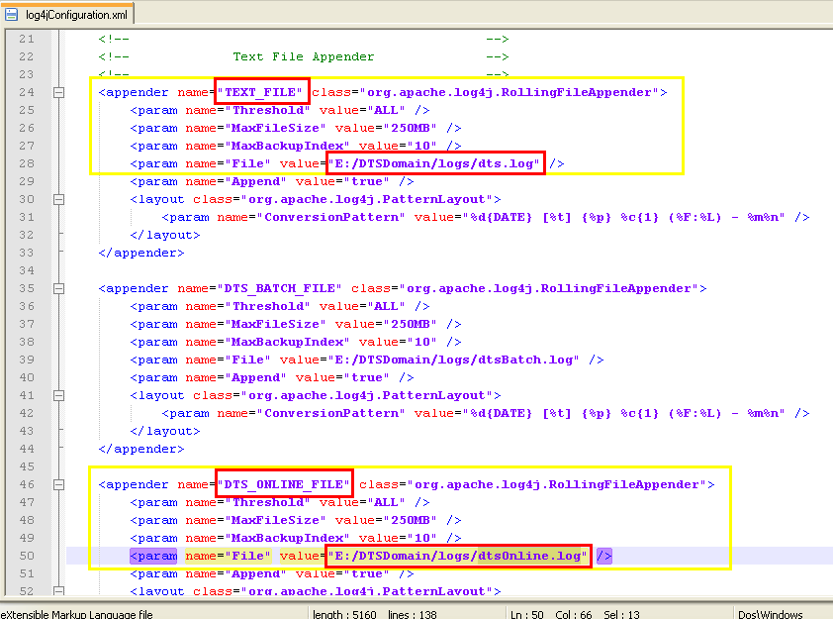

* You can also have the log files under the logs folder of ‘dtsCore’ project so that you can open and see the logs from within the Eclipse IDE. Change the above file path to ‘logs/dts.log’ and **‘**logs/dtsOnline.log’ in order to see it from eclipse.

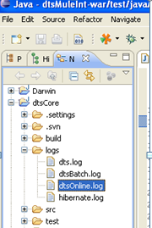

### Setting up the Logging Level for the DTS Projects

Log levels of DTS log files can be set through the ‘log4jConfiguration.xml’(inside **dtsCore\src\conf** folder).

* Open the ‘log4jConfiguration.xml’. Find the logging level values and modify as per your requirement. There are multiple log files. So you need to set it for each one separately.

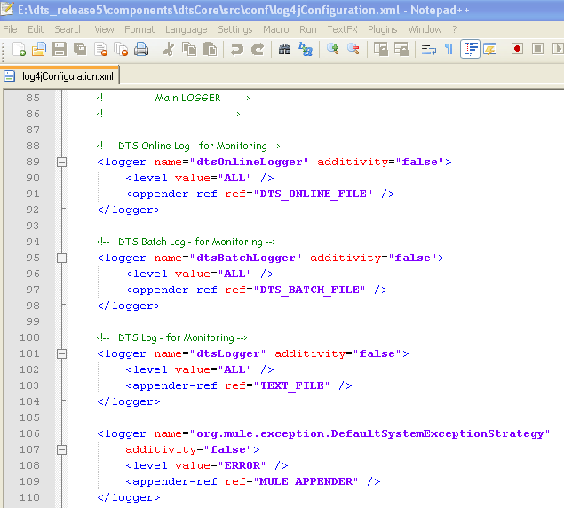

* Identify the appended log file using the green marked section. Modify the red marked section for changing the log level for the appended log file. The value can be any eligible log level value of log4j API.

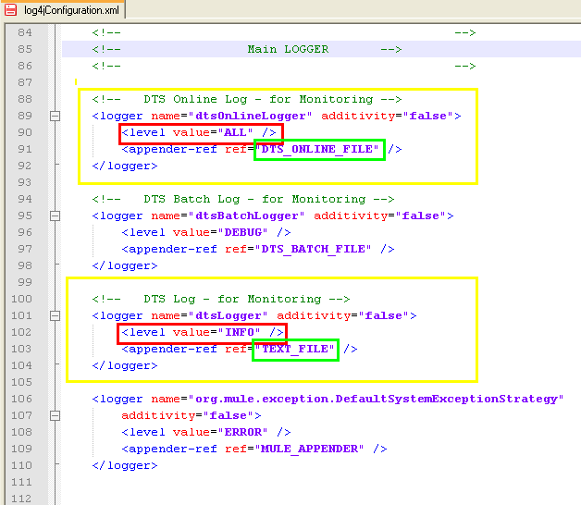

### Setting up the DTS Logging in Eclipse IDE Console

The DTS root logging can be set to Eclipse console so that the DTS logs can be seen from within the Eclipse IDE in its console window. This can be set through the ‘log4jConfiguration.xml’(inside **dtsCore\src\conf** folder).

* Open the ‘log4jConfiguration.xml’. Find the root appender reference as shown below.

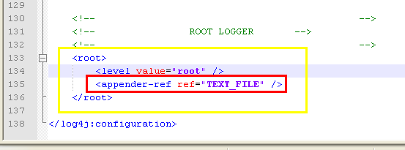

* Change the appender reference to ‘STDOUT’. So the root log entries get displayed in the console window of Eclipse.

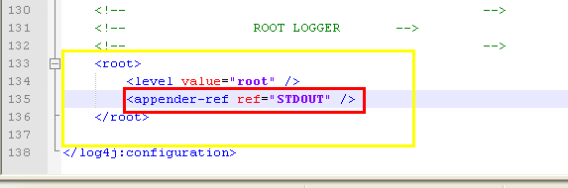

### Using HTTP for Web Service instead of HTTPS

When running locally, it is better to configure the web services using the http as the protocol instead of https. Of course, the web services exposed using https in real-life. But for keeping things simple, we use http when running in local machine. So we need to edit the Mule flow to change the inbound protocol configuration from https to http.

* Open the ‘dts-mule-config.xml’ file (inside dtsMuleInt-war\web\WEB-INF folder) and locate the <https:connector> definition section.

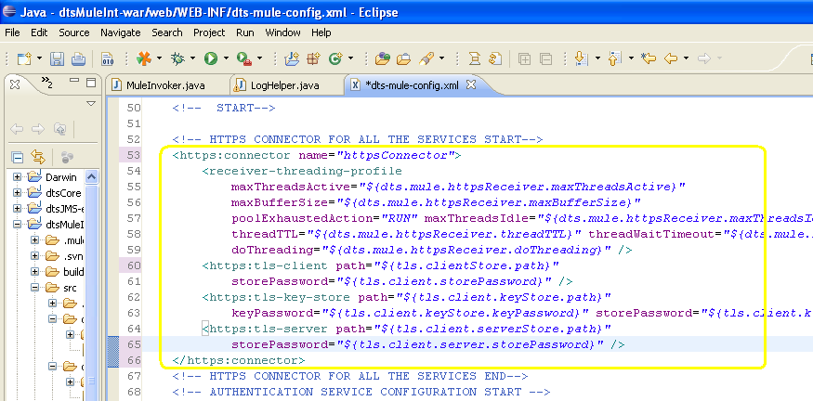

* Change it to <http:connector> and comment out the <https:xxxx> parameters (<https:tls-client>, <https:tls-key-store> and <https:tls-server> inner tags) as shown below.

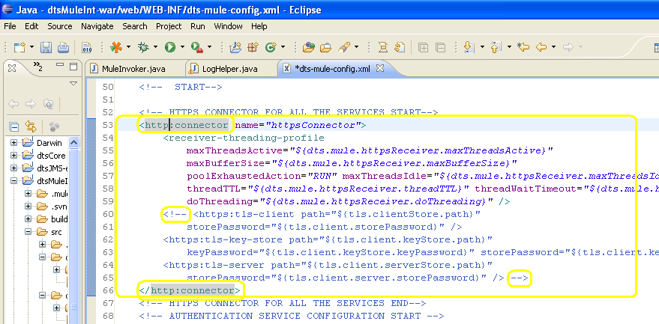

* Locate the < simple-service> definition section.

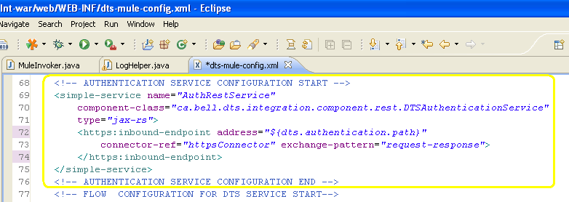

* Change the < https:inbound-endpoint> tag to < http:inbound-endpoint> tag.

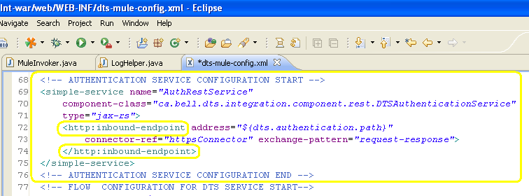

### Setting the Mule Configuration Path

Before starting the Mule Engine, the mule configuration path should be verified. The path is present inside the ‘MuleInvoker.java’ file (inside /dtsMuleInt-war/test/java/ca/bell/dts/integration folder).

* Open the ‘MuleInvoker.java’ file. Make sure that the ‘**d**ts-mule-config.xml’ path is relevant and correct to the latest DTS branch.

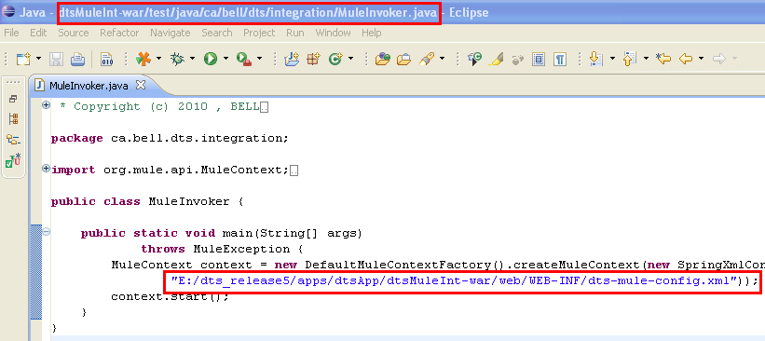

### Starting the Mule Engine

Starting the DTS Mule Engine can be done by executing the MuleInvoker.java file’s main method. This will eventually publish the services configured in ‘**d**ts-mule-config.xml’ file.

You need to be in VPN while you start the DTS application because the application will try to make a connection to the DTS database and RSA Server database it points to.

* Open the ‘MuleInvoker.java’ file. Right click on the file and Run As (click) Java Application (click).

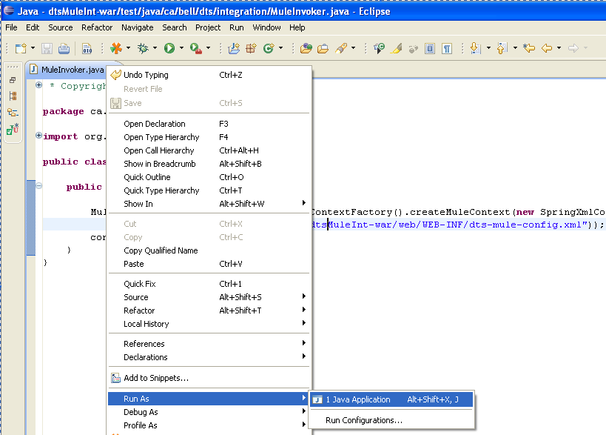

(If you are getting file not found exception for ‘MuleInvoker.java’, then build the ‘dtsMuleInt-war’ project alone from Eclipse and then execute ‘MuleInvoker.java’ once again as stated above)

This will start the DTS Mule Engine which in turn will start listening to the inbound(s) configured.

## Running DTS RP Services from Eclipse

When we run DTS RP project from within eclipse, we actually run the DTS RP Mule flow by starting the Mule engine. The Mule will expose the web services (dtsWebService, dtsService and certDtsService) as configured in the DTS Mule flow (PCI\src\web\WEB-INF\ dtsrp-mule-config.xml).

### Setting Java Runtime for DTS RP Project

The Java Runtime Environment (JRE) needs to be set up for all the DTS RP Project. Because the DTS RP war should be deployed in Tomcat Server, the SUN Java Runtime needs to be set up for all the DTS projects.

Before doing this, make sure that you have added the SUN JRE to the Eclipse IDE as specified earlier in the Adding Sun Java Runtime to Eclipse section.

* Import the RP Project (PCI) to Eclipse if not done already. Please refer here to know how to import DTS RP Project to Eclipse.
* Right click on the PCI project and select the properties.

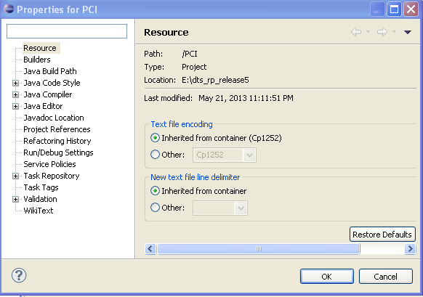

* Select the ‘Java Build Path’ in the left pane. Then click on the ‘Libraries’ Tab in the right pane. Make sure that the JRE entry is pointing to SUN JDK.

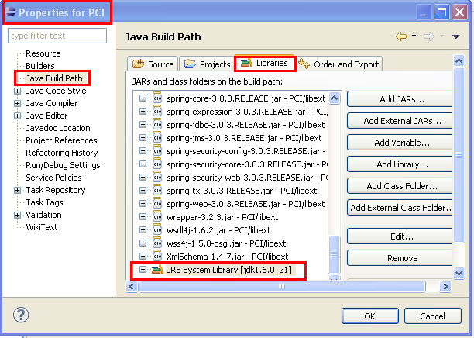

* If the JRE entry is not pointing to SUN JDK, then select the entry and click on the ‘Edit’ button. Select the SUN JDK entry from the list.

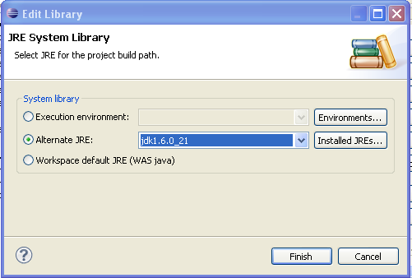

* If the ‘JRE System Library’ entry is not at all present in the Libraries List, add library by clicking on the ‘Add Library’ button.

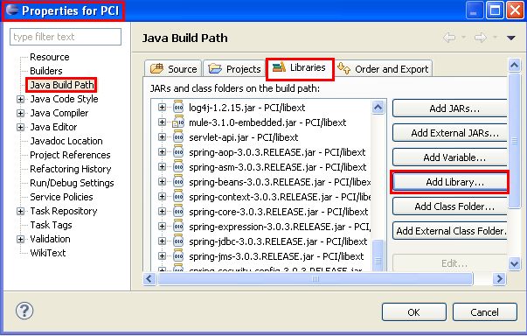

* Select ‘JRE System Library’ from the list and click on the ‘Next’ button.



* Then select the Alternate JRE option and select SUN JDK option from the list and click on the ‘Finish’ button.

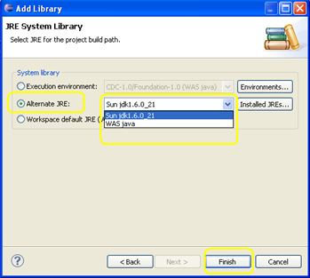

### Adding Third party Libraries for DTS RP Project

Add the external jar files to DTS RP project by performing the below given steps. These files are under <DTS RP Checkout folder>\libext folder.

* Import the RP Project (PCI) to Eclipse if not done already. Please refer here to know how to import DTS RP Project to Eclipse.
* Right click on the PCI project and select the properties.



* Select ‘Java Build Path’ from the left pane. Select ‘Libraries’ tab and click on ‘Add Jars’ button.

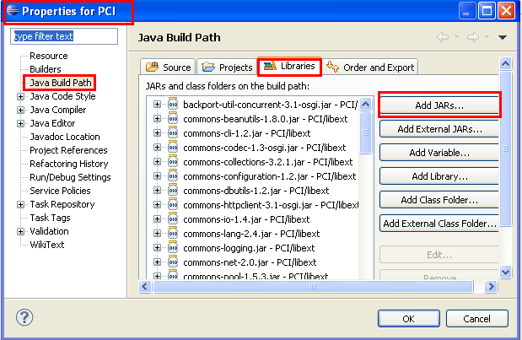

* Expand the ‘PCI’ folder. Then expand the ‘libext’ folder. Select all jar files available under it.

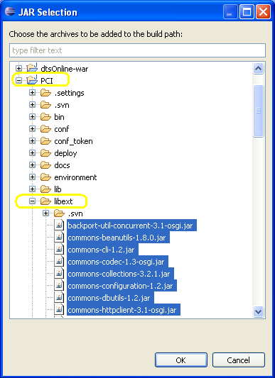

* Click OK. Now all the jar files selected get listed in the java build path window. Click OK.

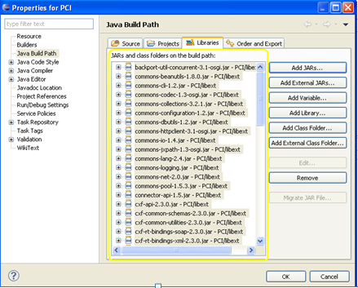

### Cleaning and Building the DTS RP Project

In order to clean and build the DTS RP project, follow the steps given below. While building the projects, any unresolved references get listed by the eclipse.

* To build projects individually, make sure that the ‘Build Automatically’ option is unchecked under the ‘Project’ menu option.

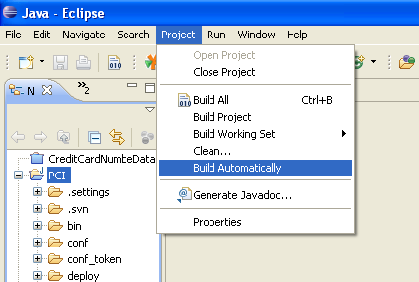

* Select ‘Project’ Menu 🡪 Clean. Select the PCI project. Choose the ‘Clean projects selected below’ radio button. Select the ‘Start a build immediately’ checkbox. Opt the ‘Build only the selected projects’ radio button. Click OK.

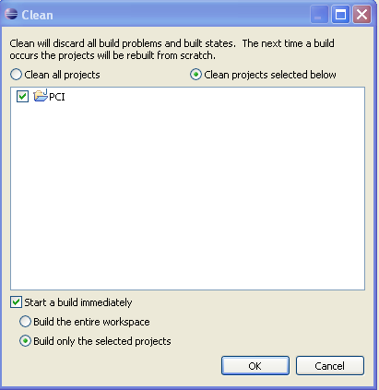

* This will start the clean and build from eclipse for the selected project. Status for the same can be seen in the Eclipse status bar on the bottom of the IDE.

 🡪 

* The errors/problems/warnings during the build get listed in the ‘Error Log’ and ‘Problems’ windows. Open them if not done already.

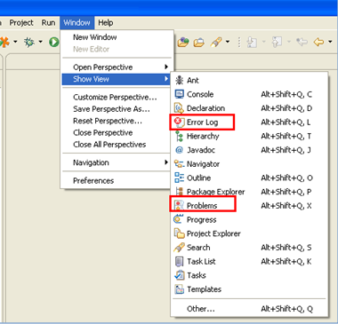

* These windows get displayed in the right bottom pane if the IDE.

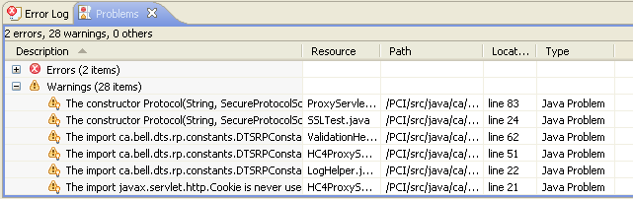

* Resolve all the errors and take a build again. Warnings can be avoided depends on the context.

### Setting up the Log File Location for the DTS RP Project

Log file location of DTS RP project can be set using the log4j.xml (inside <DTS RP Checkout folder>\conf folder).

* Open the ‘log4j.xml’ and locate text file appender section. Find ‘RP_TRACE_LOG’ and ‘RP_AUDIT_LOG’ appenders and modify as per your requirement. There are multiple log files. So you need to set it for each one separately.

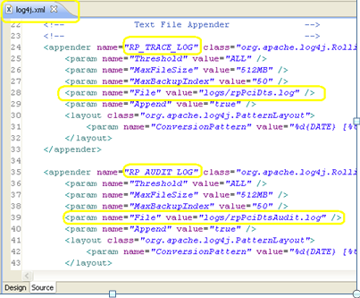

* Here you can see the RP log files are in the location <DTS RP Checkout folder>\logs folder.

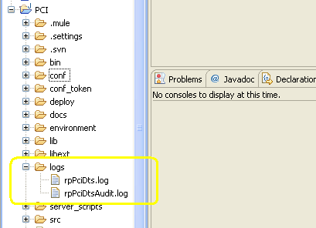

### Setting up the Logging Level for the DTS RP Project

Log levels of DTS log files can be set through the ‘log4j.xml’(inside <DTS RP Checkout folder>\conf folder).

* Open the ‘log4j.xml’. Find the logging level values and modify as per your requirement. There are multiple log files. So you need to set it for each one separately. Identify the appended log file using the green marked section. Modify the log level value in the yellow marked section. The value can be any eligible log level value of log4j API.

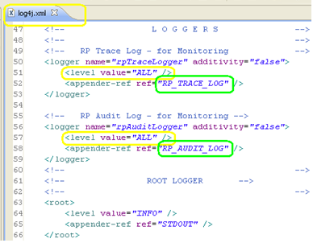

### Setting up the DTS RP Logging in Eclipse IDE Console

The DTS RP root logging can be set to Eclipse console so that the DTS RP logs can be seen from within the Eclipse IDE in its console window. This can be set through the ‘log4j.xml’inside <DTS RP Checkout folder>\conf folder).

* Open the ‘log4j.xml’. Find the root appender reference. Make sure that the root appender points to ‘STDOUT’as shown below.

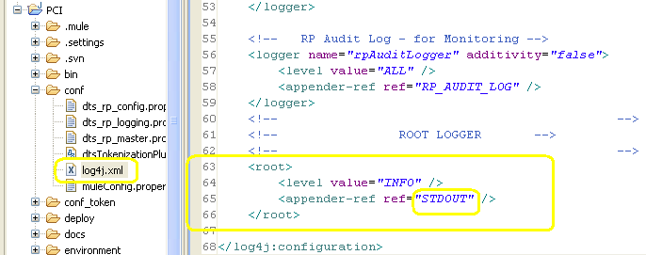

### Using HTTP for Web Service instead of HTTPS

When running locally, it is better to configure the web services using the http as the protocol instead of https. Of course, the web services exposed using https in real-life. But for keeping things simple, we use http when running in local machine. So we need to edit the RP Mule flow to change the inbound and outbound protocol configurations from https to http.

* Open the ‘dtsrp-mule-config.xml’ file (inside /PCI/src/web/WEB-INF folder) and locate the <https:connector> definition section.

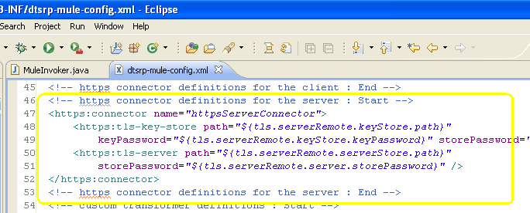

* Change the <https:connector> tag to <http:connector> tag and comment out the parameters (<https:tls-key-store> and <https:tls-server> tags) as shown below.

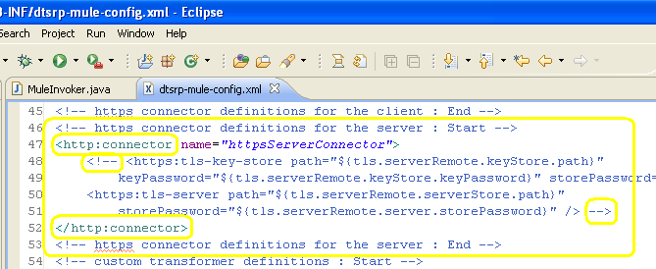

### Setting the Mule Configuration Path

Before starting the Mule RP Engine, the mule configuration path should be verified. The path is present inside the ‘MuleInvoker.java’ file (inside /PCI/src/testing/ca/bell/dts/rp/integration folder).

* Open the ‘MuleInvoker.java’ (inside /PCI/src/testing/ca/bell/dts/rp/integration folder) in Eclipse and make sure that the **dtsrp-mule-config.xml** path is correct.

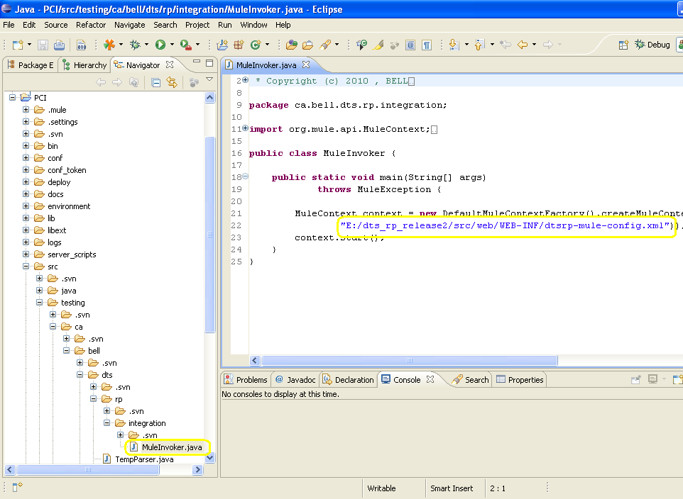

### Starting the RP Mule Engine

Starting the DTS RP Mule Engine can be done by executing the MuleInvoker.java file’s main method. This will eventually publish the services configured in ‘**d**tsrp-mule-config.xml’ file.

* . Right click on the MuleInvoker.java file and Run As (click) Java Application (click).

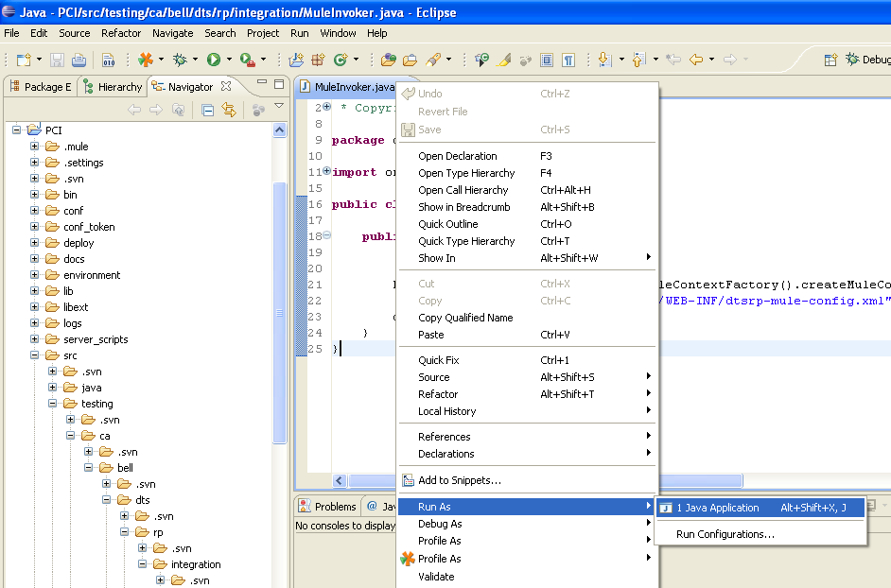

It will start the RP Mule Engine which in turn will start listening to the inbound(s) configured and publishes the services listed.